

EPM Query Introduction Hands-On Exercise –
HRP 100

Description

This hands-on exercise is designed for EPM users to get familiar with a basic understanding of the concepts of Query in Core-CT EPM.

This exercise focuses on the following topics:

Core-CT Reference Materials and Training Tools
EPM Reporting Tools and Navigation
Establishing criteria, editing query display, query creation, joining tables
Exercise 1: Data Dictionary
Exercise 2: Execute an existing query
Exercise 3 & 4: Modify an existing query
Exercise 5-7: Create a simple query, prompts, criteria, edits
Exercise 8-10: Join tables
Exercise 11: Query Maintenance, including adding to favorites, copying to other user(s), deleting queries, and renaming a private query

Pre-Requisites: Access to Core-CT EPM and HRMS tables used in this exercise.

EPM HRP 100

Exercise 1:

Data Dictionary

Navigation: Main Menu > Core-CT EPM > Reporting Tools > Data Dictionary

Skills: Locating information using the Data Dictionary

Reference: EPM Data Dictionary

The purpose of this exercise is to acquaint a user with the EPM Data Dictionary, an online reference tool. The EPM Data Dictionary contains the fields, associated reporting tables and field definitions for all reporting tables in the Enterprise Performance Management (EPM) data warehouse.

First, the Data Dictionary offers three search fields.

Reporting Table Name: Utilize this search field when you know the name of the Reporting Table and you would like to know more information specific to the table. *Remember all Reporting Tables begin with CTW_.

Reporting Table Field Name: Utilize this search field when you know the name of the Reporting Field and you would like to know which Reporting Tables utilize this field. *Remember, the name of a Reporting Field utilizes a CORE CT naming convention.

Reporting Field Label Name: Utilize this search field when you don’t know the name of the Reporting Field but rather know commonly used words that may be associated with one or more Reporting Fields.

Second, users can choose from a list of logical search parameters for each search field. The most commonly used logical search parameters are “begins with” and “contains.”

Third, users can access a short definition/description and translate values, if any, for any search value returned simply by selecting the value’s link.

Scenario: You have been tasked with finding all tables containing the fields: Employee Id, Employee Class, Department ID and Salary.

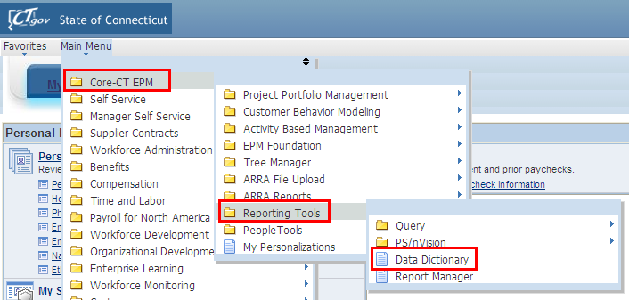

- Enter LOCATION into search field labeled Reporting Table Field Name

- Select Search
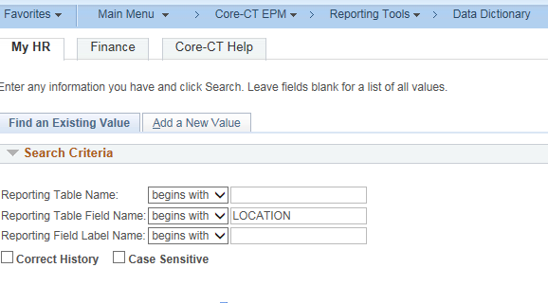
Results: Listing of all tables containing the field Location appears

- Clear the results by selecting the Clear button and return to Search

- Enter EMPL_CLASS into search field labeled Reporting Table Field Name

- Select Search
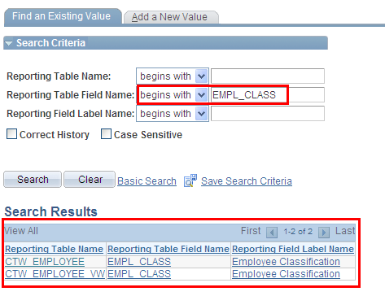

Results: Listing of all tables containing the field EMPL_CLASS appears

- Select Employee Classification link under the table heading Reporting Field Label Name

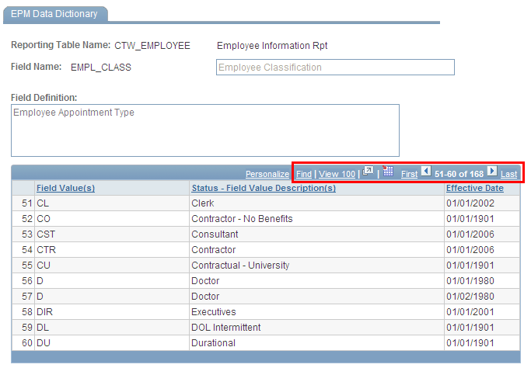

Results: Listing of all Employee Class values appears

- Select Return to Search button located at the bottom left of the screen

- Select the Clear button to clear search criterion

- Enter DEPTID into search field labeled Reporting Table Field Name

- Select Search
Results: Listing of all tables containing the field DEPTID appears

- Select Department link under the table heading Reporting Field Label Name

Results: Listing of all Department ID’s appears. Note: Be mindful of the Reporting Table selected—DEPTID Financials has different values than DEPTID HR

Using Search tools for Data Dictionary values

- Select the Find link on the Field Value Header Tool bar located in the search return table.

- Type in the first three letters of your agency. *The Find functionality works similar to Excel and will display requested values

- Select Ok

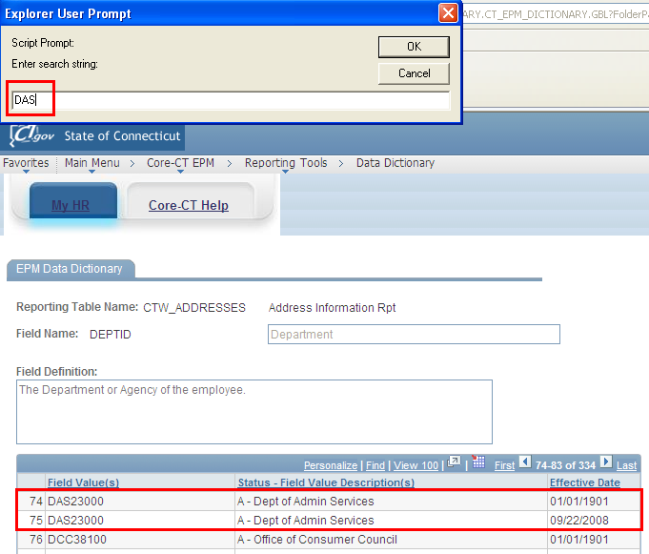

Changing Page Display Functionality

- Select View 100 link on the Field Value Header Tool bar to view 100 values at a time.

Other Search Options: To find Fields that contains a keyword

- Select Return to Search button located at the bottom left of the screen

- Select the Clear button to clear search criterion

- Select drop down arrow to access condition type options for the search field labeled Reporting Field Label Name

- Select contains option

- Enter Salary into the search field labeled Reporting Field Label Name

- Select Search

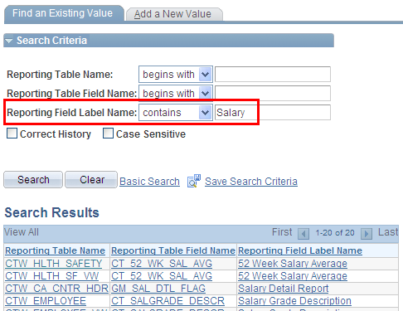

Results: All fields containing the word salary are displayed. By using the condition type of contains and being as specific as possible with your choice of words, you can search for data without knowing the People Soft name of the field.

EPM HRP 100

Exercise 2:

Run an Existing Query

Scenario: Your supervisor has instructed you to run a report identifying all active employees and active positions for your department.

Skills: Finding and Running an existing Query

Reference: Catalog of Online Financial Reports and EPM Queries

Navigation: Main Menu > Core-CT EPM > Reporting Tools > Query > Query Manager

- Select the Advanced Search tab

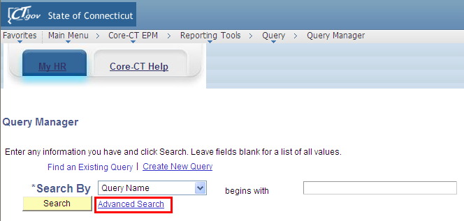

- Enter HR in the search field labeled, Folder Name

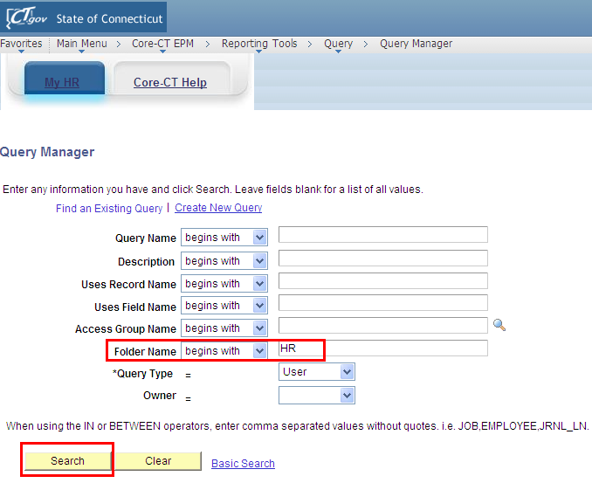

- Select Search
Results: Listing of all queries in the HR folder appears

- Within the results displayed, locate the Query titled, CT_CORE_HR_POSNS_ALL_BY_DEPT

- Under the Run to Excel option, select Excel
Results: Run time prompts appear

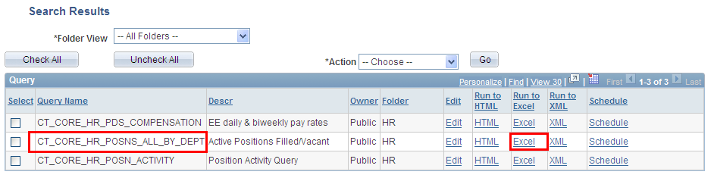
- To execute this query, locate run time prompt titled, DEPTID like (%) in the upper left hand corner

- Enter the first three letters of your agency’s DEPT ID %

- Select View Results

Results: The query will run to completion and display on the screen. Note the number of rows returned.
Access Field Definitions and Predefined Values

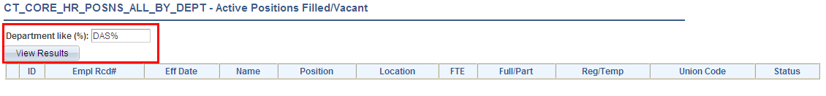

EPM HRP 100

Exercise 3:

Modifying an Existing Query

Skills: Learn how to modify an existing query, add prompt criteria.

Navigation: Main Menu > Core-CT EPM > Reporting Tools > Query > Query Manager

Scenario: You have been asked to modify the query, CT_CLASS_HR_JOBCODE to include a prompt for DEPTID to provide a list of all active employees and their job codes in a specified agency.

- Select the Advanced Search tab

- Enter CLASS in the search field labeled, Folder Name

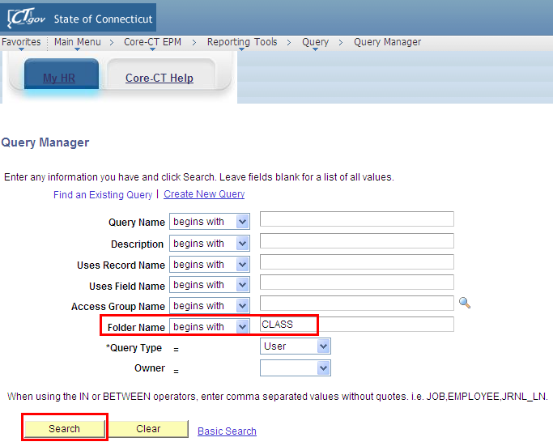
Results: Listing of all queries in the CLASS folder appears

- Within the results displayed, locate the Query titled, CT_CLASS_HR_JOBCODE

- Select the Edit hyperlink located to the right of the name of the report

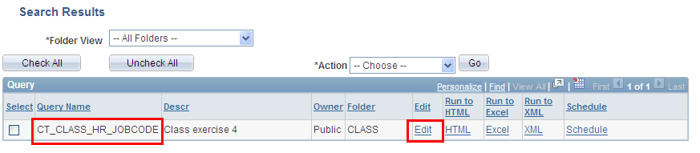

- Select the Query tab

- Locate the expand option denoted by a plus sign (+) on a folder to the left of a record titled, CTW_EMPLOYEE_VW

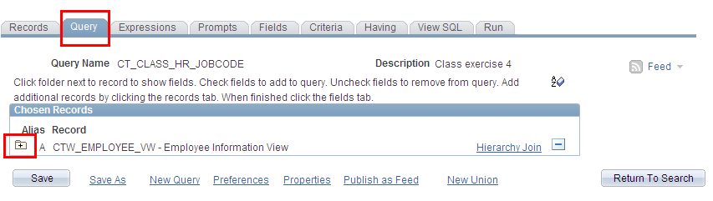
Results: CTW_EMPLOYEE_VW record is the table used to build the query. All the fields contained in this record/table are displayed. All checked fields will display on the final report.

To add reporting fields to the query report

- Locate the Fields titled, LOCATION and CT_LOCATION_DESCR

- Check the box next to the Field names

Results: The Fields, LOCATION and CT_LOCATION_DESCR will now display on the final report

To remove a field from the query report

- Locate the Field titled, BUSINESS_TITLE

- Uncheck the box next to the Field name

Results: The Field, BUSINESS_TITLE, will not display on the final report

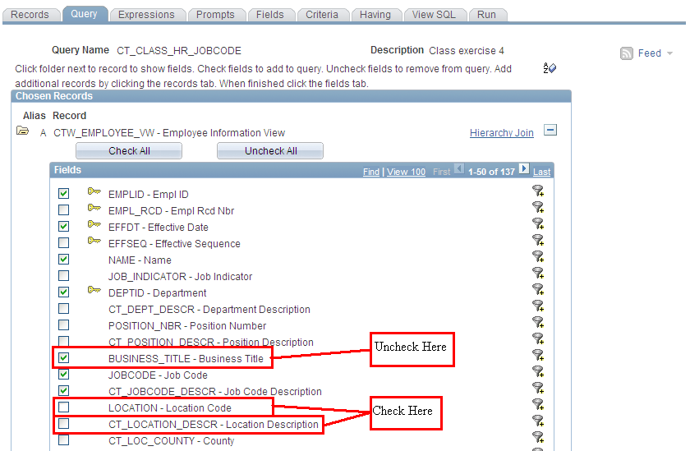

To add criteria/prompt to a reporting Field from the Fields tab

- Locate the Field titled, DEPTID, on the Fields tab

- Select the Add Criteria icon represented by the picture of a funnel located to the right of the Field name, DEPTID

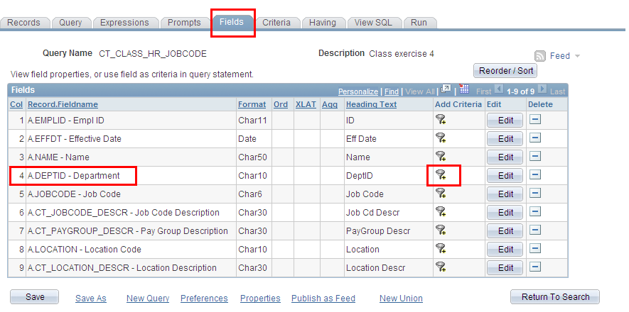

Results: The Edit Criteria Properties page appears for the Field, DEPTID

- Select like as a condition type from the drop down menu

- Within the Choose Expression 2 Type, select the prompt radio button

- Within the Expression 2 box, select the New Prompt link

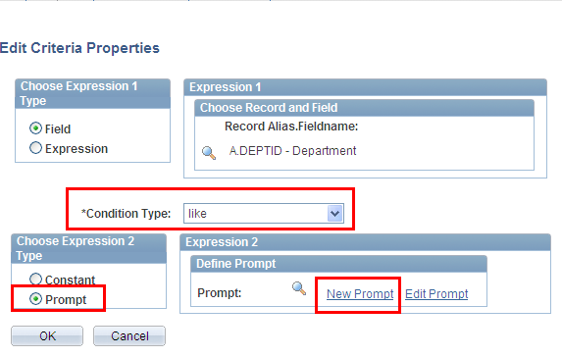

Results: The Edit Prompt Properties page appears

- Locate the Heading Text field and enter Department (like-%)

- Select Ok

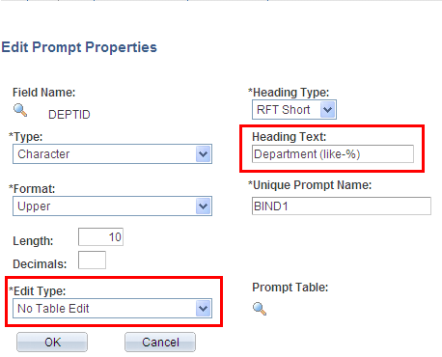

To add criteria to a reporting Field that is not displayed in the final report, you must add criteria from either the Query or Criteria tab.

- Select the Query Tab and locate the Field titled, EMPL_STATUS

- Select the Add Criteria icon represented by the picture of a funnel located to the right of the Field name, EMPL_STATUS
Results: The Edit Criteria Properties page appears for the Field, EMPL_STATUS

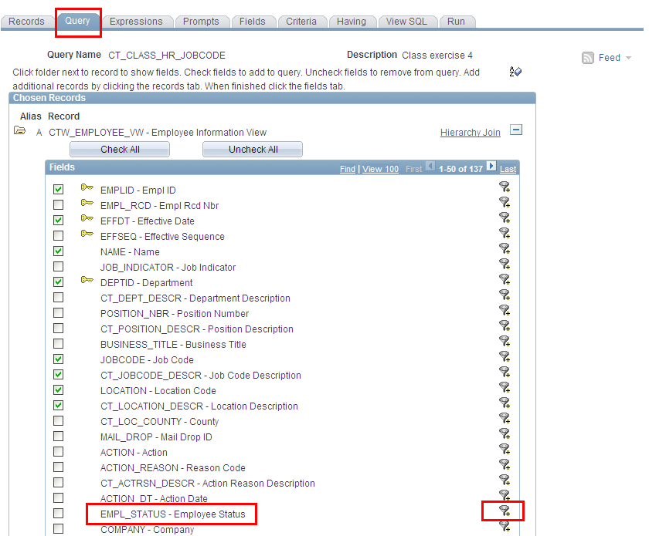

- Select in list as a condition type from the drop down menu

- Select the looking glass icon located within the Expression 2>Edit List to display the predetermined values for this field

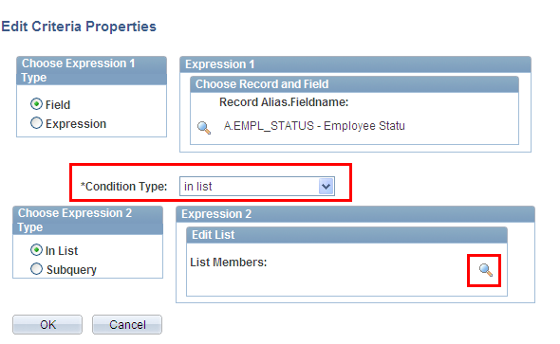
- Select the Add Value key for each of the following values: A - Active, L - Leave, P - Leave w/Py, and S - Suspended

- After selecting, click Add Value for each value. Select OK after validating the list of members on the Edit Criteria Properties page.

Results: You have established selection criteria for the Field, EMPL_STATUS without the field displaying on the final report. PLEASE NOTE: If you are required to enter alpha values, make sure these are capitalized.

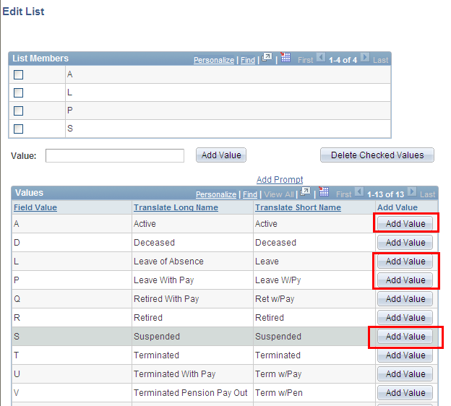

Review and Save

- Select Save As located in the row of links at the bottom of the query page to save your query.

- Name your query using standard naming conventions, description as well as identify a folder to save in, if appropriate.

Test Query

- Return to Search and enter the new query name in the search engine. Select Run to Excel located to the right of your saved query name on the Query Manager page. When prompted, enter the first three letters of your agency’s DEPTID followed by the percent sign (%) as well as enter a Union Code. Note: a list of Union Codes is available in data dictionary.

Results: An Excel spreadsheet will generate and display the results of your query. If appropriate, save to a location of your choice and evaluate the data.

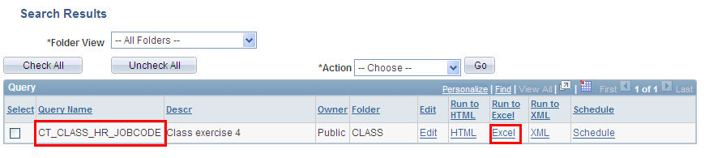

EPM HRP 100

Exercise 4:

Modifying an Existing Query

Scenario: You have been asked to modify the query you just created in Exercise three to include a prompt for Union Code as well as to reorder and sort the data fields in the final report.

Skills: Modifying an Existing Query, prompts, sort order

Navigation: Main Menu > Core-CT EPM > Reporting Tools > Query > Query Manager

- Enter the query name established in Exercise Three

- Select the Edit hyperlink located to the right of the name of the report

Results: The query will open to the Fields tab and a listing of the fields being utilized will appear

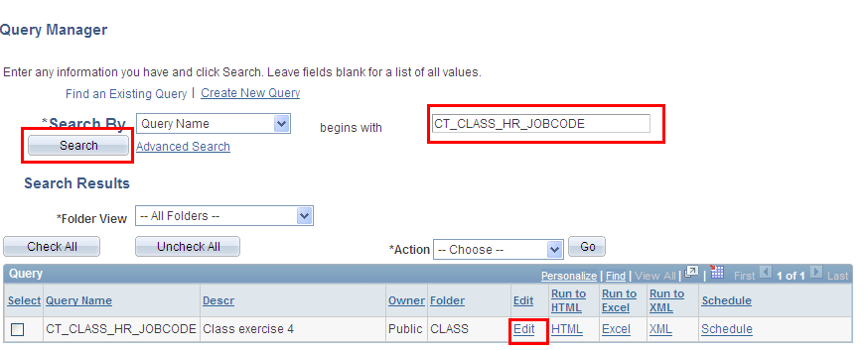

- On the Query tab, select UNION_CD to add the Union Code field to the report

To add criteria/prompt to a reporting Field from the Fields tab

- Locate the Field titled, UNION_CD, on the Fields tab

- Select the Add Criteria icon represented by the picture of a funnel located to the right of the Field name, UNION_CD
Results: The Edit Criteria Properties page appears for the Field, UNION_CD

- Select Equal To as a condition type from the drop down menu

- Within the Choose Expression 2 Type, select the prompt radio button

- Within the Expression 2 box, select the New Prompt link
Results: The Edit Prompt Properties page appears

- Locate the Heading Text field and enter Union Code =

- Select Ok
Results: You have successfully added a prompt for UNION_CD

Reorder/Sort

- On the Fields Tab, select the Reorder/Sort button, which will bring you to the Edit Field Ordering page

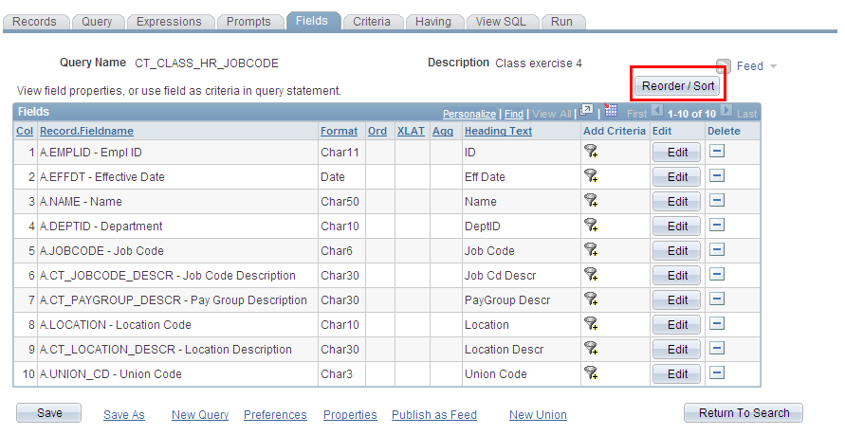

- Determine the order in which you would like the data to appear on the final report and the order in which the data should be sorted

- To reorder the data fields, enter in the left hand column the numeral 1 next to the DEPTID field to display the Department Id first. Then, enter the numeral 2 next to the EMPLID field. Lastly, enter the numeral 3 next to the NAME field.

- To sort alphabetically, enter in the right hand column the numeral 1 next to the NAME field and choose ascending by leaving unchecked the descending option. Then sort employees by their job code, enter the numeral 2 next to the JOBCODE field and choose ascending.

- Select OK which will return you to the Fields tab and select SAVE to save query

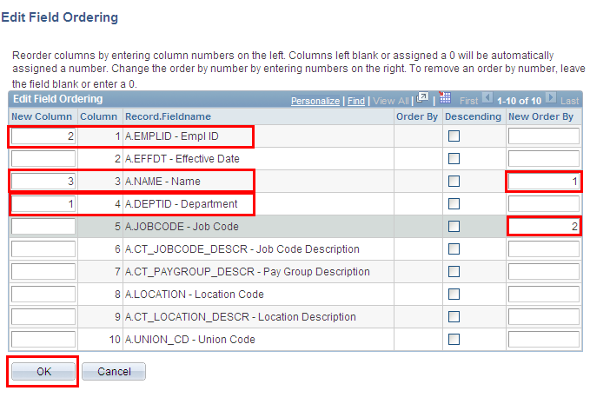

Test Query

- Return to Search and enter the query name in the search engine. Select Run to Excel located to the right of your saved query name on the Query Manager page
Results: An Excel spreadsheet will generate and display the results of your query. Note the differences in report format from Exercise 3. If appropriate, save to a location of your choice and evaluate the data.

EPM HRP 100

Exercise 5:

Creating a Query

Scenario: Build a query to provide a list of positions that are currently approved.

Skills: Creating a Query, data sampling, adding criteria, effective dated record

Reference: EPM Data Dictionary, HRMS Reporting Table Summary

Navigation: Main Menu > Core-CT EPM > Reporting Tools > Query > Query Manager

- On the Query Manager page, select the Create New Query link, which will automatically take you to the records tab

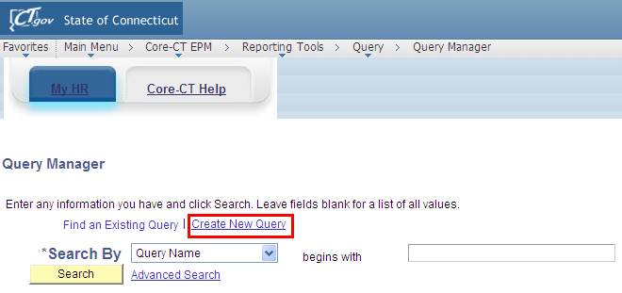

- Enter CTW_POSITION in the Search By>Record Name search field

- Select Search

- On the search results page, select Add Record which is located right of the record name, CTW_POSITION

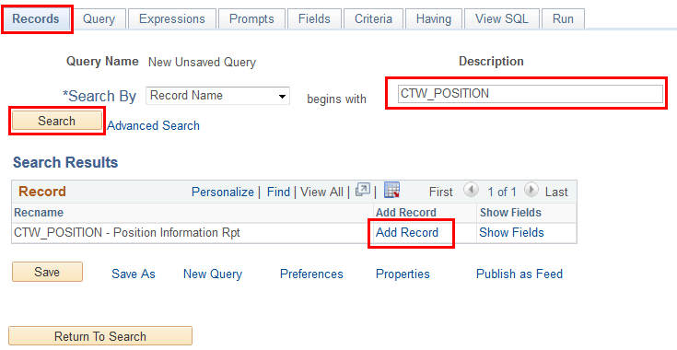

Results: Upon adding the record, the effective date pop up notification appears stating, An effective date criteria has been automatically added for this effective dated record.

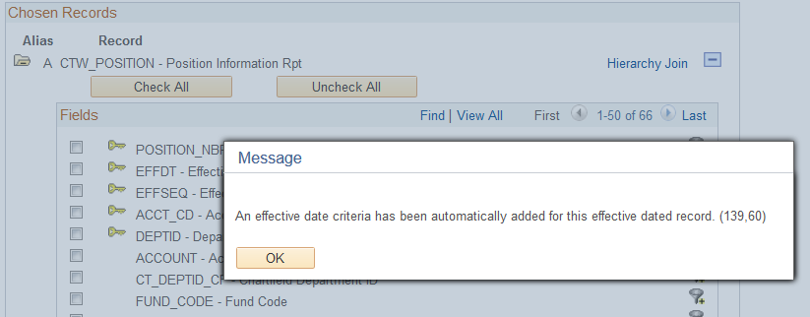

- Select Ok. You are now on the Query tab.

- Within the listing of fields, select the CHECK ALL button and ensure that all fields have been checked.

- Locate and select the Fields tab located at the top of the page

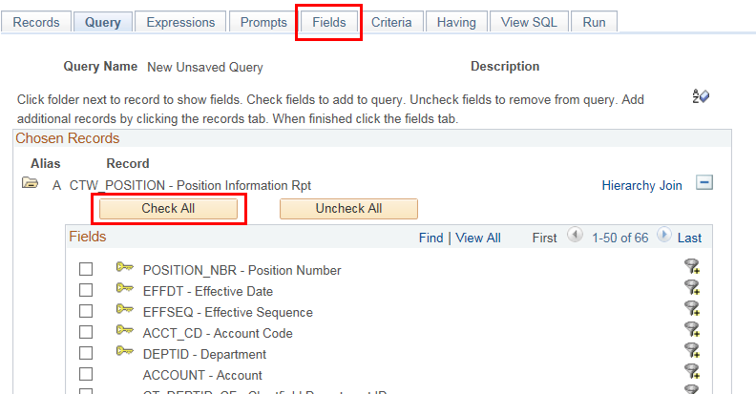

To add criteria to a reporting Field from the Fields tab

- Locate the Field titled, DEPTID, on the Fields tab

- Select the Add Criteria icon represented by the picture of a funnel located to the right of the Field name, DEPTID
Results: The Edit Criteria Properties page appears for the Field, DEPTID

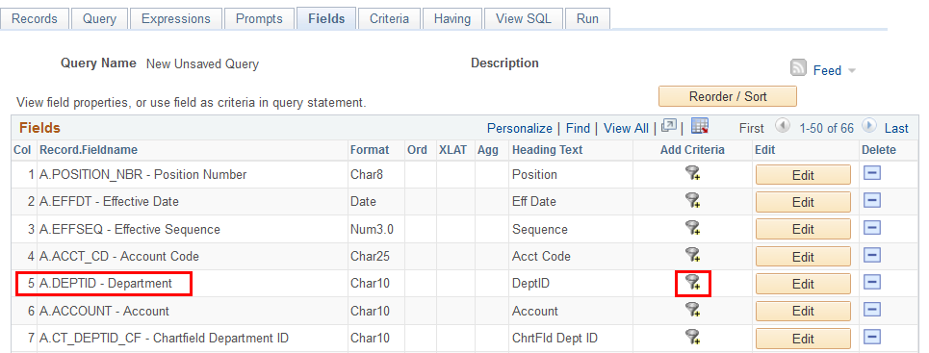

- Select like as a condition type from the drop down menu

- Within the Expression 2 > Define Constant box, enter the first three letters of your agency followed by the percent sign (%)

Results: You have established selection criteria for the Field, DEPTID, using the wildcard (%) which will return all agency employees.

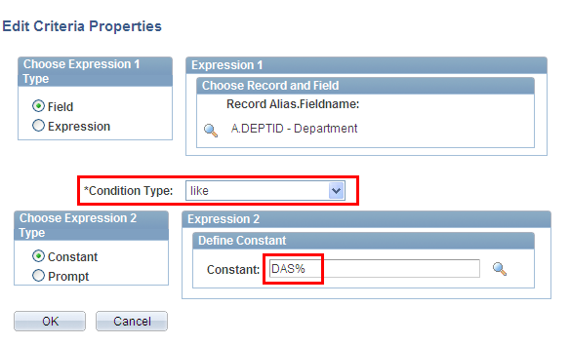

- Click OK

To add criteria/prompt to a reporting Field from the Fields tab

- locate the Field titled, POSN_STATUS, on the Fields tab

- Select the Add Criteria icon represented by the picture of a funnel located to the right of the Field name, POSN_STATUS

Results: The Edit Criteria Properties page appears for the Field, POSN_STATUS

- Select in list as a condition type from the drop down menu

- Select the looking glass icon located within the Expression 2 > Edit List to display the predetermined values for this field

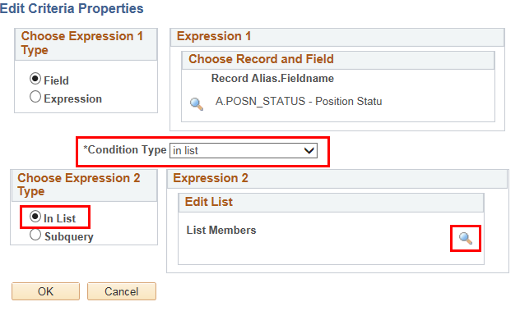

- Click the Add Value link for the following values: A – Approved, P – Proposed, and D - Rejected

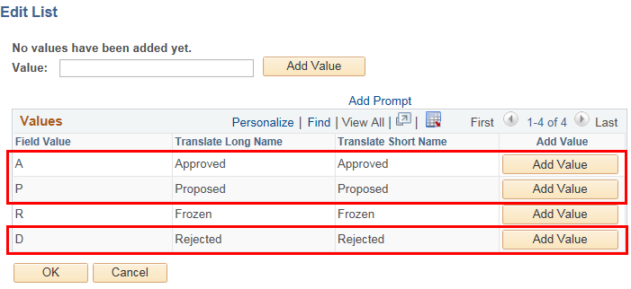

- Click OK after validating the list of members on the Edit Criteria Properties page.

To add criteria/prompt to a reporting Field from the Fields tab

- locate the Field titled, EFF_STATUS, on the Fields tab

- Select the Add Criteria icon represented by the picture of a funnel located to the right of the Field name, EFF_STATUS

Results: The Edit Criteria Properties page appears for the Field, EFF_STATUS

- Select equal to as a condition type from the drop down menu

- Select the looking glass icon located within the Expression 2 > Define Constant to display the predetermined values for this field

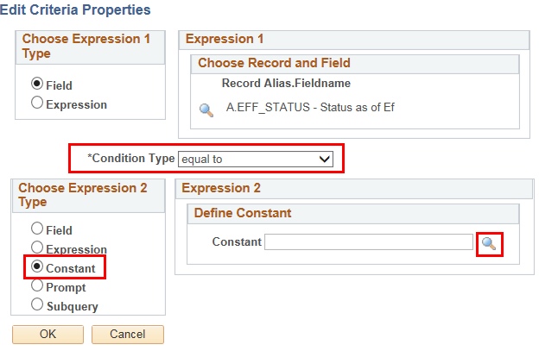

- Click the Select Constant link for the value of A – Active

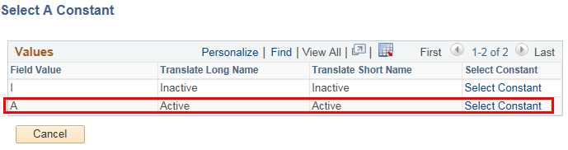

- Click OK after validating the list of members on the Edit Criteria Properties page.

Review and Save

- Select Save As located in the row of links at the bottom of the query page to save your query.

- Name your query using standard naming conventions, descriptions as well as identify a folder to save in, if appropriate. Note: All queries should be saved as PRIVATE.

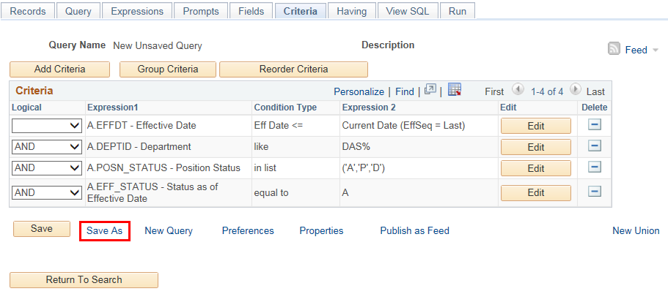

Test Query

- Select Run to Excel located to the right of your saved query name on the Query Manager page

Results: An Excel spreadsheet will generate and display the results of your query. If appropriate, save to a location of your choice and evaluate the data.

To view historical information

- Select the Edit link located to the right of your saved query name on the Query Manager page, which will bring you to the Fields tab

- Select the Criteria tab and select the delete button marked as a minus sign (-) next to the row of criteria labeled, A.EFFDT-Effective Date Eff Date <= Current Date (EffSeq = Last).

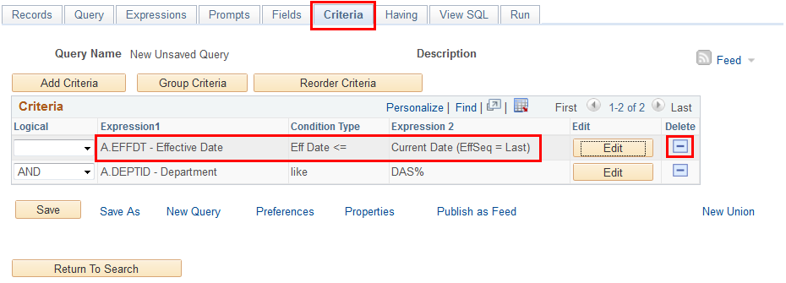

Results: You have now eliminated the effective date criteria which limited the results to only the most current information. Elimination of the effective date criteria allows the display of historical, current and future dated rows.

- Select SAVE to save your query or SAVE AS to save your query under a

EPM HRP 100

Exercise 6:

Creating A Query

Scenario: Your supervisor has requested a listing of all employees in each separate location of your agency, including hire date and union.

Skills: Creating a Query, adding criteria, effective dated record, sort order

Reference: EPM Data Dictionary, HRMS Reporting Table Summary

Navigation: Main Menu > Core-CT EPM > Reporting Tools > Query > Query Manager

- Select the Create New Query link, which will automatically take you to the records tab

- Enter CTW_EMPLOYEE_VW in the Search By>Record Name search field

- Select Search

- On the search results page, select Add Record which is located right of the record name, CTW_EMPLOYEE_VW
Results: Upon adding the record, the effective date pop up notification appears stating, An effective date criteria has been automatically added for this effective dated record.

- Acknowledge the Effective Date criteria by selecting Ok. You are now on the Query tab.

- Within the listing of fields, select the following fields: EMPLID, NAME, DEPTID, CT_DEPT_DESCR, LOCATION, CT_LOCATION_DESCR, EMPL_STATUS, JOBCODE, CT_JOBCODE_DESCR, UNION_CD

- Locate and select the Fields tab

To add criteria to a reporting Field from the Fields tab

- Locate the Field titled, EMPL_STATUS, on the Fields tab

- Select the Add Criteria icon represented by the picture of a funnel located to the right of the Field name, EMPL_STATUS
Results: The Edit Criteria Properties page appears for the Field, EMPL_STATUS

- Select in list as a condition type from the drop down menu

- Select the looking glass icon located within the Expression 2>Edit List to display the predetermined values for this field

- Select the add value key for the following values: A=active, L=leave of absence, P=leave w/pay, and S=suspended

- After selecting add value for each value desired, then select OK twice

Results: You have established selection criteria for the Field, EMPLOYEE STATUS. PLEASE NOTE: If you are required to enter alpha values, make sure these are capitalized.

To Sort

- On the Fields tab, select the Reorder/Sort button, which will bring you to the Edit Field Ordering page

- In the right hand column, enter the numeral 1 next to the Field, DEPTID. Enter the numeral 2 next to the Field, LOCATION. Note: The default for sort order is ascending. If you wish for the data to be in descending order, select the box under the Column Order by Descending.

- Select OK which will return you to the Fields tab

Review and Save

- Select Save As located in the row of links at the bottom of the query page to save your query.

- Name your query using standard naming conventions, description as well as identify a folder to save in, if appropriate. Note: All queries should be saved as PRIVATE.

Test Query

- Select Run to Excel located to the right of your saved query name on the Query Manager page

Results: An Excel spreadsheet will generate and display the results of your query. If appropriate, save to a location of your choice and evaluate the data.

EPM HRP 100

Exercise 7:

Creating A Query

Scenario: Design a query to return all agency employees active in benefits billing for medical and dental insurance.

Skills: Creating a Query, adding criteria, prompts, effective date

Reference: EPM Data Dictionary, HRMS Reporting Table Summary

Navigation: Main Menu > Core-CT EPM > Reporting Tools > Query > Query Manager

- Select the Create New Query link, which will automatically take you to the records tab

- Enter CTW_BEN_BILL_VW in the Search By>Record Name search field

- Select Search

- On the search results page, select Add Record which is located right of the record name, CTW_BEN_BILL_VW
Results: Upon adding the record, the effective date pop up notification appears stating, “An effective date criteria has been automatically added for this effective dated record.”

- Select Ok. You are now on the Query tab.

- Within the listing of fields, select the following fields: EMPLID, PLAN_TYPE, EFFDT, DEPTID, BILLING_STATUS, BILLING_REASON

- Locate and select the Fields tab

To add criteria to a reporting Field from the Fields tab

- Locate the Field titled, PLAN_TYPE, on the Fields tab

- Select the Add Criteria icon represented by the picture of a funnel located to the right of the Field name, PLAN_TYPE
Results: The Edit Criteria Properties page appears for the Field, PLAN_TYPE

- Select in list as a condition type from the drop down menu

- Select the looking glass icon located within the Expression 2>Edit List to display the predetermined values for this field

- Select the add value key for the following values: 10 and 11

- Select OK after validating the list of members displayed on the Edit Criteria Properties page.
Results: The criteria limiting the query to the medical and dental plan types are set up in a list format.

- Locate the Field titled, BILLING_STATUS, on the Fields tab

- Select the Add Criteria icon represented by the picture of a funnel located to the right of the Field name, BILLING_STATUS
Results: The Edit Criteria Properties page appears for the Field, BILLING_STATUS

- Select equal to as a condition type from the drop down menu

- Within the Choose Expression 2 Type, select the constant button

- Within the Expression 2 box, enter A to define the constant value of available for billing.

- Select OK
Results: You have established selection criteria for the Field, BILLING_STATUS. PLEASE NOTE: You can set the constant by either typing in the value or choosing it from the predefined values by selecting the looking glass and then selecting the appropriate value

To add criteria/prompt to a reporting Field from the Fields tab

- Locate the Field titled, DEPTID, on the Fields tab

- Select the Add Criteria icon represented by the picture of a funnel located to the right of the Field name, DEPTID

Results: The Edit Criteria Properties page appears for the Field, DEPTID

- Select like as a condition type from the drop down menu

- Within the Choose Expression 2 Type, select the prompt button

- Within the Expression 2 box, select the New Prompt link
Results: The Edit Prompt Properties page appears. Remember: Prompts cannot be reordered; they must be created in the order they will appear at runtime.

- Locate the Heading Text field and enter Department (like %)

- Select Ok twice

Review and Save

- Select Save As located in the row of links at the bottom of the query page to save your query.

- Name your query using standard naming conventions, description as well as identify a folder to save in, if appropriate. Note: All queries should be saved as PRIVATE.

Test Query

- Select Run to Excel located to the right of your saved query name on the Query Manager page

Results: An Excel spreadsheet will generate and display the results of your query. If appropriate, save to a location of your choice and evaluate the data.

EPM HRP 100

Exercise 8:

Creating a Query, Joining Tables

Scenario: Design a query to identify all employees who have filed workers compensation claims after a certain date.

Skills: Creating a New Query, join tables, prompts, translate values

Reference: EPM Data Dictionary, HRMS Reporting Table Summary, EPM Job Aid: Reporting Table Indexes and Join Criteria

First, employee workers compensation information is located on the reporting table, CTW_HLTH_SF_VW, and employee information on the reporting table, CTW_EMPLOYEE_VW

Second, utilizing the EPM Job Aid – Reporting Table Indexes and Join Criteria (embedded excel spreadsheet), determine whether or not these two tables can be joined.

Note: The two tables can be successfully joined by the fields: EMPLID and EMPL_RCD

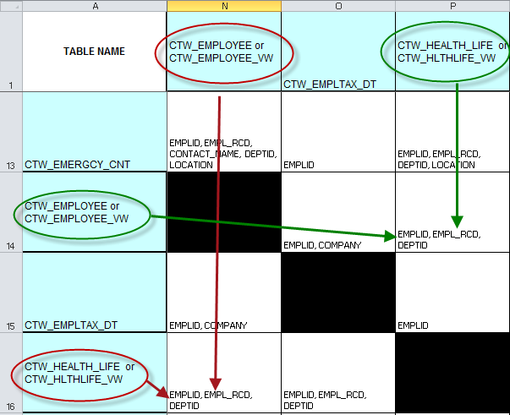
Navigation: Main Menu > Core-CT EPM > Reporting Tools > Query > Query Manager

- Select the Create New Query link, which will automatically take you to the records tab

- Enter the primary record for the new query, CTW_HLTH_SF_VW in the Search By>Record Name search field

- Select Search

- On the search results page, select Add Record which is located right of the record name, CTW_HLTH_SF_VW
Results: Upon adding the record, the effective date pop up notification appears stating, “An effective date criteria has been automatically added for this effective dated record.”

- Select Ok. You are now on the Query tab.

- Within the listing of fields, select the following fields: EMPLID, INCIDENT_NBR, CLAIM_NBR, NAME, INCIDENT_TYPE, INCIDENT_DT, DEPTID, LOCATION, CLAIM_STATUS, OPEN_DT, CLOSE_DT

- Return to the Records Tab to select the second record for the new query

- Enter the secondary record for the new query, CTW_EMPLOYEE_VW in the Search By>Record Name search field

- Select Search

- On the search results page, select Join Record which is located right of the record name, CTW_EMPLOYEE_VW

- Select record to be joined, CTW_HLTH_SF_VW.

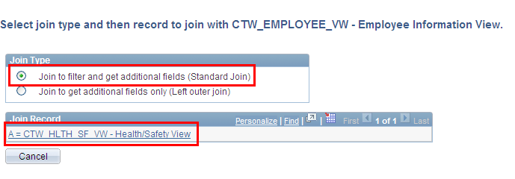

- Auto Join Criteria page will appear. Accept the join type: Standard Join. Customize default criteria by deselecting the box for the join criteria A.DEPTID=B.DEPTID. Note: The job aid reference Reporting Table Indexes and Join Criteria indicates this to be an invalid join criterion.

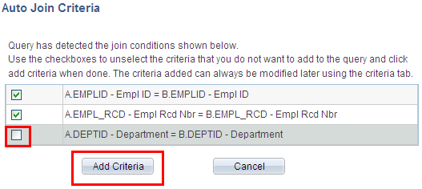

- Select Add Criteria button to accept modified default field joins. Note: A pop-up notification will appear stating that the CTW_EMPLOYEE_VW table is an effective dated table. Select okay to acknowledge.

- Within the listing of fields from the record, CTW_EMPLOYEE_VW, select the following fields: POSITION_NBR, CT_POSITION_DESCR, EMPL_STATUS

- Locate and select the Fields tab located at the top of the page

To add translate values/criteria to a reporting Field from the Fields tab

- Locate the Field titled, INCIDENT_TYPE, on the Fields tab

- Select the Edit button for the Field name, INCIDENT_TYPE
Results: The Edit Field Properties page appears for the Field, INCIDENT_TYPE

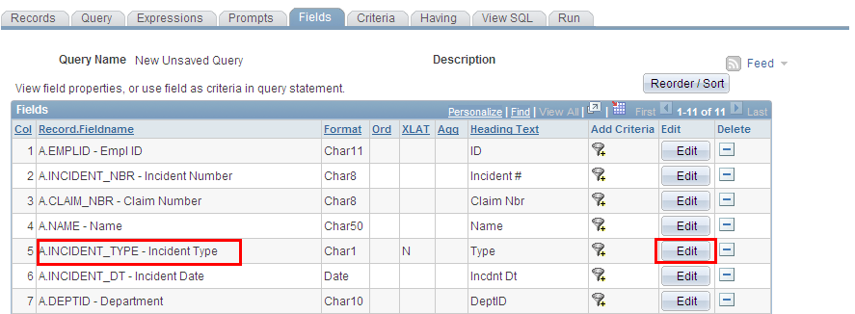

- Select Translate Value Long and then select ok

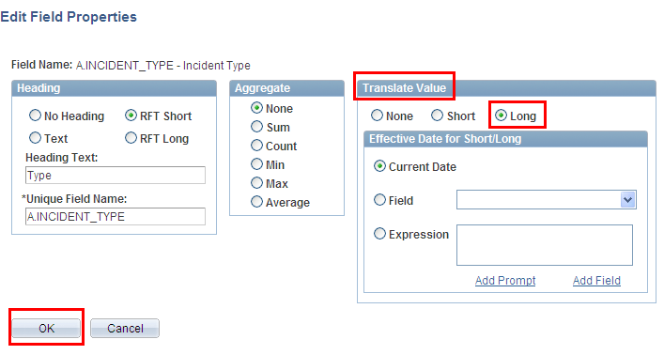

Results: The long version of the predetermined translate value has been selected. You can view the available values by selecting the looking class on the edit criteria page, accessed by the Add Criteria Icon next to the field. Translate values are only available for selected fields.

- Locate the Field titled, CLAIM_STATUS, on the Fields tab

- Select the Edit button for the Field name, CLAIM_STATUS
Results: The Edit Field Properties page appears for the Field, CLAIM_STATUS

- Select Translate Value Long and then select ok

To add criteria/prompt to a reporting Field from the Fields tab

- Select the Add Criteria icon represented by the picture of a funnel located to the right of the Field name, DEPTID

- Select like as a condition type from the drop down menu

- Within the Choose Expression 2 Type, select the prompt radio button

- Within the Expression 2 box, select the New Prompt link
Results: The Edit Prompt Properties page appears. Remember: Prompts cannot be reordered; they must be created in the order they will appear at runtime.

- Locate the Heading Text field and enter Department (like-%)

- Select Ok twice

- Locate the Field titled, OPEN_DT, on the Fields tab

- Select the Add Criteria icon represented by the picture of a funnel located to the right of the Field name, OPEN_DT
Results: The Edit Criteria Properties page appears for the Field, OPEN_DT

- Select greater than as a condition type from the drop down menu

- Within the Choose Expression 2 Type, select the prompt button

- Within the Expression 2 box, select the New Prompt link
Results: The Edit Prompt Properties page appears. Remember: Prompts cannot be reordered; they must be created in the order they will appear at runtime.

- Locate the Heading Text field and enter Claim Open Date >

- Select Ok twice

Review and Save

- Select Save As located in the row of links at the bottom of the query page to save your query.

- Name your query using standard naming conventions, description as well as identify a folder to save in, if appropriate. Note: All queries should be saved as PRIVATE.

Test Query

- Select Run to Excel located to the right of your saved query name on the Query Manager page. Enter appropriate values when prompted. For Department is like %, you should enter your agency’s three letter code followed by the percent symbol, %. For claim open date >, enter 7/1/2009.

Results: An Excel spreadsheet will generate and display the results of your query. If appropriate, save to a location of your choice and evaluate the data.

EPM HRP 100

Exercise 9:

Creating a Query, Joining Tables

Scenario: Design a query to audit self-service personal data updates. Current HRMS functionality allows an employee to change their personal information. Name and address changes require workflow approval. Business phone and email cannot be changed via self-service.

Skills: Creating a Query, adding criteria, prompts, effective date

Reference: EPM Data Dictionary, HRMS Reporting Table Summary, EPM Job Aid: Reporting Table Indexes and Join Criteria

Employee information is on the reporting table, CTW_EMPLOYEE_VW, and email/phone information is on CTW_ADDRESSESVW.

Utilizing the EPM Job Aid – Reporting Table Indexes and Join Criteria (embedded excel spreadsheet), determine whether or not these two tables can be joined.

Note: The two tables can be successfully joined by the field: EMPLID, EMPL_RCD, and DEPTID

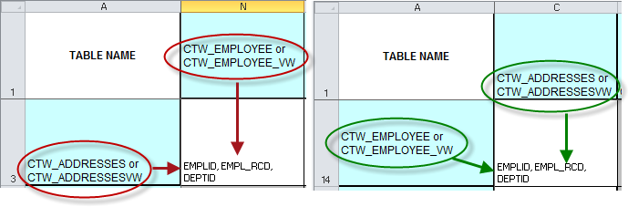

Navigation: Main Menu > Core-CT EPM > Reporting Tools > Query > Query Manager

- Select the Create New Query link, which will automatically take you to the records tab

- Enter CTW_EMPLOYEE_VW in the Search By > Record Name search field

- Select Search

- On the search results page, select Add Record which is located right of the record name, CTW_EMPLOYEE_VW
Results: Upon adding the record, the effective date pop up notification appears stating, “An effective date criteria has been automatically added for this effective dated record.”

- You are now on the Query tab.

- Within the listing of fields, select the following fields: EMPLID, EMPL_RCD, NAME, DEPTID, CT_JOBCODE_DESCR, CT_LOCATION_DESCR, EMPL_STATUS

- Return to the Records Tab to select the second record for the new query

- Enter the secondary record for the new query, CTW_ADDRESSESVW in the Search By>Record Name search field

- Select Search

- On the search results page, select Join Record instead of Add Record for the record, CTW_ADDRESSESVW.

- Select record to be joined, CTW_ EMPLOYEE_VW.

- Auto Join Criteria page will appear. Accept the join type: Standard Join.

- Select Add Criteria button to accept modified default field joins: EMPLID, EMPL_RCD, and DEPTID

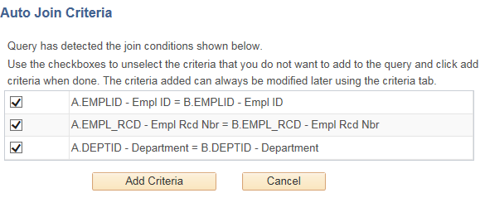

- Within the listing of fields from the record, CTW_ADDRESSESVW, select the following fields: ADDRESS_TYPE, ADDRESS1, ADDRESS2, ADDRESS3, CITY, STATE, POSTAL

- Locate and select the Fields tab located at the top of the page

To add criteria to a reporting Field from the Fields tab

- Locate the Field titled, EMPL_STATUS, on the Fields tab

- Select the Add Criteria icon represented by the picture of a funnel located to the right of the Field name, EMPL_STATUS
Results: The Edit Criteria Properties page appears for the Field, EMPL_STATUS

- Select in list as a condition type from the drop down menu

- Select the looking glass icon located within the Expression 2 > Edit List to display the predetermined values for this field

- Select the add value key for the following values: A – Active, L – Leave, P – Leave w/Py, and S - Suspended

- Select OK after validating the list of members displayed on the Edit Criteria Properties page.

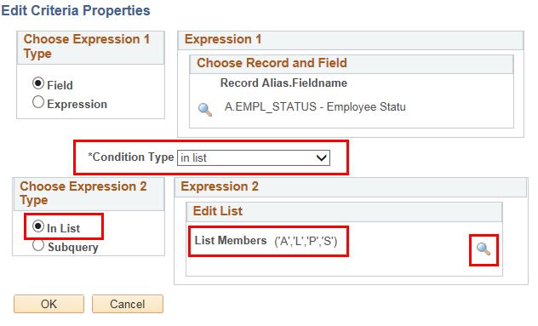

To add criteria/prompt to a reporting Field from the Fields tab

- Locate the Field titled, DEPTID, on the Fields tab

- Select the Add Criteria icon represented by the picture of a funnel located to the right of the Field name, DEPTID

Results: The Edit Criteria Properties page appears for the Field, DEPTID

- Select like as a condition type from the drop down menu

- Within the Choose Expression 2 Type, select the prompt button

- Within the Expression 2 > Define Prompt box, select the New Prompt link
Results: The Edit Prompt Properties page appears. Remember: Prompts cannot be reordered; they must be created in the order they will appear at runtime.

- Locate the Heading Text field and enter Department (like- %)

- Select Ok twice

To add criteria/prompt to a reporting Field from the Fields tab

- locate the Field titled, ADDRESS_TYPE, on the Fields tab

- Select the Add Criteria icon represented by the picture of a funnel located to the right of the Field name, ADDRESS_TYPE

Results: The Edit Criteria Properties page appears for the Field, ADDRESS_TYPE

- Select equal to as a condition type from the drop down menu

- Within the Choose Expression 2 Type, select the prompt button

- Within the Expression 2 > Define Prompt box, select the New Prompt link
Results: The Edit Prompt Properties page appears. Remember: Prompts cannot be reordered; they must be created in the order they will appear at runtime.

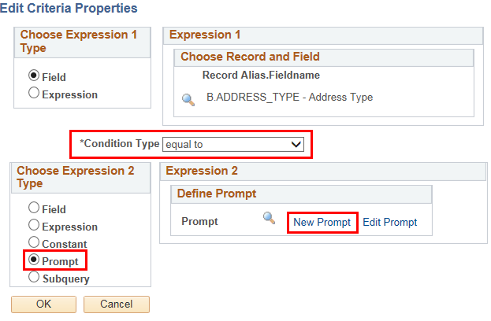

- Locate the Heading Text field and enter Enter Address Type =

- Select Ok twice

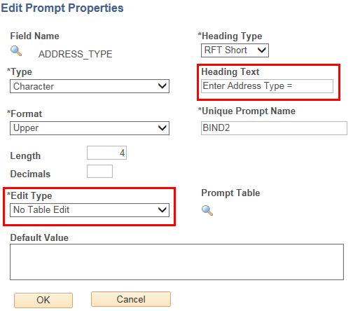

Review and Save

- Select Save As located in the row of links at the bottom of the query page to save your query.

- Name your query using standard naming conventions, description as well as identify a folder to save in, if appropriate. Note: All queries should be saved as PRIVATE.

Test Query

- Select Run to Excel located to the right of your saved query name on the Query Manager page

- Enter one of the following prompt values for ADDRESS_TYPE:

BILL
BUSN
CAMP
CHK
DORM
EGWP
HOME
LEGL
MAIL
OTH
OTH2
PERM
PREF

Results: An Excel spreadsheet will generate and display the results of your query. If appropriate, save to a location of your choice and evaluate the data.

EPM HRP 100

Exercise 10:

Creating a Query, Joining Tables

Scenario: Design a query returning position funding sources for all active employees in your agency.

Skills: Creating a Query, join tables, prompts, adding criteria, effective date

Reference: EPM Data Dictionary, HRMS Reporting Table Summary, EPM Job Aid: Reporting Table Indexes and Join Criteria

Employee information is on the reporting table, CTW_EMPLOYEE_VW, and position information is on CTW_POSITION.

Utilizing the EPM Job Aid – Reporting Table Indexes and Join Criteria (embedded excel spreadsheet), determine whether or not these two tables can be joined.

Note: The two tables can be successfully joined by the field: POSITION_NBR

Navigation: Main Menu > Core-CT EPM > Reporting Tools > Query > Query Manager

- Select the Create New Query link, which will automatically take you to the records tab

- Enter the primary record for the new query, CTW_POSITION in the Search By>Record Name search field

- Select Search

- On the search results page, select Add Record which is located right of the record name, CTW_POSITION
Results: Upon adding the record, the effective date pop up notification appears stating, “An effective date criteria has been automatically added for this effective dated record.”

- Select Ok. You are now on the Query tab.

- Within the listing of fields, select the following fields: DEPTID, POSITION_NBR, CT_POSITION_DESCR, ACCT_CD, FUND_CODE, CLASS_FLD, PROGRAM_CODE, PROJECT_ID, BUDGET_REF, DIST_PCT, UNION_CD, MAX_HEAD_COUNT, POSN_STATUS

- Return to the Records Tab to select the second record for the new query

- Enter the secondary record for the new query, CTW_EMPLOYEE_VW in the Search By > Record Name search field

- Select Search

- On the search results page, select Join Record which is located right of the record name, CTW_EMPLOYEE_VW

- Select record to be joined, CTW_POSITION.

- Auto Join Criteria page will appear. Accept join type: Standard Join. Customize default criteria by deselecting the box for the join criteria: A.EFFSEQ=B.EFFSEQ, A.DEPTID=B.DEPTID. Note: The job aid reference Reporting Table Indexes and Join Criteria indicates this to be invalid join criteria.

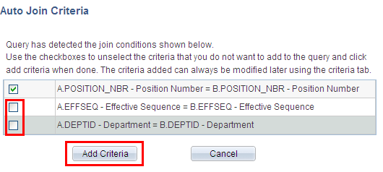

- Select Add Criteria button to accept modified default field joins. Note: A pop-up notification will appear stating that the CTW_EMPLOYEE_VW table is an effective dated table. Select okay to acknowledge.

- Within the listing of fields from the record, CTW_EMPLOYEE_VW, select the following fields: EMPLID, EMPL_RCD, EFFDT, EMPL_STATUS, LOCATION, CT_LOCATION_DESCR, NAME, ACTION, CT_ACTRSN_DESCR, ACTION_DT

- Locate and select the Fields tab

To add criteria/prompt to a reporting Field from the Fields tab

- Select the Add Criteria icon represented by the picture of a funnel located to the right of the Field name, EMPL_STATUS

- Select in list as a condition type from the drop down menu

- Select the looking glass icon located within the Expression 2, Edit List to display the predetermined values for this field

- Select the add value key for the following values: A – Active, L – Leave, P – Leave w/Py, and S – Suspended.

- Select OK after validating the list of members displayed on the Edit Criteria Properties page
Results: You have established selection criteria for the Field, EMPL_STATUS.

PLEASE NOTE: If you are required to enter alpha values, make sure these are capitalized.

- Locate the Field titled, DEPTID, on the Fields tab

- Select the Add Criteria icon represented by the picture of a funnel located to the right of the Field name, DEPTID

- Select like as a condition type from the drop down menu

- Within the Choose Expression 2 Type, select the prompt radio button

- Within the Expression 2 box, select the New Prompt link
Results: The Edit Prompt Properties page appears. Remember: Prompts cannot be reordered; they must be created in the order they will appear at runtime.

- Locate the Heading Text field and enter Department (like- %)

- Select Ok twice

Review and Save

- Select Save As located in the row of links at the bottom of the query page to save your query.

- Name your query using standard naming conventions, description as well as identify a folder to save in, if appropriate. Note: All queries should be saved as PRIVATE.

Test Query

- Select Run to Excel located to the right of your saved query name on the Query Manager page. Enter appropriate values when prompted.

EPM HRP 100

Exercise 11:

Query Maintenance

Skills: Add to favorites, Copy to User, Delete Selected, Move to Folder, Rename a private query

Navigation: Main Menu > Core-CT EPM > Reporting Tools > Query > Query Manager

To rename a query

- Enter CLASS_ASSET in the Search By>Record Name search field

- Select Search

- Select CLASS_ASSET query by checking the box to the left of the query name

- Select the action button drop down menu located near the middle of the top of the page and choose Rename Selected.

- Select Go. The Rename Queries page will appear.

- Enter the new query name in the appropriate box and select OK. The query has been renamed. Renaming a query does not create a copy but rather actually changes the name of the existing query.

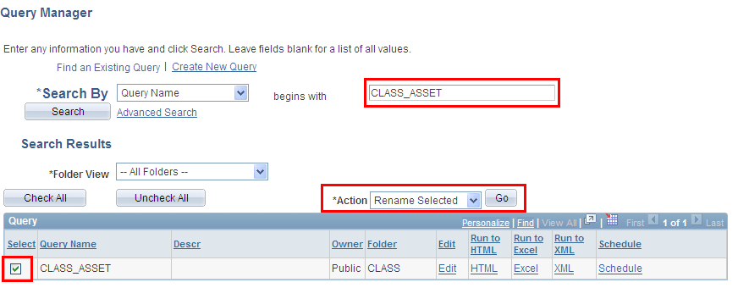

To delete a private query

- Select the query you wish to delete from the list of private queries by checking the box to the left of the query name.

- Select the action button drop down menu located near the middle of the top of the page and choose Delete. Select Go. Note: A warning/confirmation screen will appear verifying the deletion of the selected query.

- Verify deletion is the action you wish to perform. Select yes, if this is correct. Important Note: No list of queries selected to be deleted appears! Be very careful with this function!

To copy a private query to another user

- Select the query you wish to copy to another user by checking the box to the left of the query name.

- Select the action button drop down menu located near the middle of the top of the page and choose Copy to User. Select Go.

- UserID screen will appear. Enter the UserID of the person to whom you want to send the query. Upon successful copy, the sender will receive a message indicating that the query had been successfully copied to another user. The sender will then need to notify the recipient. Note: The UserID is the person’s CORE UserID. The recipient of the query must have the appropriate security access to be able to run the query.

To use folders and favorites

- Search for a query and select the check box to the left of the query name

- Select the action button drop down menu located near the middle of the top of the page and choose Move to Folder. Select Go. Folder screen will appear.

- Select an existing folder option by selecting the drop down menu to see a list of available folders. Enter a folder name of your choice. Query has been moved to a folder for ease of search.

- To set as a favorite, select the action button drop down menu located near the middle of the top of the page and choose Add to Favorites. Select Go.
Note: Your query will go directly to the on-screen list of favorite queries. To remove, just select the minus (-) button.

