Copying an analysis XML and applying it to other analyses

Issue:
User is trying to copy the XML with option of Report links Such as EDIT/Print/Analyze/”copy” in Dashboards. After copying the XML, User is trying to use copied XML to replicate the dashboard results as New Analysis. However that XML is wrapped with definition and it is not useful for further analysis.

Solution Example:
Login into Analytics URL: https://stars.ct.gov/

After logging into the analytics, Click on Create New Analysis as referenced below->

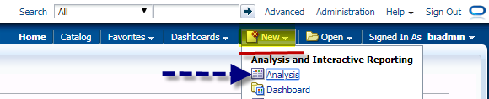

In this example: we are selecting BISAMPLE Subject Area and fields from drop down list.

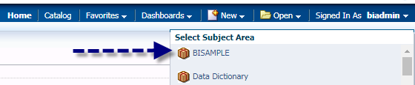

Select Year column (Drag and drop or double click) from Time Dimension (Expand it by clicking on arrows) and selecting Filter from the dropdown and making the column “as prompted” as referenced below and click OK.

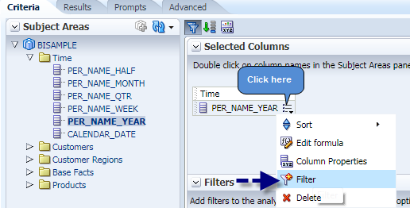
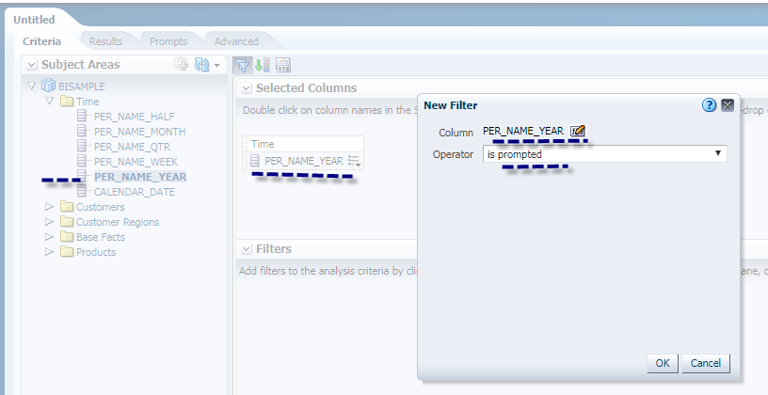

To save this report: Navigate to /My Folders/Testing/Year and click OK.
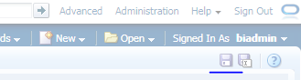
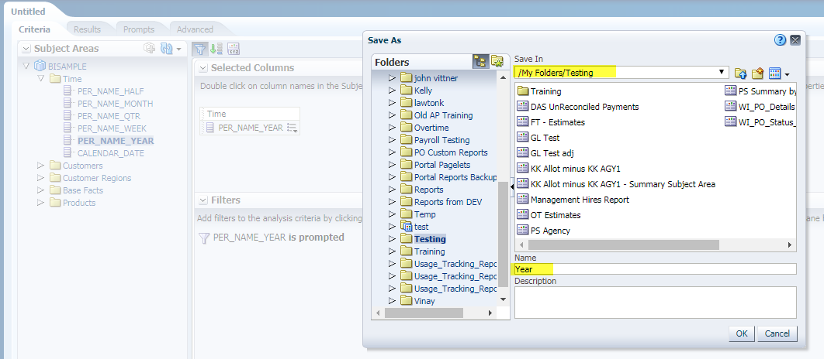

Navigate to the Advanced Tab and observe the XML Result here.
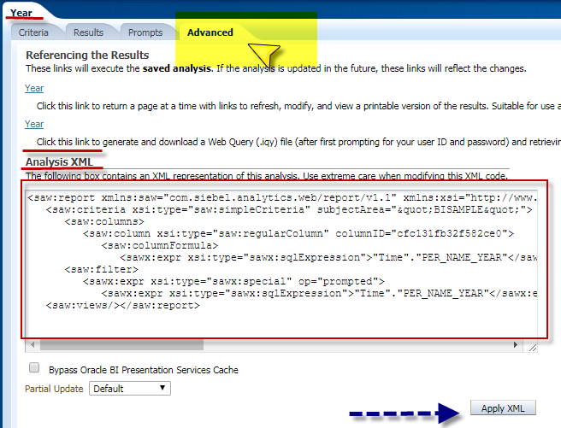

<saw:report xmlns:saw="com.siebel.analytics.web/report/v1.1" xmlns:xsi="http://www.w3.org/2001/XMLSchema-instance" xmlns:xsd="http://www.w3.org/2001/XMLSchema" xmlns:sawx="com.siebel.analytics.web/expression/v1.1" xmlVersion="201201160">
<saw:criteria xsi:type="saw:simpleCriteria" subjectArea="&quot;BISAMPLE&quot;">
<saw:columns>
<saw:column xsi:type="saw:regularColumn" columnID="cfc131fb32f582ce0">
<saw:columnFormula>
<sawx:expr xsi:type="sawx:sqlExpression">"Time"."PER_NAME_YEAR"</sawx:expr></saw:columnFormula></saw:column></saw:columns>
<saw:filter>
<sawx:expr xsi:type="sawx:special" op="prompted">
<sawx:expr xsi:type="sawx:sqlExpression">"Time"."PER_NAME_YEAR"</sawx:expr></sawx:expr></saw:filter></saw:criteria>
<saw:views/></saw:report>

Create a DASHBOARD Prompt with same column.
Click New>Dashboard Prompt

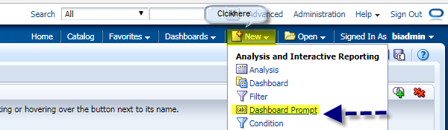
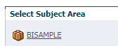

Select BISAMPLE from drop down list.

Click on the plus and Select NEW Column Prompt.

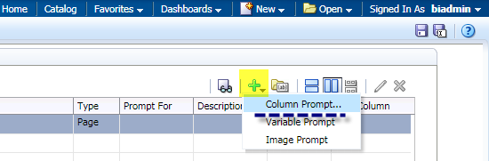
Expand Arrows to navigate BISAMPLE ->Time.

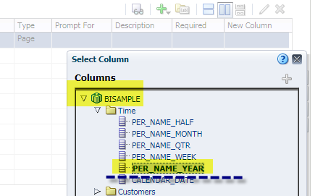

Select Per_Name_Year Click Ok

Click on ok in Next Screen.
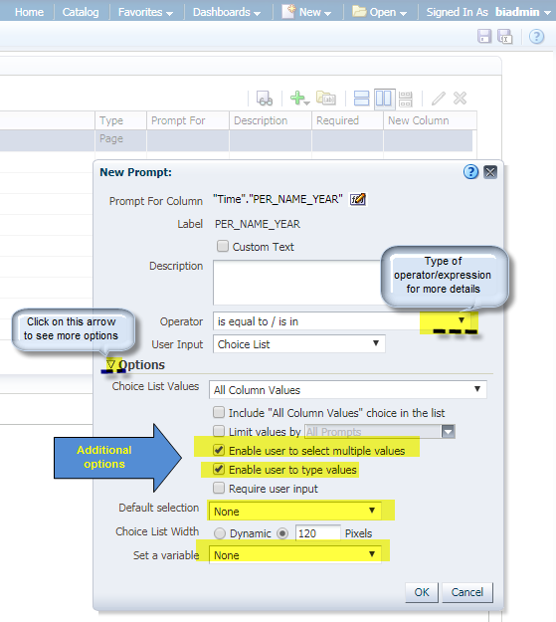
Save this prompt as YearPrompt under path /My Folder/Testing /Year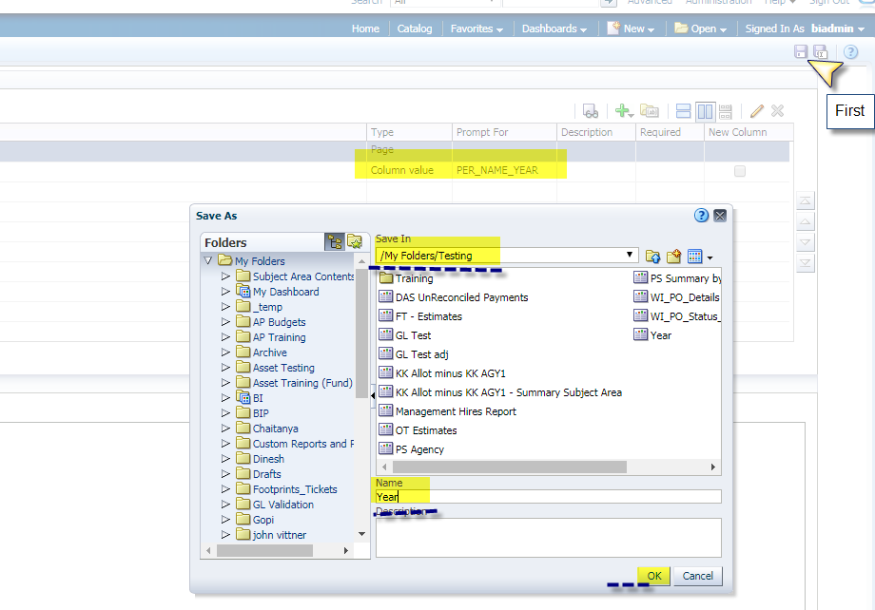

At this point one report, and one prompt filter has been created for report values. The next step is a creating dashboard page to embeed the report and prompt.

Navigation> “My Dashboard”.

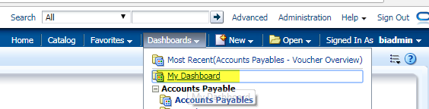

Click “Edit Dashboard” to create a new page.

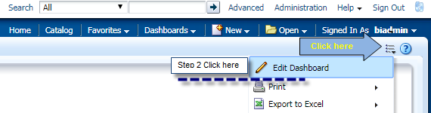

Click on as referenced below to create a new dashboard page.

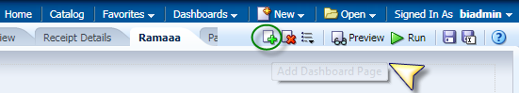
Page Name – Test
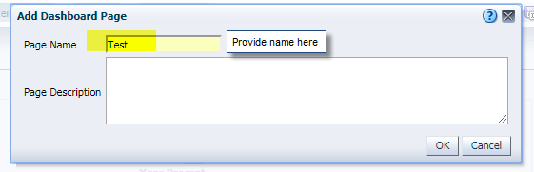

Click on OK.

Drag and Drop Year Prompt and Year Report to the new page by navigating to /My Folders/Testing.

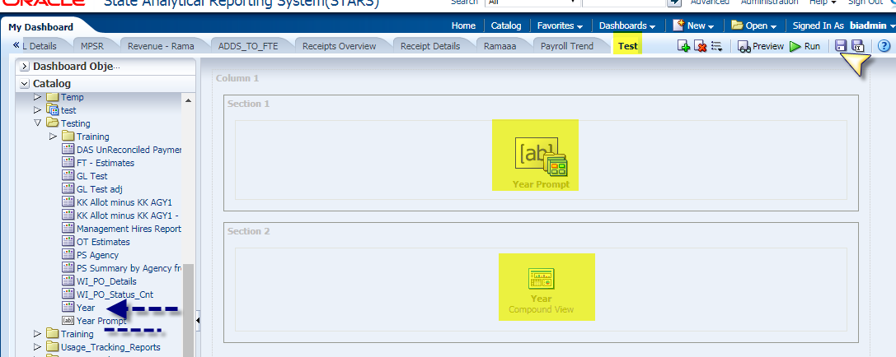

Save the Dashboard. Click on Save at the top right corner.
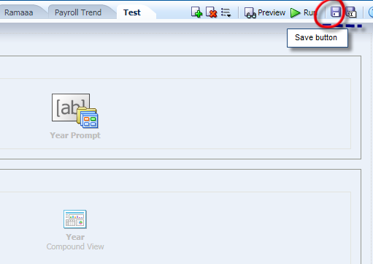

Click on Dashboard Properties to enable the Page Report Links.

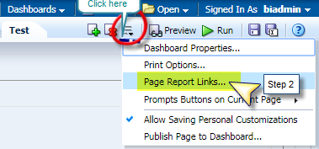

Click on Customize, select Copy and click OK.

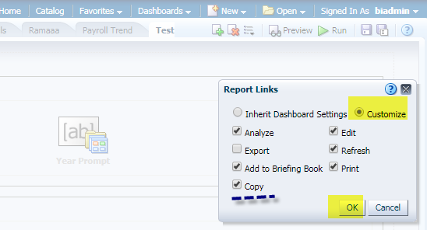

Save the dashboard page and click on RUN.

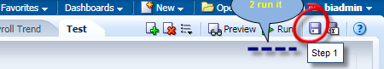

Select a value from the prompt and click Apply.

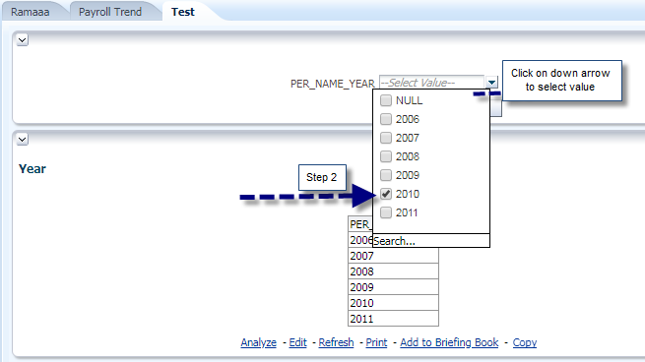
Step 3 Apply.
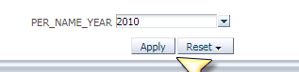

Results

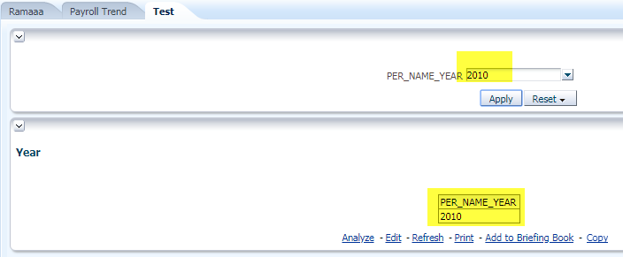

.

Click Copy XML located at the bottom of the report.

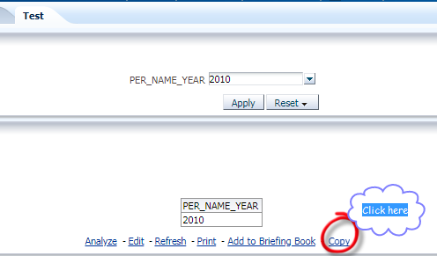

Paste the XML in any notepad/wordpad. This is the example of the XML below.

<?xml version="1.0"?>
-<sawcl:clipboard xmlns:sawcl="com.siebel.analytics.web/clipboard/v1">
-<sawcl:reportQuery>
-<saw:report xmlVersion="201201160" xmlns:sawx="com.siebel.analytics.web/expression/v1.1" xmlns:xsd="http://www.w3.org/2001/XMLSchema" xmlns:xsi="http://www.w3.org/2001/XMLSchema-instance" xmlns:saw="com.siebel.analytics.web/report/v1.1">
-<saw:criteria subjectArea=""BISAMPLE"" xsi:type="saw:simpleCriteria">
-<saw:columns>
-<saw:column xsi:type="saw:regularColumn" columnID="cfc131fb32f582ce0">
-<saw:columnFormula>
<sawx:expr xsi:type="sawx:sqlExpression">"Time"."PER_NAME_YEAR"</sawx:expr>
</saw:columnFormula>
</saw:column>
</saw:columns>
-<saw:filter>
-<sawx:expr xsi:type="sawx:list" promptPrimarySubjectArea=""BISAMPLE"" op="in">
<sawx:expr xsi:type="sawx:sqlExpression">"Time"."PER_NAME_YEAR"</sawx:expr>
<sawx:expr xsi:type="xsd:string">2010</sawx:expr>
</sawx:expr>
</saw:filter>
</saw:criteria>
-<saw:views>
-<saw:view xsi:type="saw:compoundView" name="compoundView!1">
-<saw:cvTable>
-<saw:cvRow>
-<saw:cvCell viewName="titleView!1">
-<saw:displayFormat>
<saw:formatSpec/>
</saw:displayFormat>
</saw:cvCell>
</saw:cvRow>
-<saw:cvRow>
-<saw:cvCell viewName="tableView!1">
-<saw:displayFormat>
<saw:formatSpec/>
</saw:displayFormat>
</saw:cvCell>
</saw:cvRow>
</saw:cvTable>
</saw:view>
<saw:view xsi:type="saw:titleView" name="titleView!1"/>
-<saw:view xsi:type="saw:tableView" name="tableView!1" scrollingEnabled="false">
-<saw:edges>
<saw:edge showColumnHeader="true" axis="page"/>
<saw:edge axis="section"/>
-<saw:edge showColumnHeader="true" axis="row">
-<saw:edgeLayers>
<saw:edgeLayer type="column" columnID="cfc131fb32f582ce0"/>
</saw:edgeLayers>
</saw:edge>
<saw:edge showColumnHeader="rollover" axis="column"/>
</saw:edges>
</saw:view>
</saw:views>
</saw:report>
-<sawcl:labels>
<sawcl:reportTitle>Year</sawcl:reportTitle>
</sawcl:labels>
<sawcl:views/>
</sawcl:reportQuery>
</sawcl:clipboard>

NOTE: In this example the XML copied is not useful for replicating the dashboard results for this analysis.

If you want to replicate the results, click on Edit and navigate to Advanced tab and use that XML.
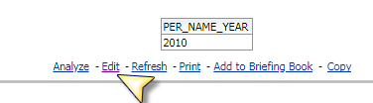
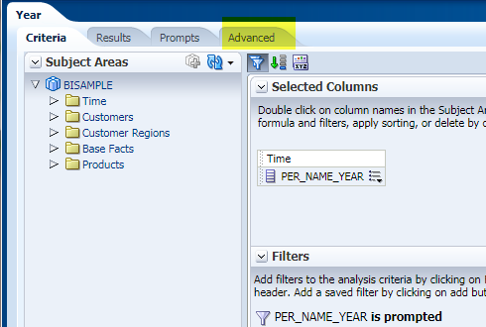

Click Apply XML.

