Processing an Employee Open Enrollment Event

Step 1: Enter your User Id and Password

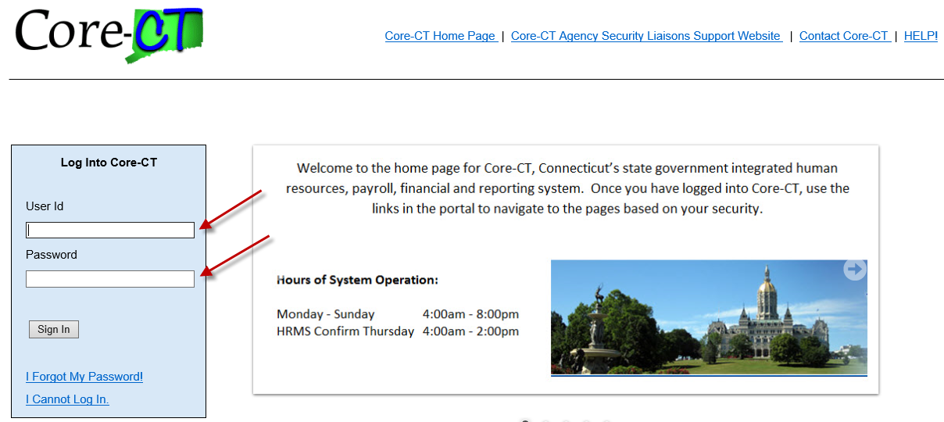
_______________________________________
Step 2: Use the following path to access the Benefits Enrollment page: Main Menu -> Self Service -> Benefits -> Benefits Enrollment
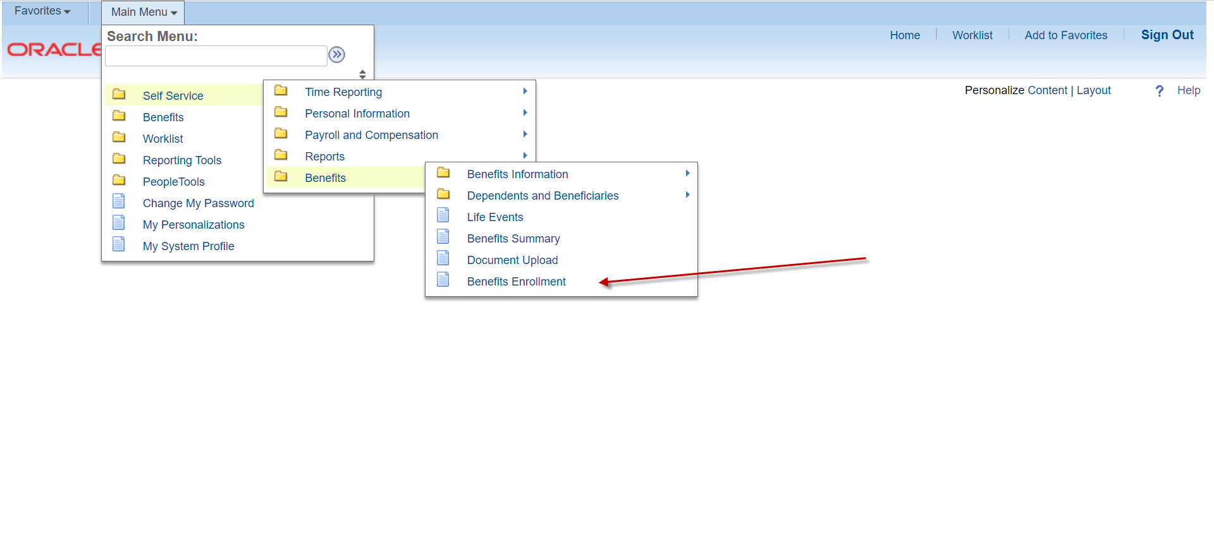
______________________________________
Step 3: Click on the highlighted Select button to initiate the Open Enrollment process.
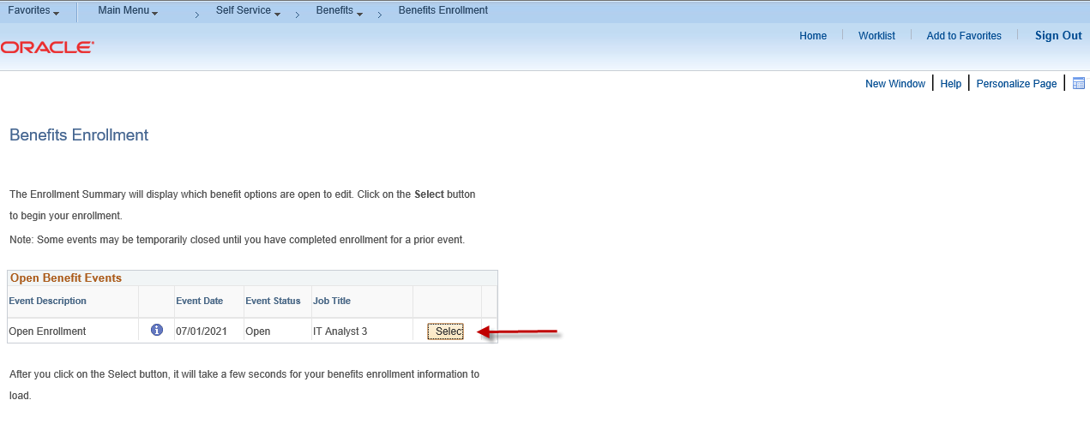
______________________________________
Step 4: Please read the important information on this page. Click on the highlighted Continue button to proceed.
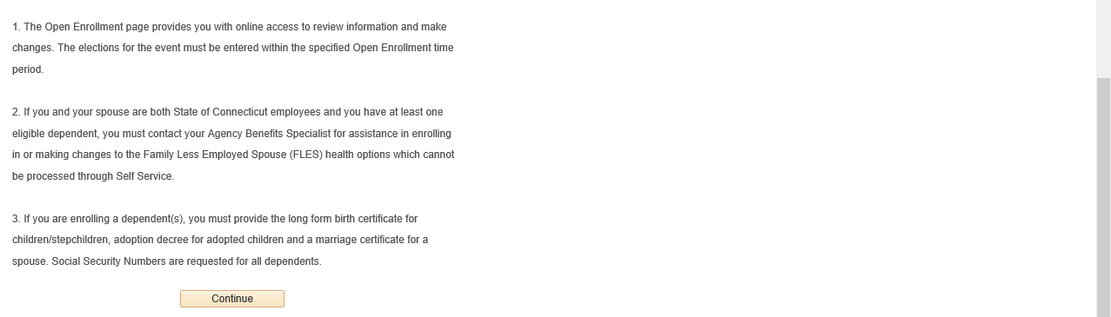
______________________________________
Step 5: Please read the Important information at the top of the page. Click on the highlighted Edit button to view the benefit plan options that are available for you to change during the annual Open Enrollment period (Medical & Dental). Note: At the bottom of the page you will find your Election Summary with estimated ‘Costs Per Pay Check’ and ‘Costs Annually’. This may change based on the elections chosen.
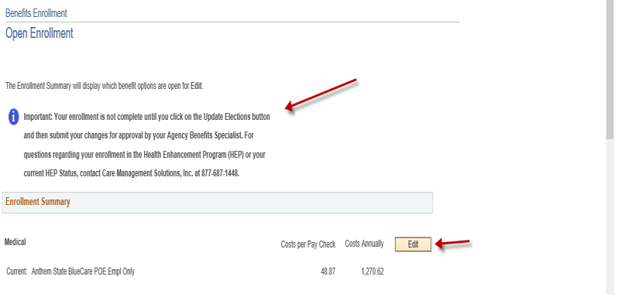
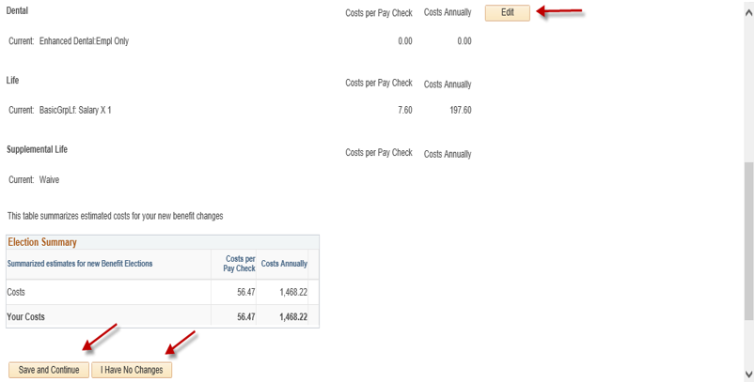

________________________________________
Step 6: After clicking on the highlighted Edit button (in this example Medical), please view the benefit plans available for you to elect or change. If you want to enroll eligible dependents in your health coverage, click on the highlighted Add/Review Dependents button at the bottom of the page or click on the highlighted Save and Continue button to proceed. Click on the highlighted Discard Changes button to restart the enrollment.
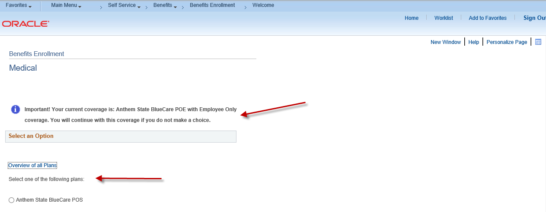
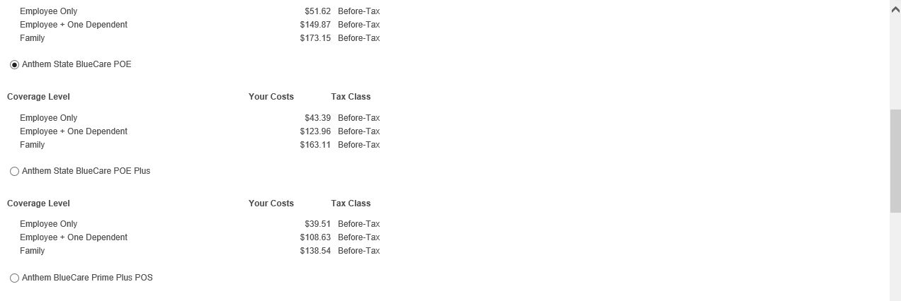
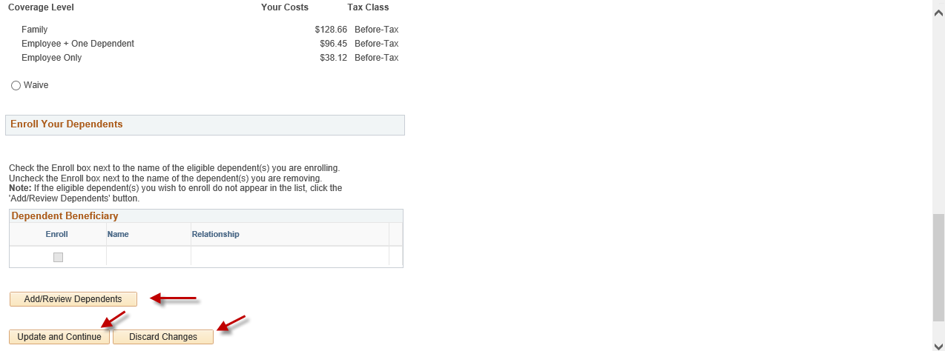
_____________________________________

Step 7: You can add a dependent by clicking on the highlighted Add a dependent or beneficiary button at the bottom of the page.
________________________________________
Step 8: Please complete all required fields (as designated by the arrows) for each new dependent that you are enrolling in health coverage. Click on the highlighted Save button and then click on the highlighted OK button. Note: If the address for the new dependent is different than the employee address, remove the checkmark in the Same Address as Employee field.

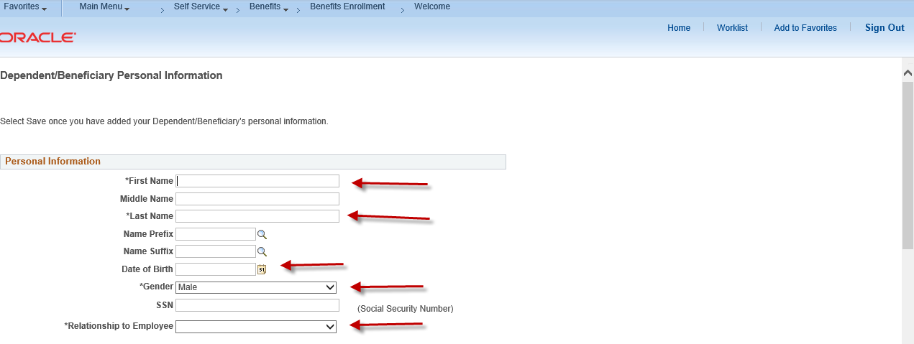
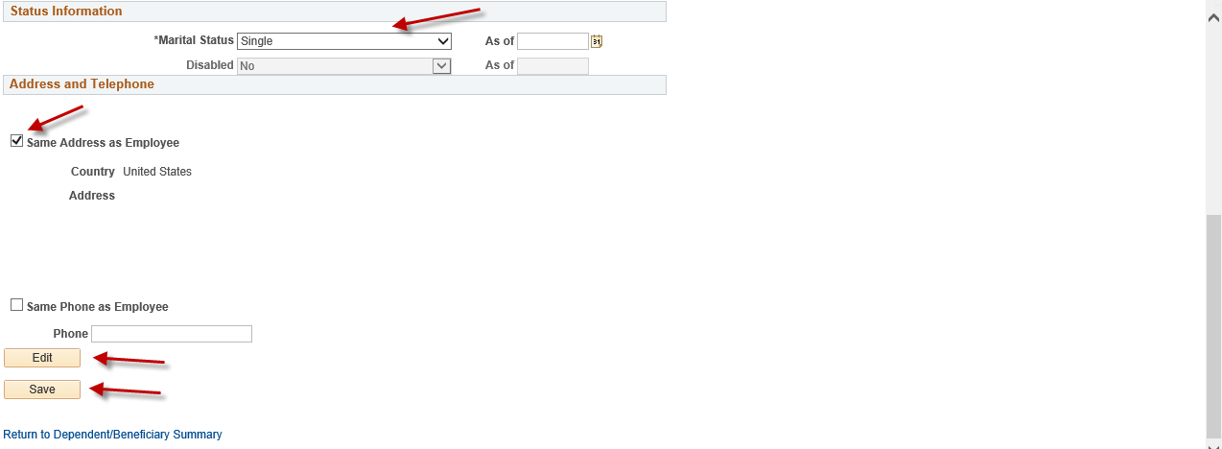

_______________________________________
Step 9: You can review your dependent information for accuracy or update if necessary. Click on the Return to Event Selection button to enroll your dependents in Medical coverage.
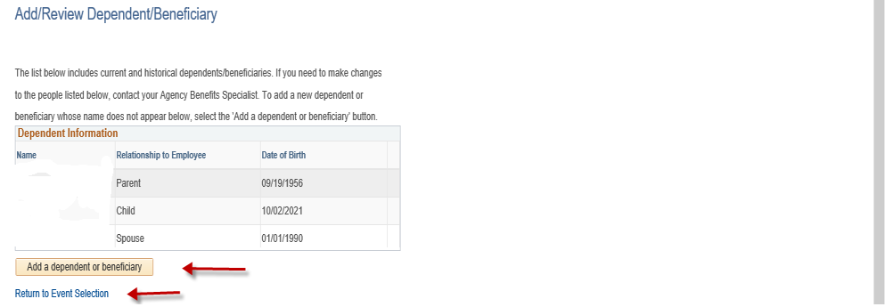
________________________________________
Step 10: After making changes to the benefit plans, please enroll or disenroll any dependents(s) by clicking or unclicking the box next to the dependent’s name. Click on the highlighted Update and Continue button to proceed or click on the highlighted Discard Changes button to restart your enrollment.

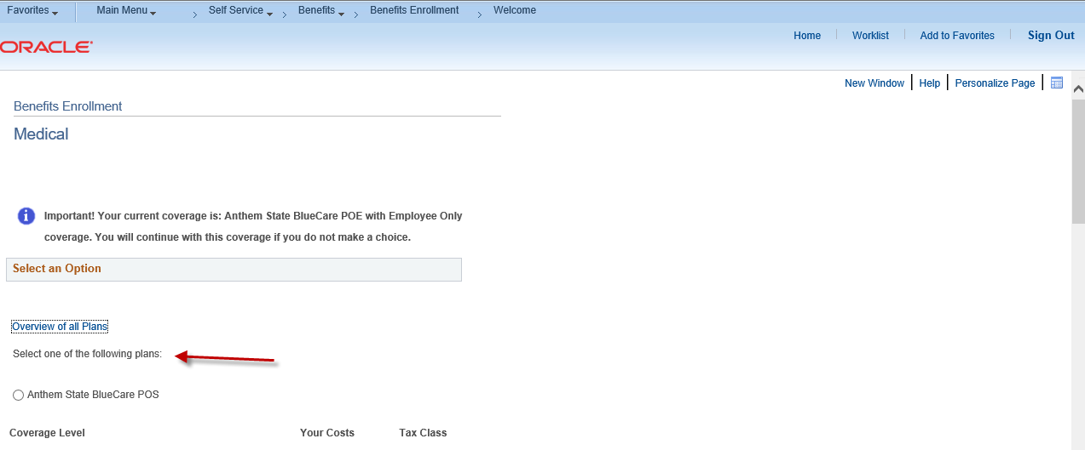
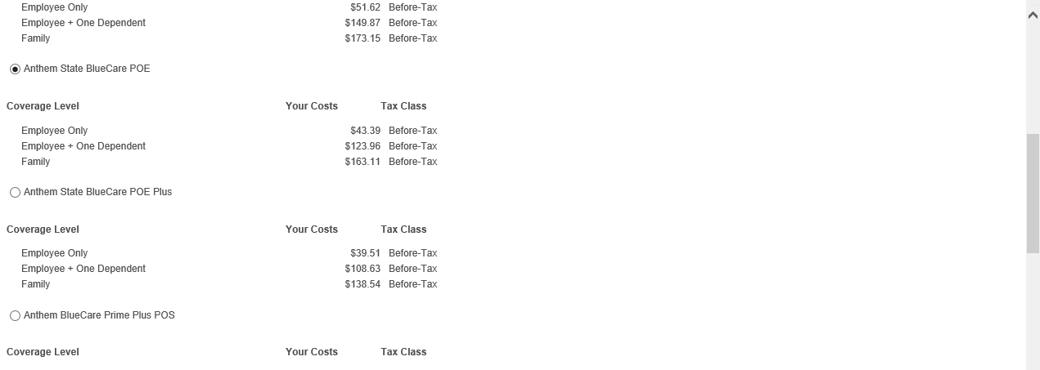
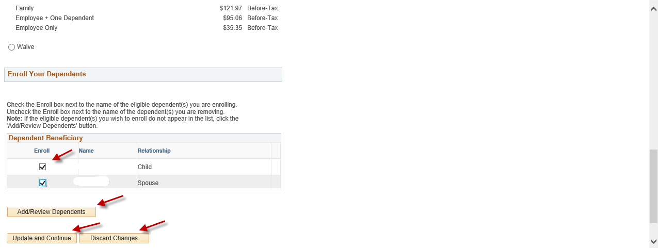
________________________________________
Step 11: You will be returned to the Benefits Enrollment page where you can review your enrollment and costs. Click on the highlighted Save and Continue button to proceed or click on the highlighted Discard Changes button to restart your enrollment.
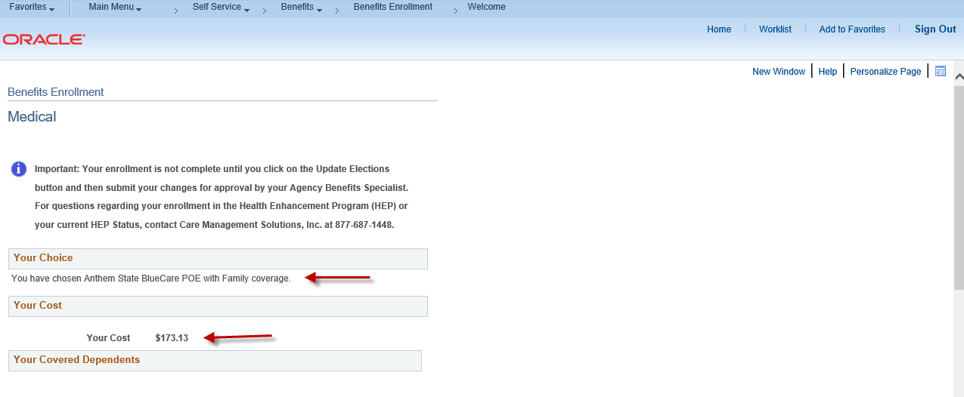
_______________________________________
Step 12: Enter required documentation in the highlighted Proof Document Upload page (e.g., long form birth certificate, marriage certificate) for each dependent you have enrolled in your health coverage. Start by clicking on the highlighted Add Attachment button. If you will not be uploading required proof documentation, click Add Note.
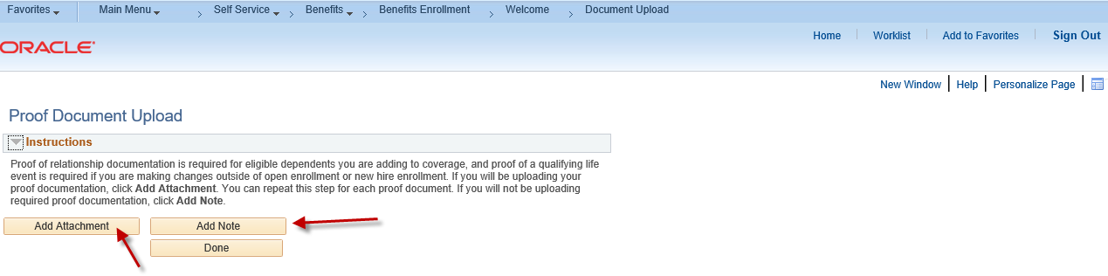
________________________________________
Step 13: Enter a document name on the Subject line (e.g., long form birth certificate, marriage certificate) and attach the required documentation by clicking on the Choose File or Browse button (as either may appear). Click on the highlighted Upload button.

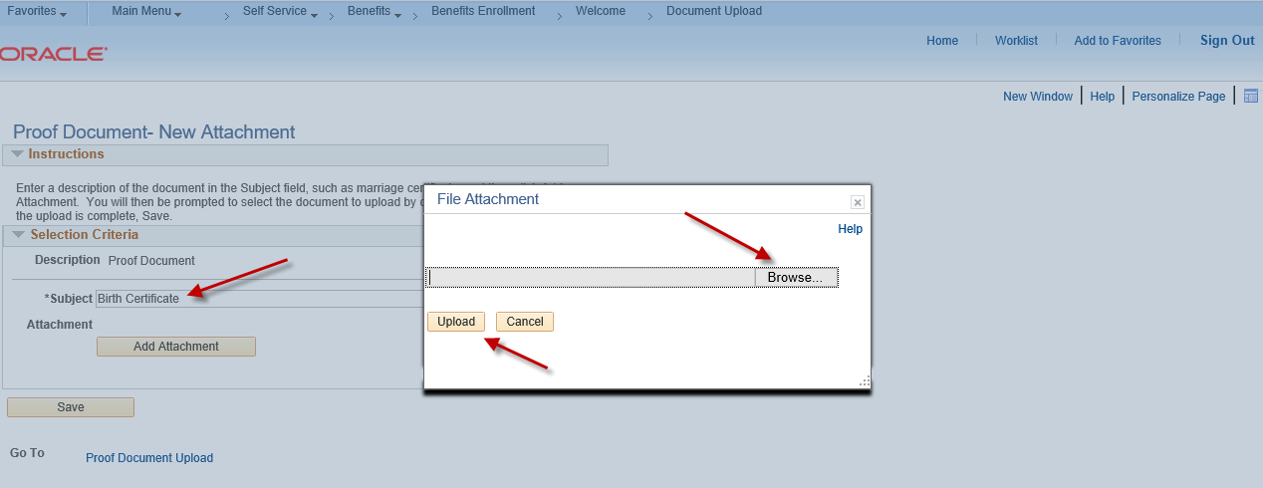
_______________________________________
Step 14: Click on the highlighted Save button once your document(s) has been uploaded. Repeat this step for each new dependent you are enrolling.
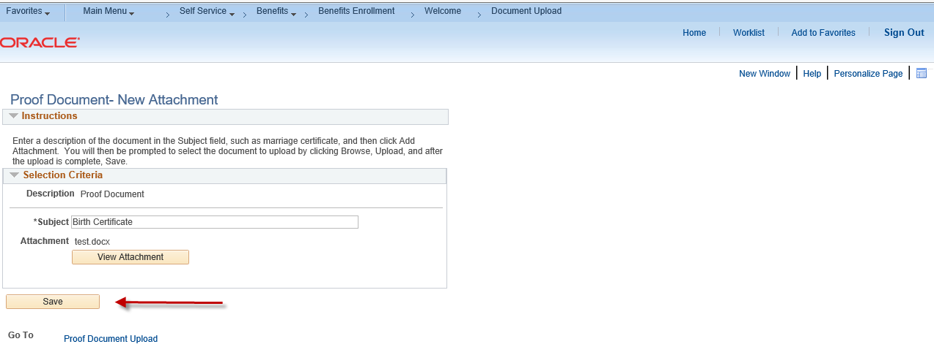
_________________________________________
Step 15: Click on the highlighted Done button to complete the Proof Document Upload process.
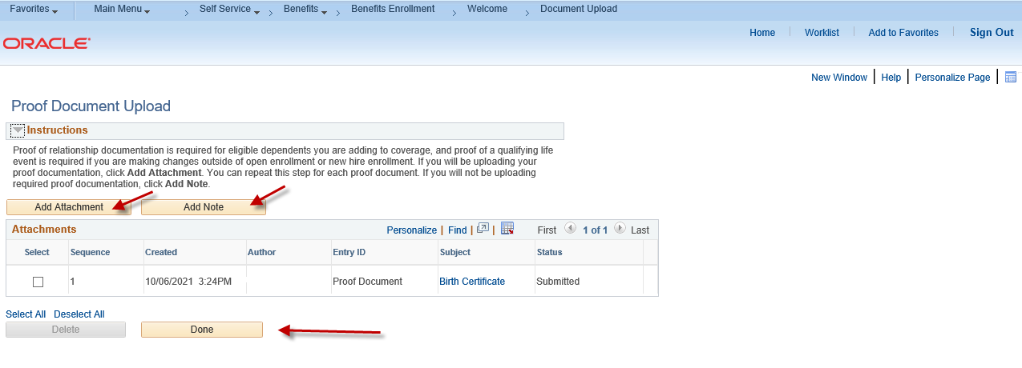
__________________________________________
Step 16: You now have the option of enrolling in other benefit plans by following the same process as the Medical example shown above.
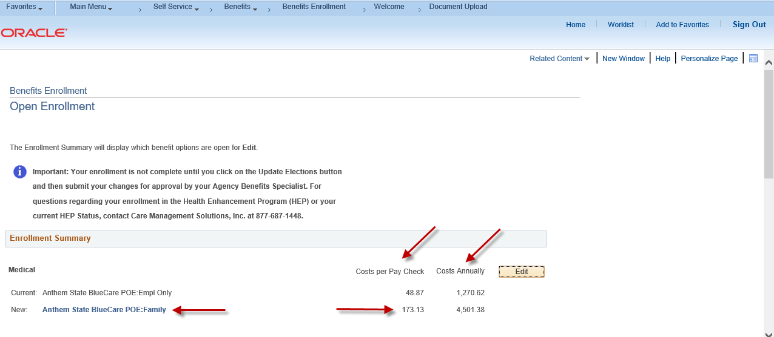
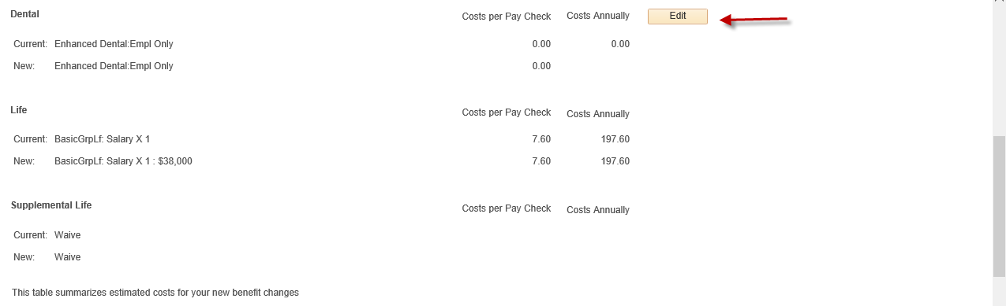
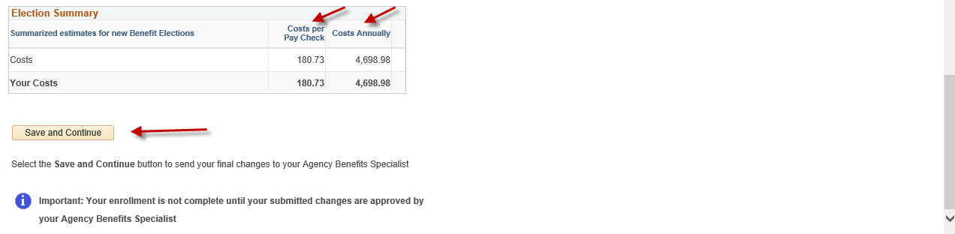

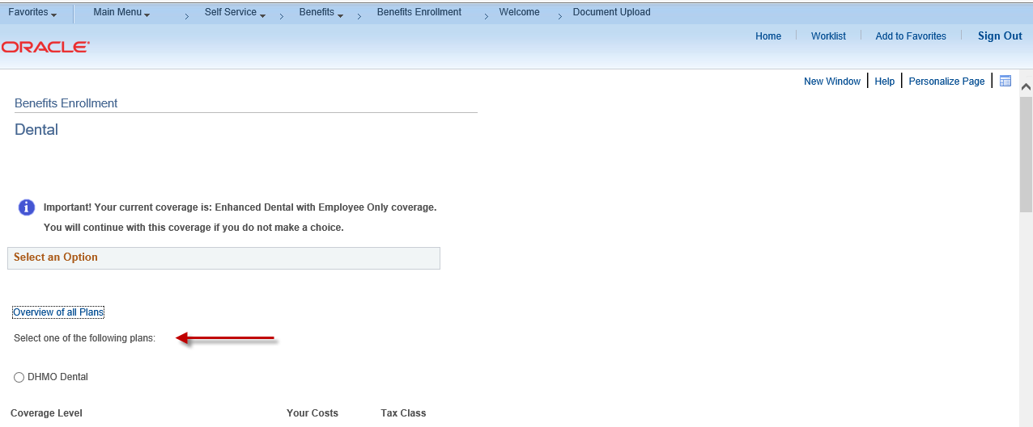
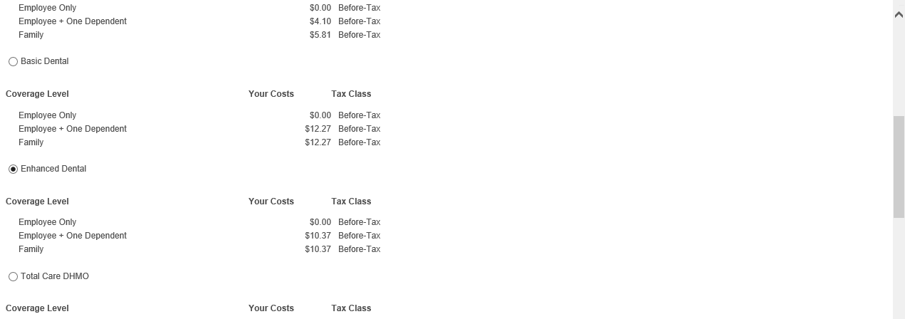
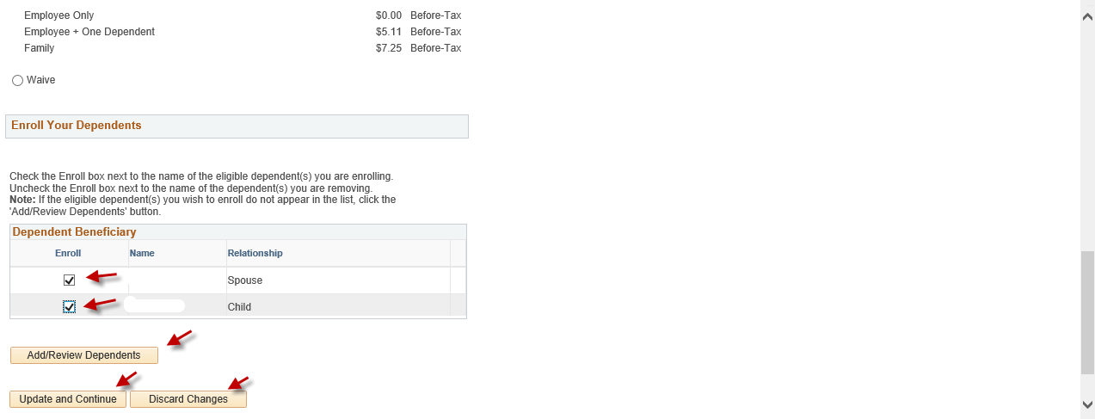
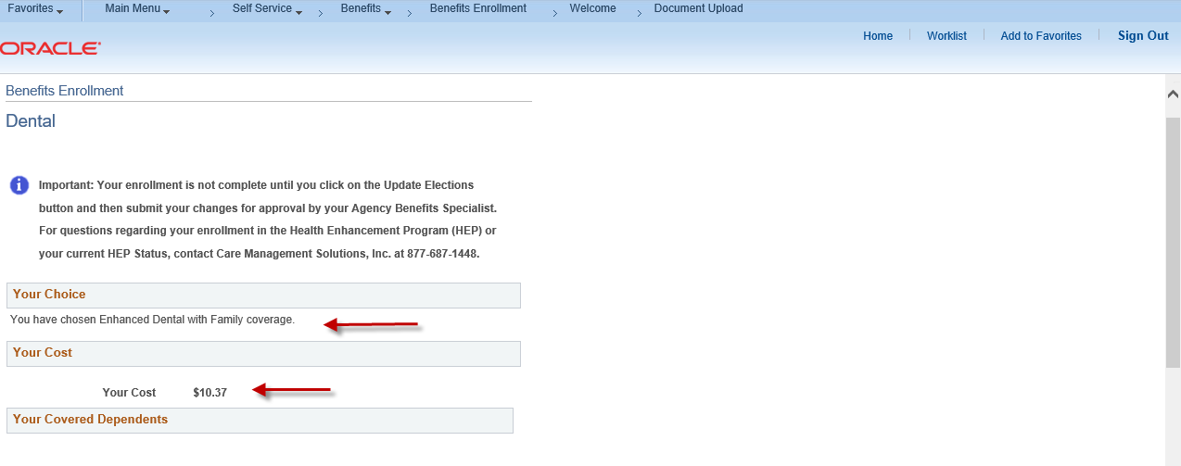
_______________________________________
Step 17: Click on the highlighted Done button to complete the Proof Document Upload process.

________________________________________
Step 18: Please review your benefit selections before submitting. Click on the highlighted Save and Continue button to proceed.
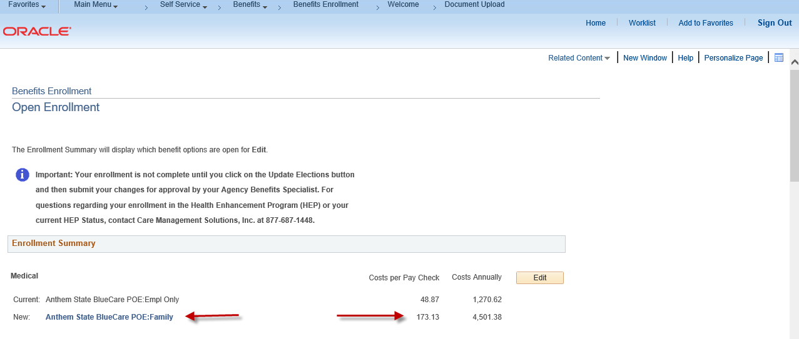
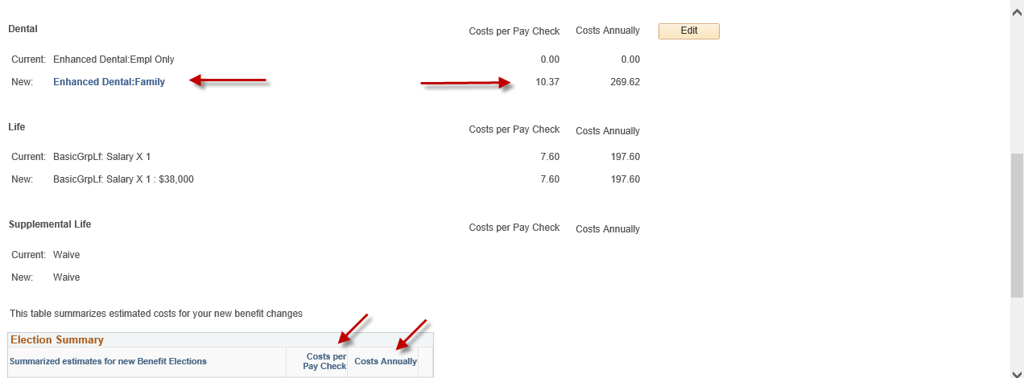
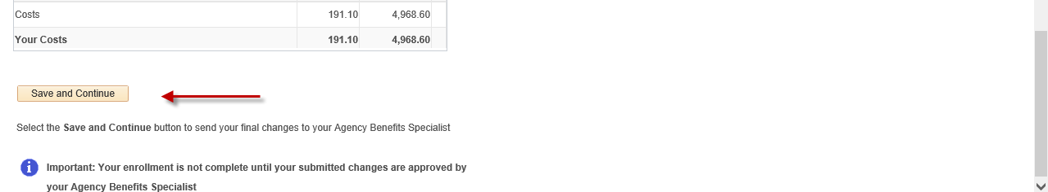
______________________________________
Step 19: Read the important Authorize Elections information in the Submit Benefit Choices page. Click on the highlighted Submit button to authorize and submit your elections or click on the highlighted Cancel button to return to the Benefits Enrollment page to make changes.
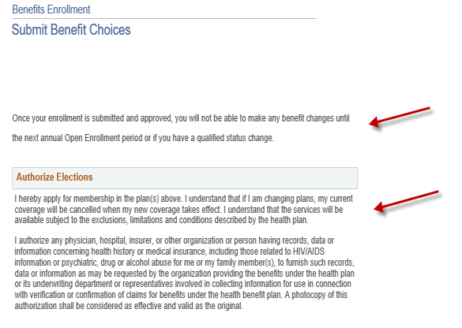
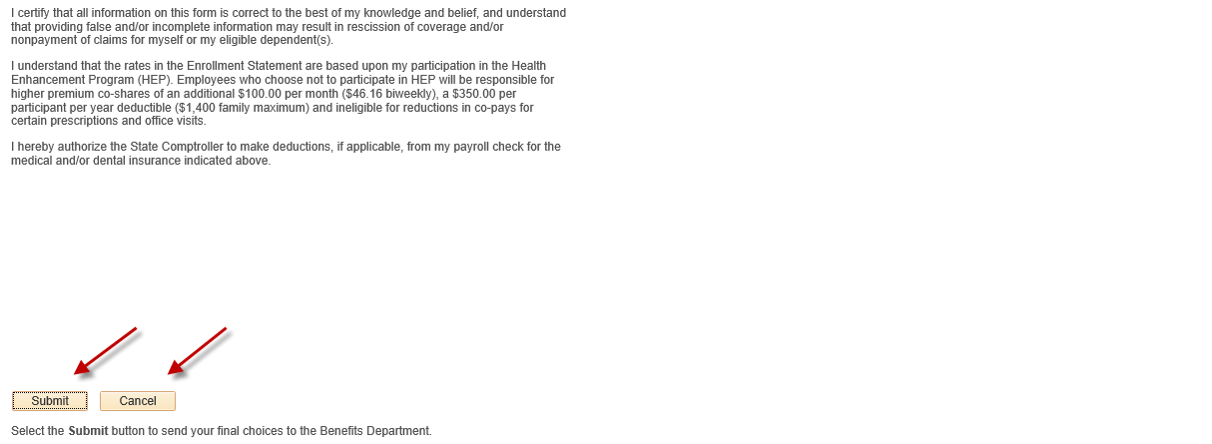
________________________________________
Step 20: Please review your benefit elections before submitting. Click on the highlighted OK button to submit your enrollment to your Agency Benefits Specialist for approval.
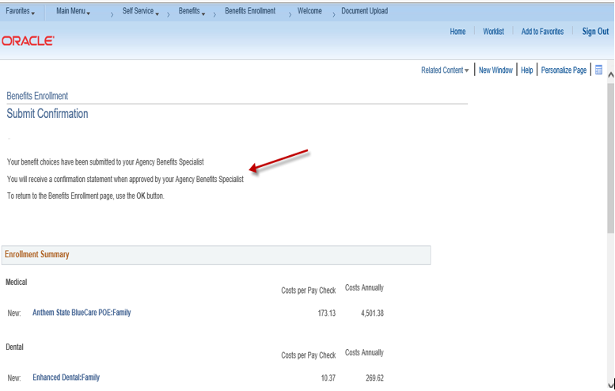
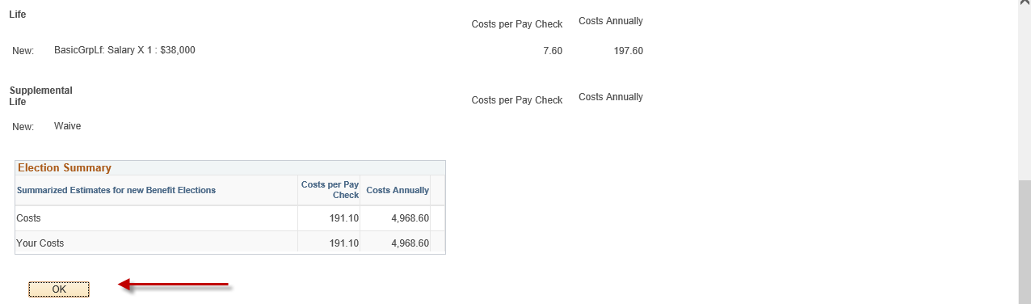

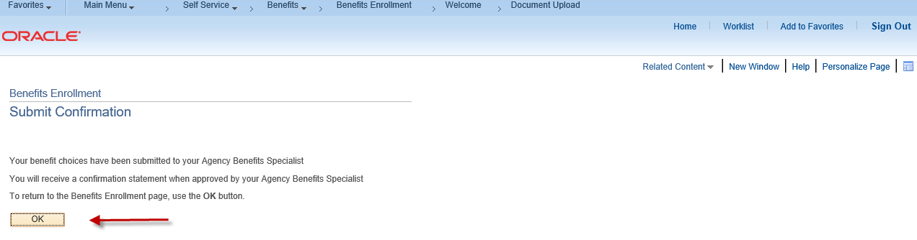

Contact your agency payroll/benefits staff if you have any questions or need assistance with your enrollment.

Revised 1/31/2022

