Processing a New Hire Event

Step 1: Enter your User Id and Password.
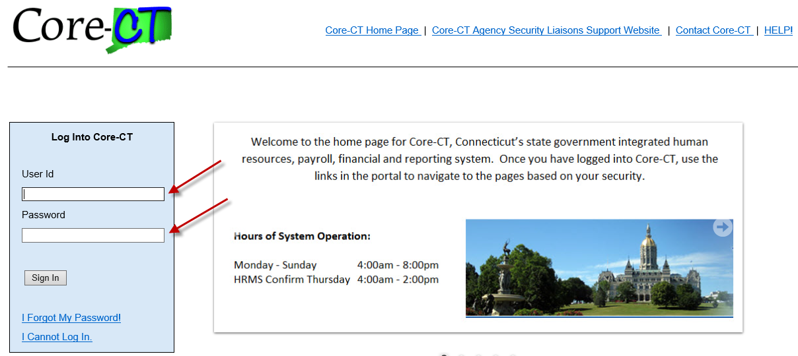
_____________________________________________
Step 2: Use the following path to access the Benefits Enrollment selection page: Main Menu -> Self Service -> Benefits -> Benefits Enrollment
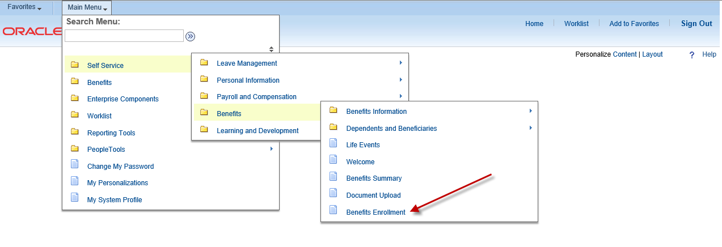
________________________________________

Step 3: Click on the highlighted Select button next to the Event Description to begin your enrollment.
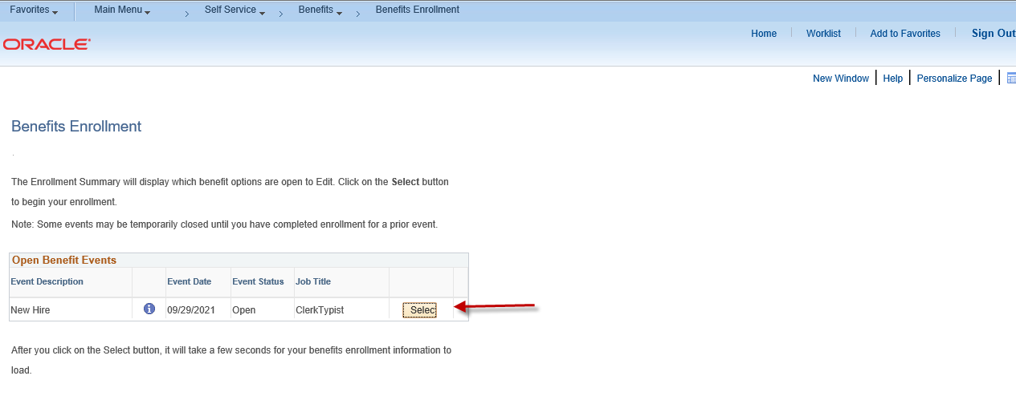
____________________________________

Step 4: Please read the important information on this page. Click on the highlighted Continue button to proceed.
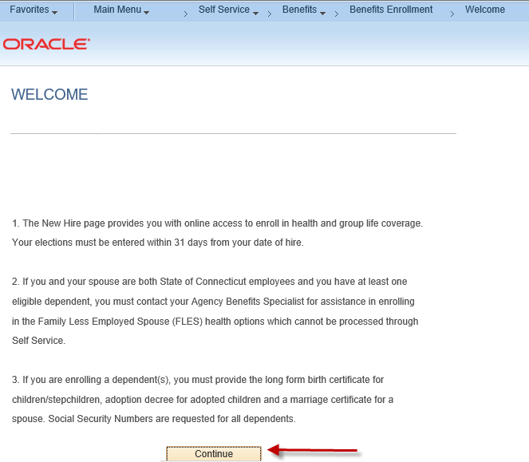

______________________________________

Step 5: The benefit options available to you will appear. Please read the important information at the top of the page. Click on the highlighted Edit button to view the benefit plan enrollment options (e.g., Medical, Dental, etc.). The Health Enhancement Program (HEP) Enrollment page will appear once you click on the highlighted Edit button for Medical. Note: The Benefits Summary at the bottom of the page will reflect your ‘Costs Per Pay Check’ and ‘Costs Annually’.

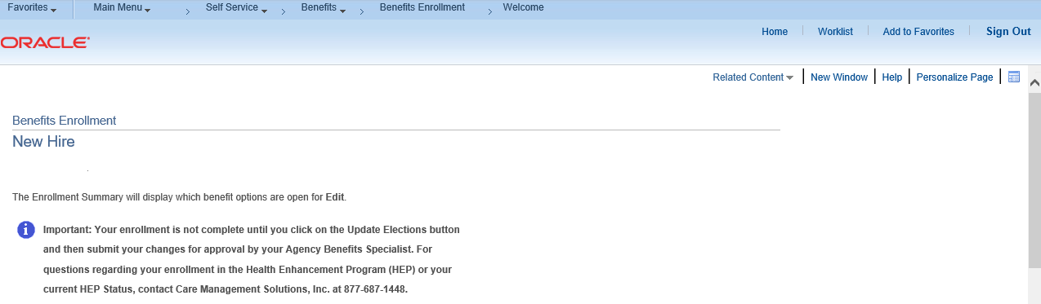

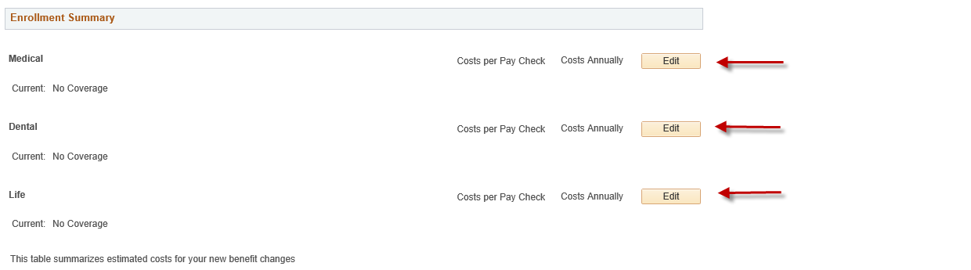
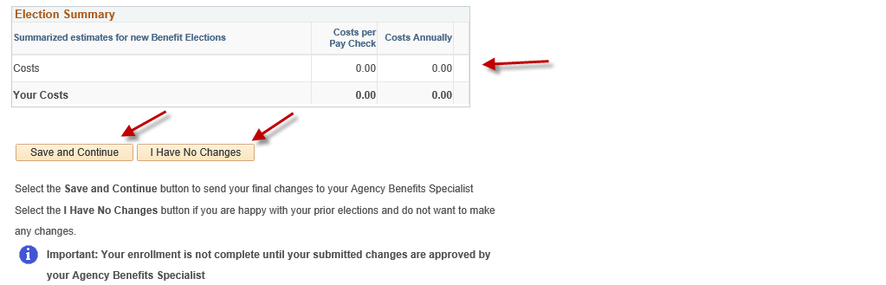

_______________________________________________

Step 6: Please read the important information in the HEP enrollment page. Select an option, then click on the highlighted Submit button at the bottom of the page.

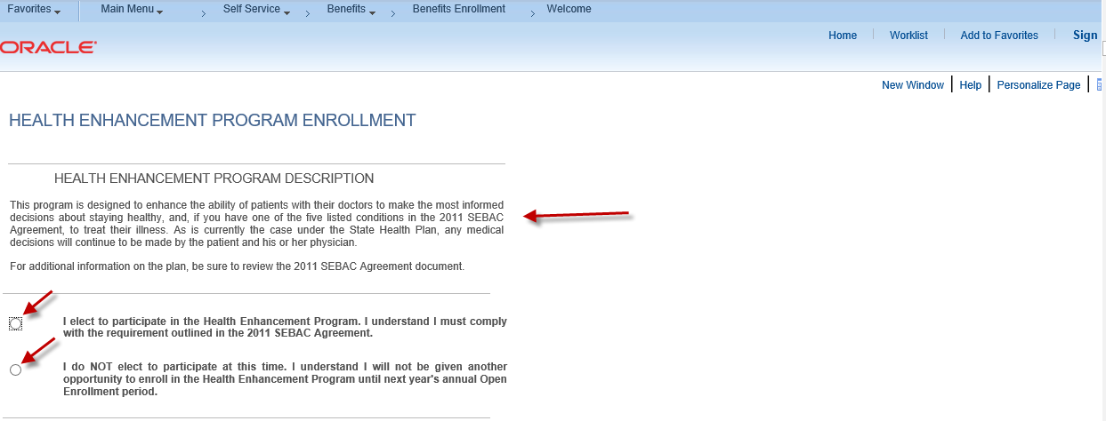

______________________________________

Step 7: The Medical options that are available to you will appear. Click on your Medical option and then click on the highlighted Update & Continue button to proceed with enrolling in other benefit plan options. Click on the highlighted Discard Changes button to restart the enrollment process.

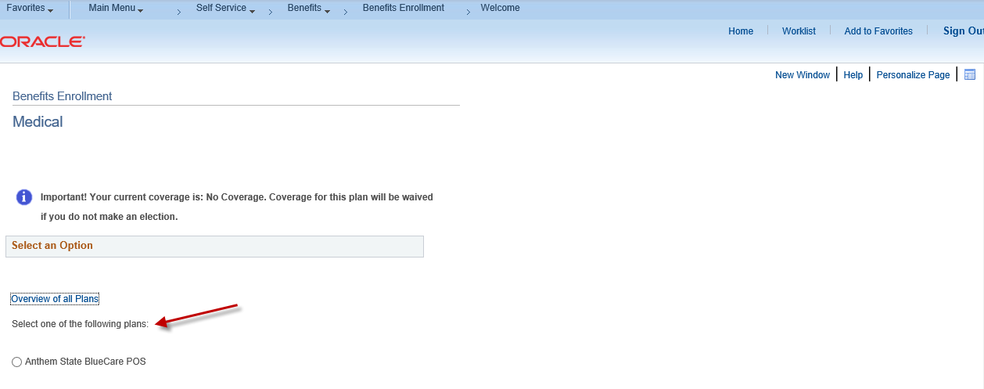
______________________________________
Step 8: If you are electing to enroll in health coverage, you will have the option of enrolling eligible dependents. If you are enrolling in life insurance coverage you must select at least one beneficiary. Click on the highlighted Add/Review Dependents button if you choose to add a dependent/beneficiary or click on the highlighted Update and Continue button if you are not enrolling anyone in your health and or life coverage. Click on the highlighted Discard Changes button to restart the enrollment process.

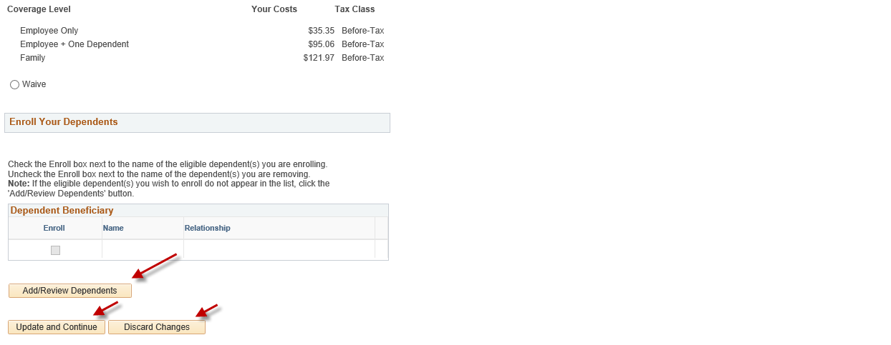
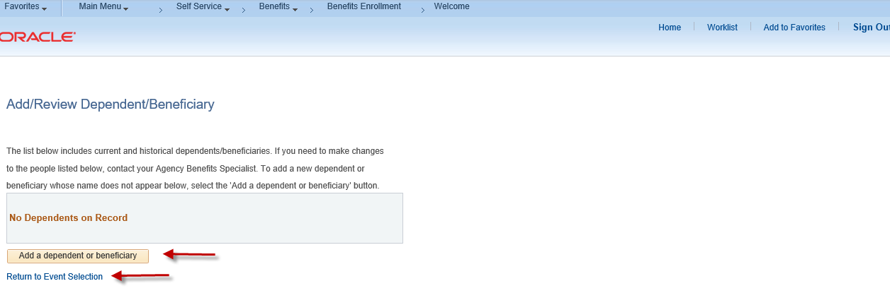
_____________________________________

Step 9: Please complete all required fields that are designated by the arrows for each dependent that you are enrolling in health coverage and each beneficiary in life insurance coverage. Click on the highlighted Edit button to update your dependent information or click on the highlighted Save button, then click on the highlighted OK button. Note: If the address for the new dependent is different than the employee address, remove the checkmark in the Same Address as Employee field.

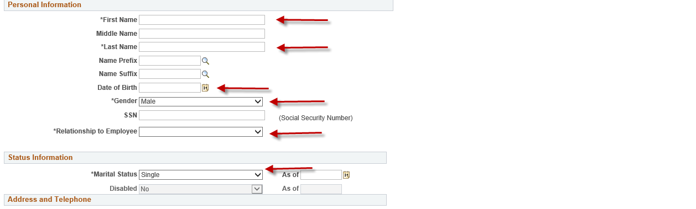

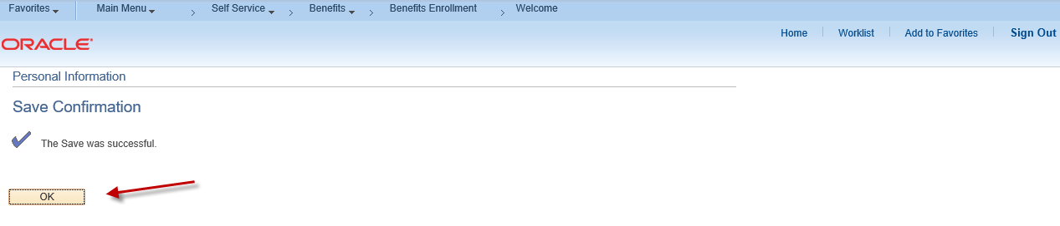
_______________________________________
Step 10: Click on the Return to Event Selection link to enroll your dependents in health coverage and beneficiaries in life insurance.
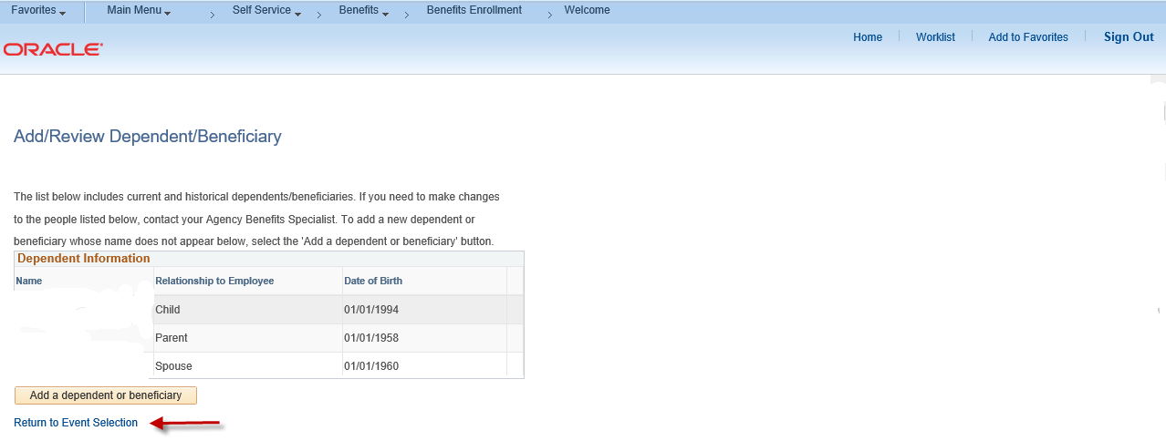
________________________________________

Step 11: Click on the Enroll box next to the Dependents/Beneficiaries you want to enroll in health coverage/life insurance. Click on the highlighted Update and Continue button to proceed or click on the highlighted Discard Changes button to restart the enrollment process.

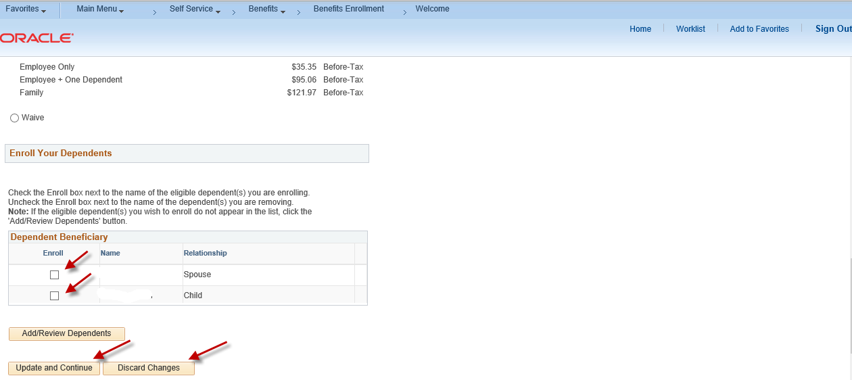

_______________________________________

Step 12: You can now review your medical costs and enrolled dependents. Click on the highlighted Update Elections button to proceed or click on the highlighted Discard Changes button to restart your enrollment.

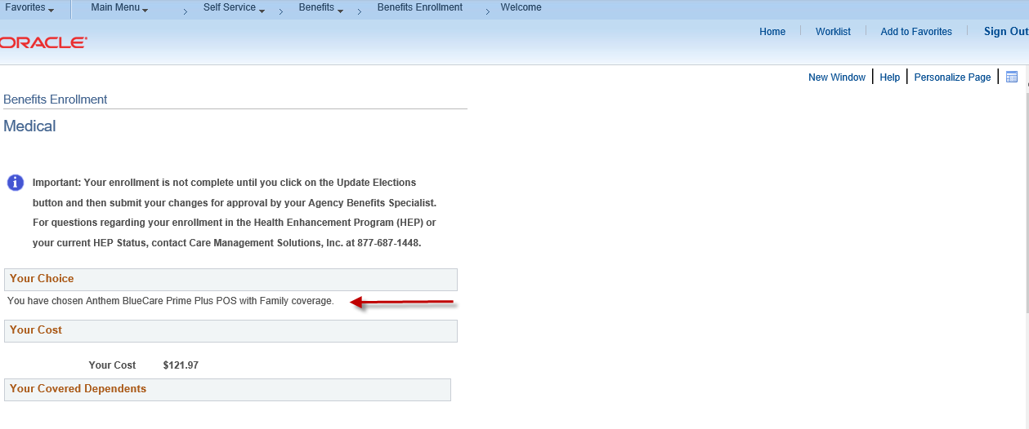

______________________________________

Step 13: Life Insurance Enrollment: Please read the important information prior to designating beneficiaries. Click on the highlighted Add/Review Beneficiaries button to add beneficiaries (if not previously entered). Click on the highlighted Update and Continue button to proceed or click on the highlighted Discard Changes button to start over.

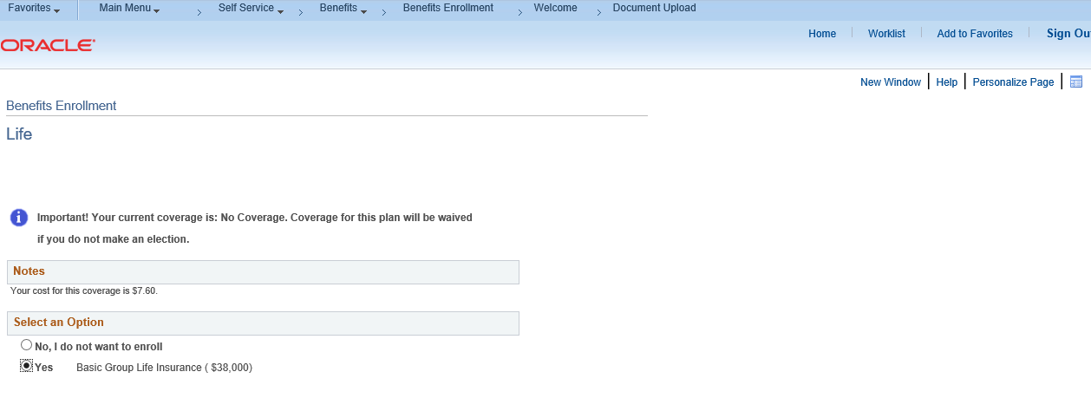

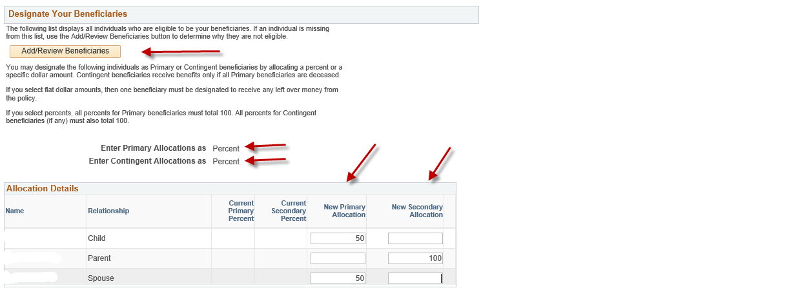

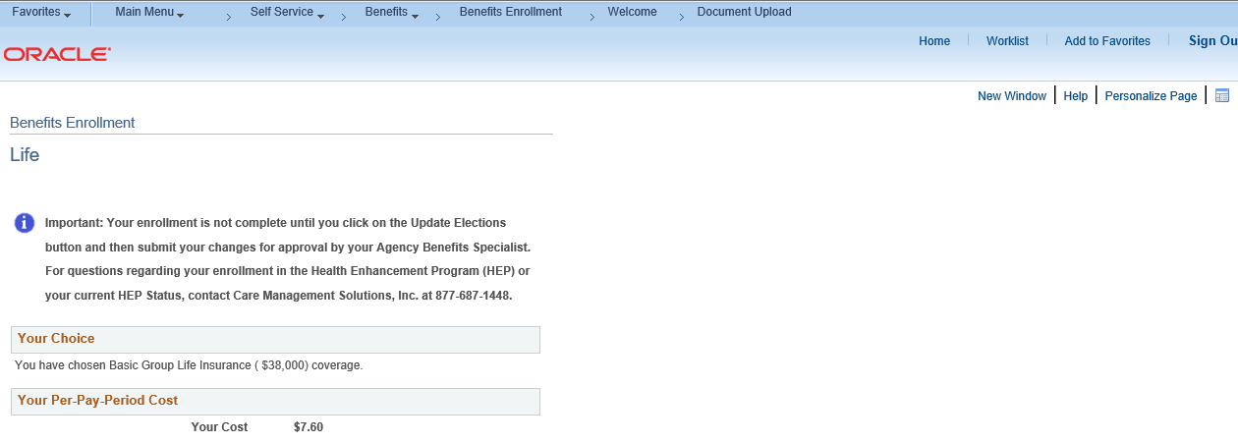
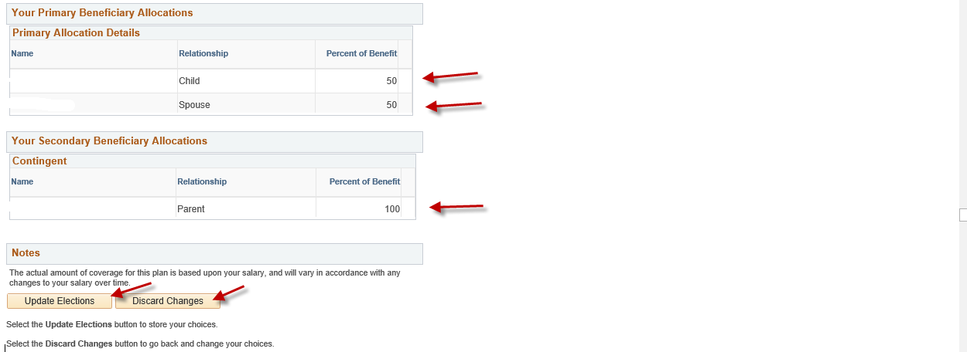

_______________________________________

Step 14: Enter required documentation in the highlighted Proof Document Upload page (e.g., long form birth certificate, marriage certificate) for each dependent you are enrolling in your health coverage. Start by clicking on the highlighted Add Attachment button. If you will not be uploading required proof documentation, click Add Note.

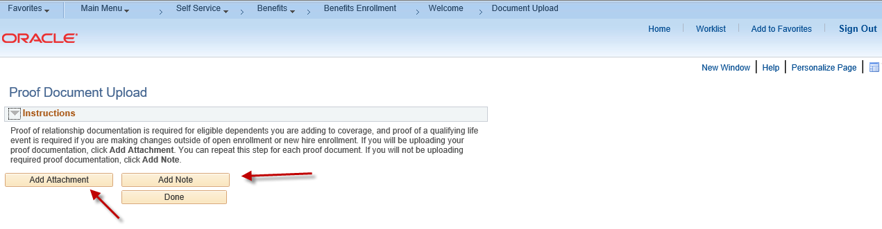
______________________________________
Step 15: Enter a document name on the Subject line (e.g., birth certificate, marriage certificate) and attach the required documentation by clicking on the Choose File or Browse button (as either may appear). Click on the highlighted Upload button.

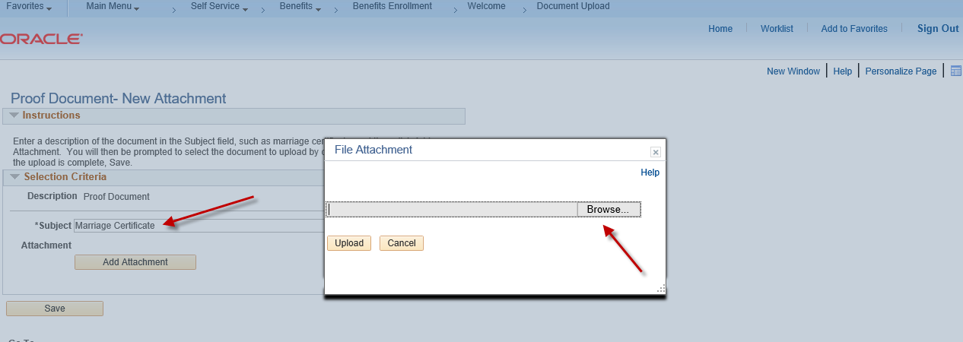

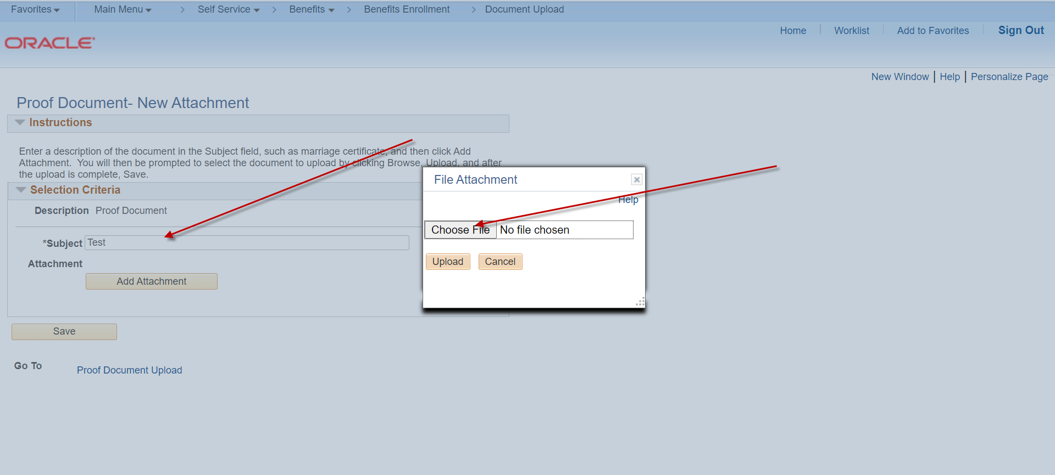
_____________________________________

Step 16: Click on the highlighted Save button once your document(s) has been uploaded. Repeat this process for each new dependent you are enrolling.
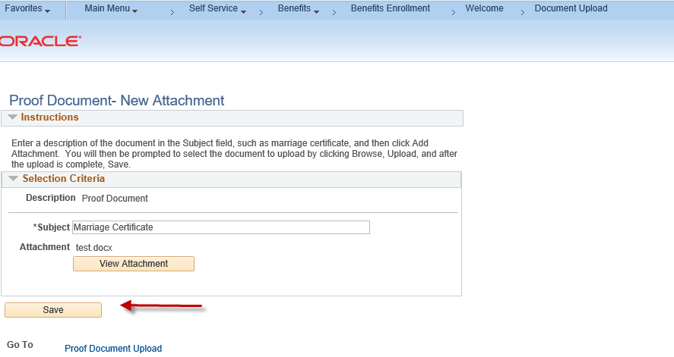

______________________________________

Step 17: Click on the highlighted Done button to complete the Proof Document Upload process.
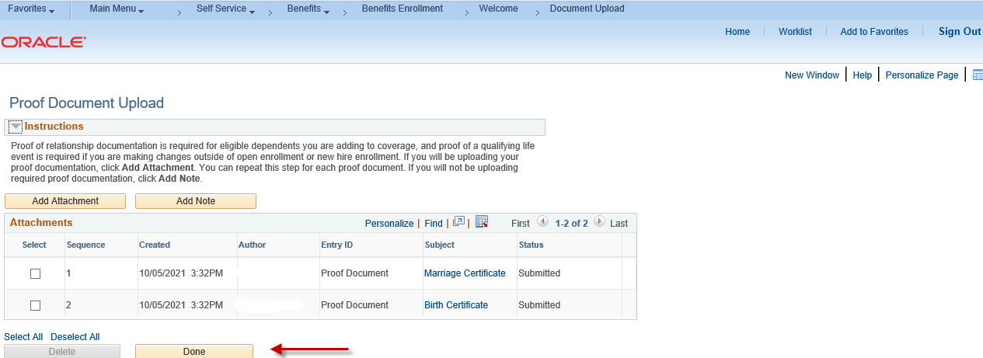

____________________________________

Step 18: You now have the option of enrolling in other benefit plans by following the same process as the Medical example shown above.
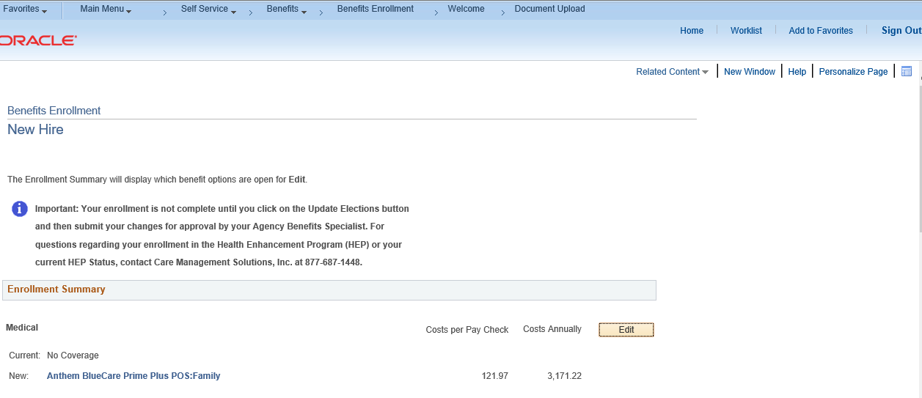

________________________________________
Step 19: Click on the highlighted Save & Continue button to proceed with your enrollment.
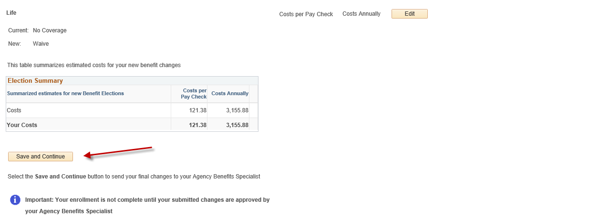

________________________________________

Step 20: Read the important information on the Authorize Elections page. Click on the highlighted Submit button to authorize and submit your elections. Click on the highlighted Cancel button to return to the prior Benefits Enrollment page to edit your enrollment.

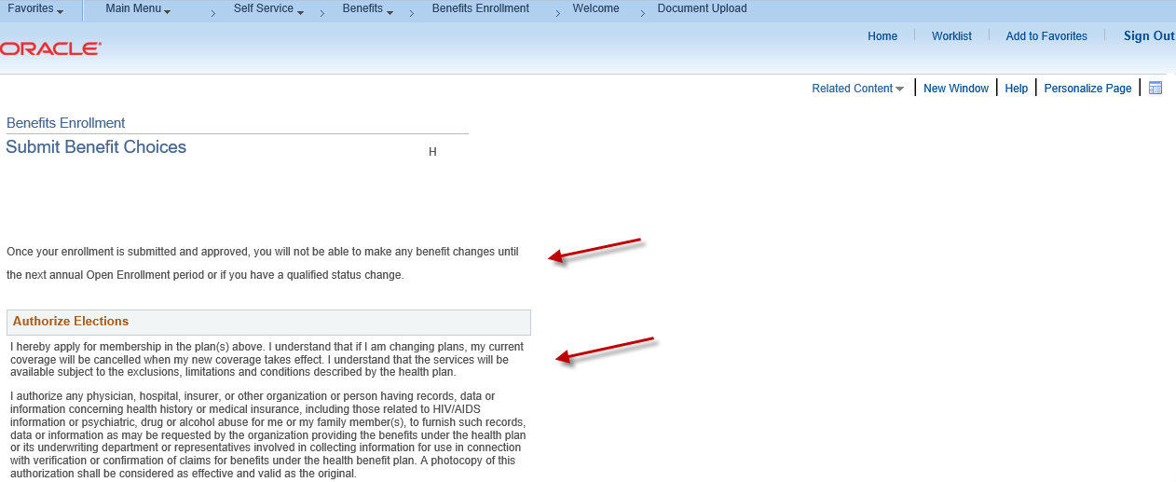
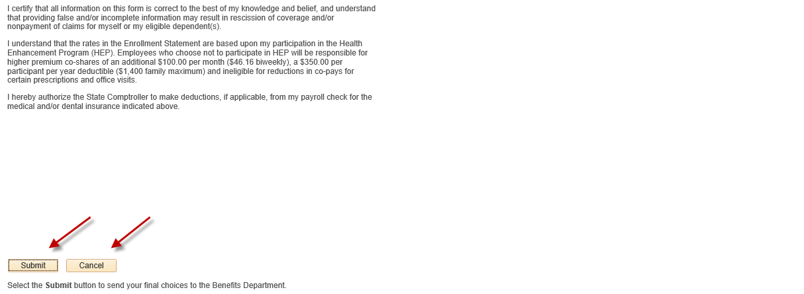

_____________________________________

Step 21: The Submit Confirmation page will appear confirming your submission to your Agency Benefits Specialist for approval. Click on the highlighted OK button to complete your submission.
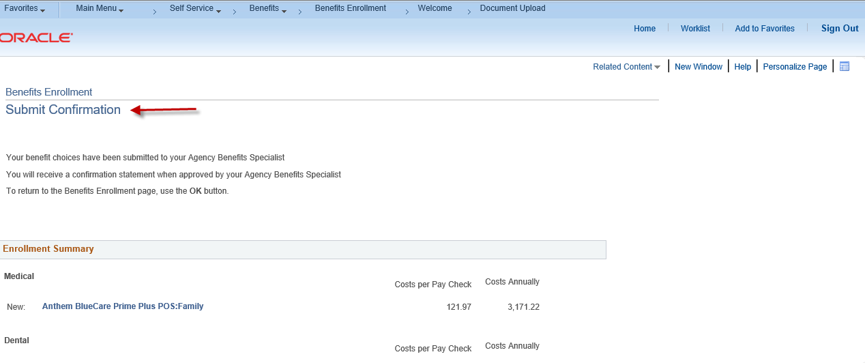

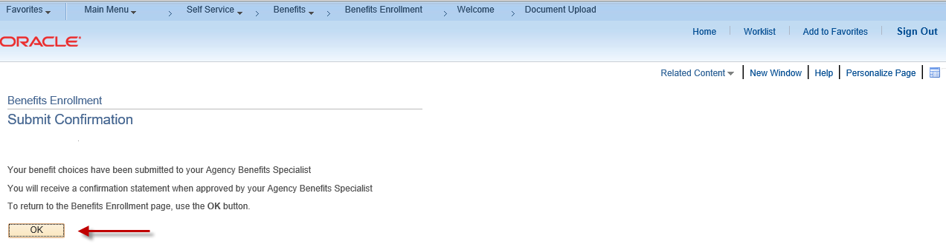

Contact your agency payroll/benefits staff if you have any questions or need assistance with your enrollment.

Revised 1/31/2022

