Processing an Employee Life Event

Step 1: Enter your User Id and Password
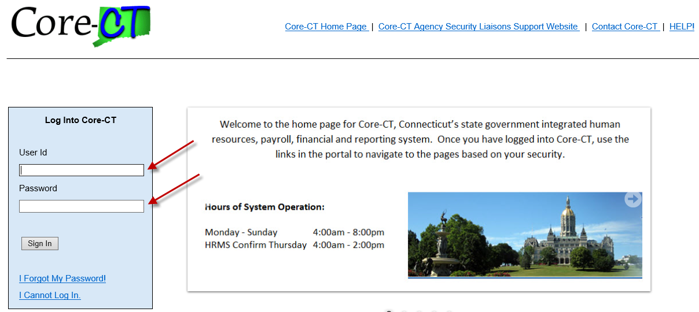

___________________________________
Step 2: Use the following path to access the Life Events selection page: Main Menu -> Self Service -> Benefits -> Life Events
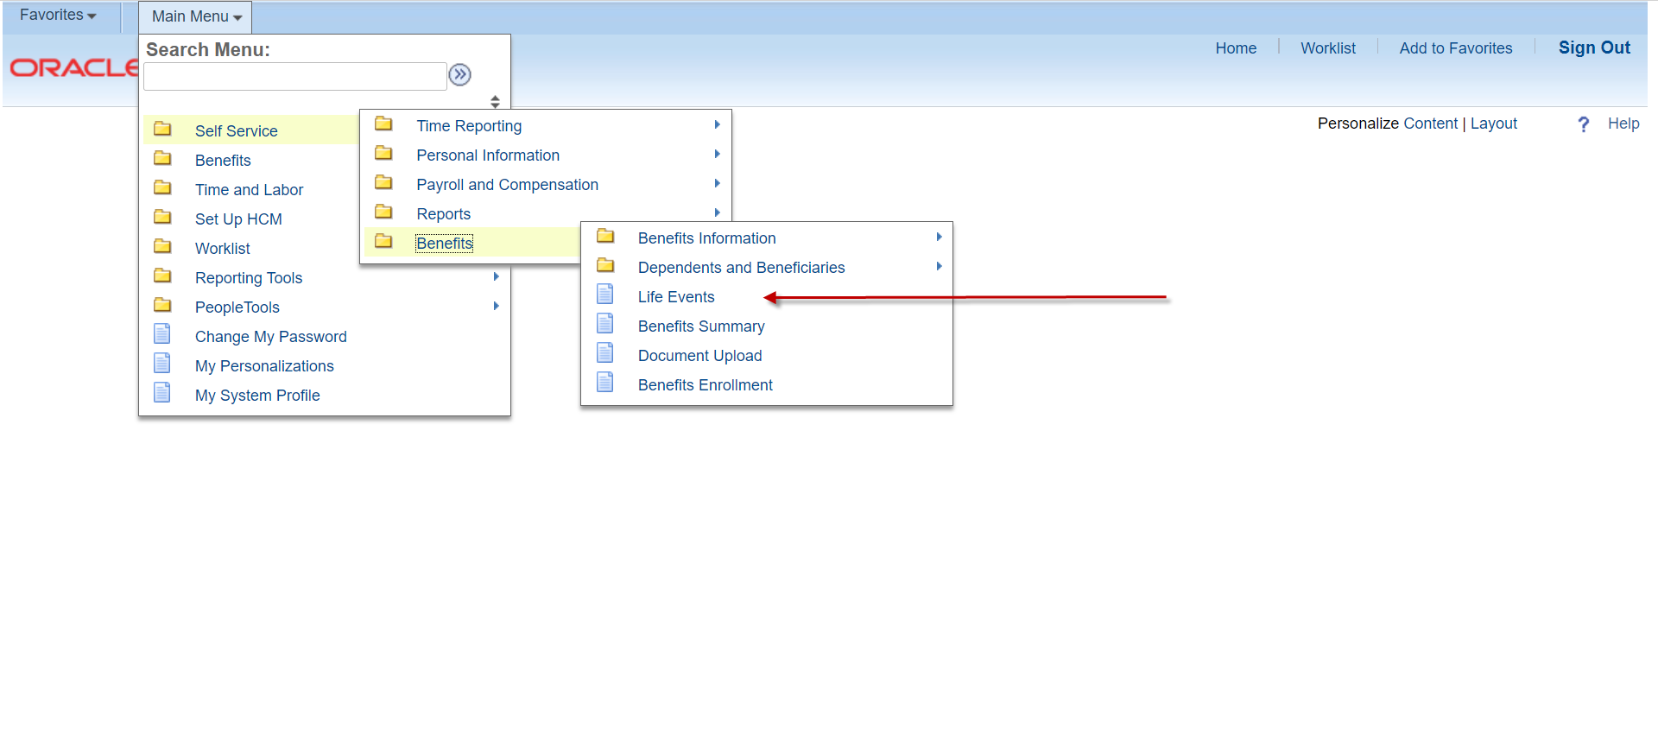
_______________________________________
Step 3: Please read the important information on this page before proceeding. Select the applicable Life Event from the list below.
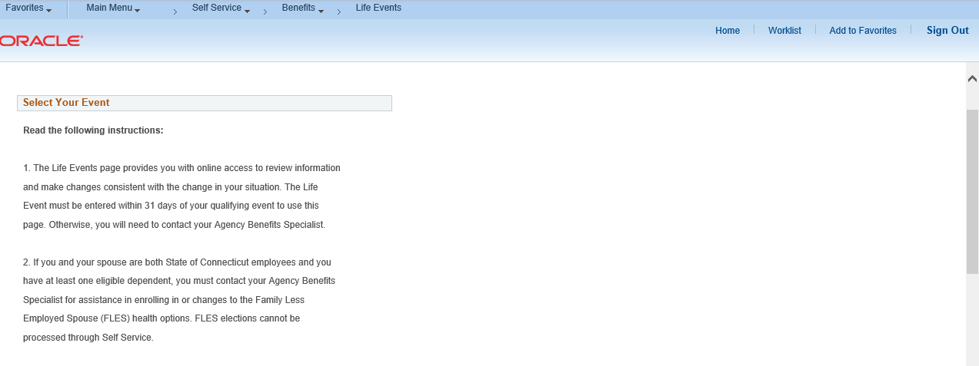
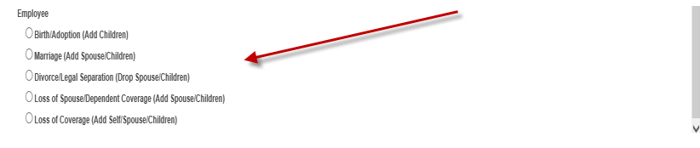
________________________________________
Step 4: Enter the Life Event date (e.g., Birth, Marriage, Loss of coverage) and click on the highlighted OK button to continue or click on the highlighted Cancel button to restart the enrollment process.

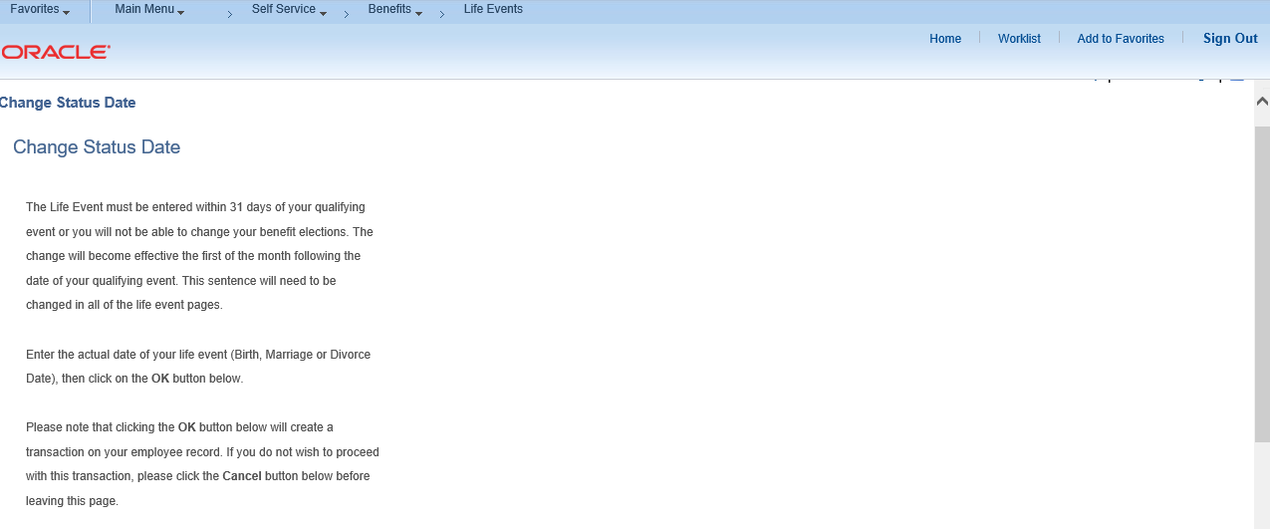

_______________________________________
Step 5: Click on the highlighted Next button on the Welcome page to proceed.
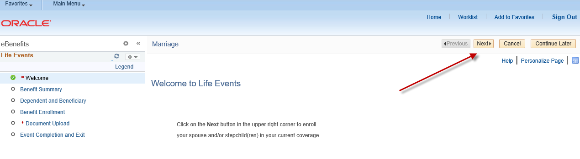
______________________________________
Step 6: If you choose to view benefit elections from a prior period, enter the date and click on the highlighted Go button. Click on the highlighted Next button to continue.
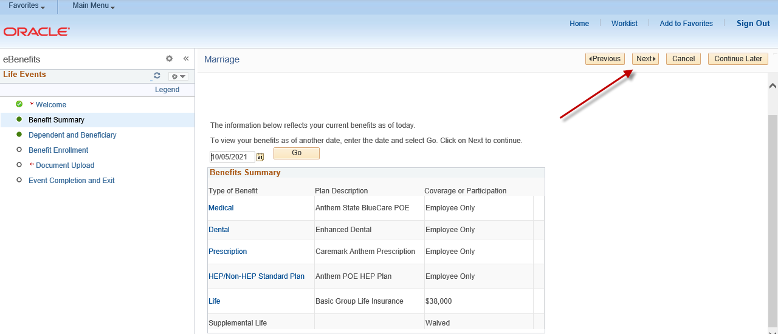
______________________________________
Step 7: You will have the option to add eligible dependents based on the Life Event by clicking on the highlighted Add a dependent or beneficiary button. Click on the highlighted Next button to continue if you are not adding a new dependent.
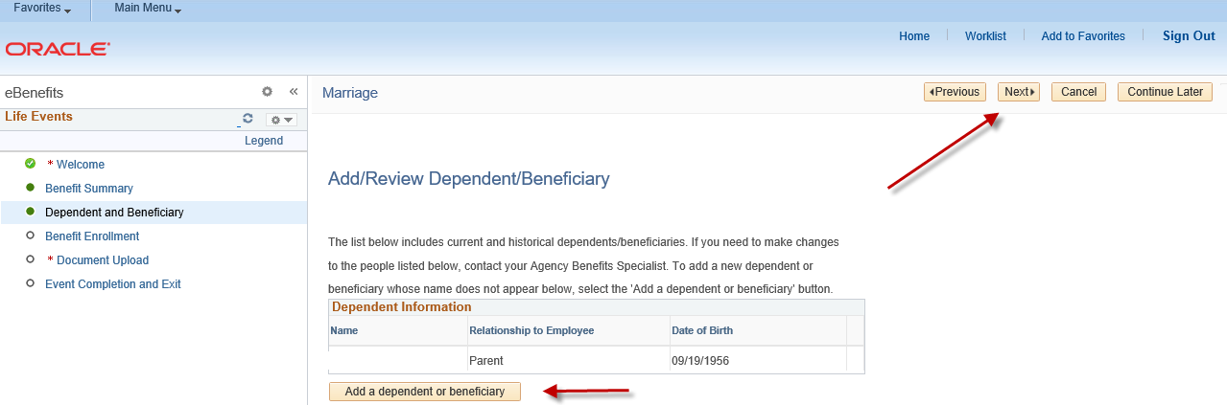

_______________________________________
Step 8: Please complete all required fields that are designated by the arrows for each dependent you are enrolling in health coverage and click on the highlighted Save button. Click on the highlighted Edit button to update your dependent(s) information or click on the highlighted OK button to continue. Note: If the address for the new dependent is different than the employee address, remove the checkmark in the Same Address as Employee field.

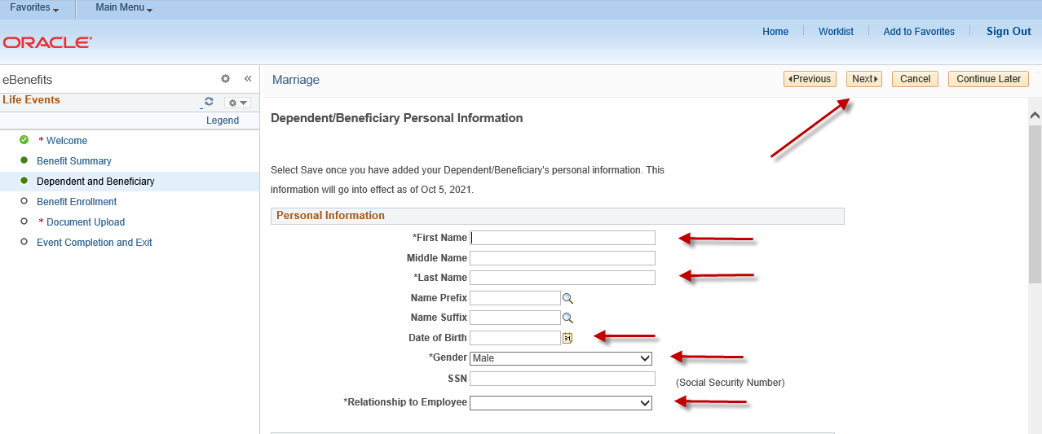
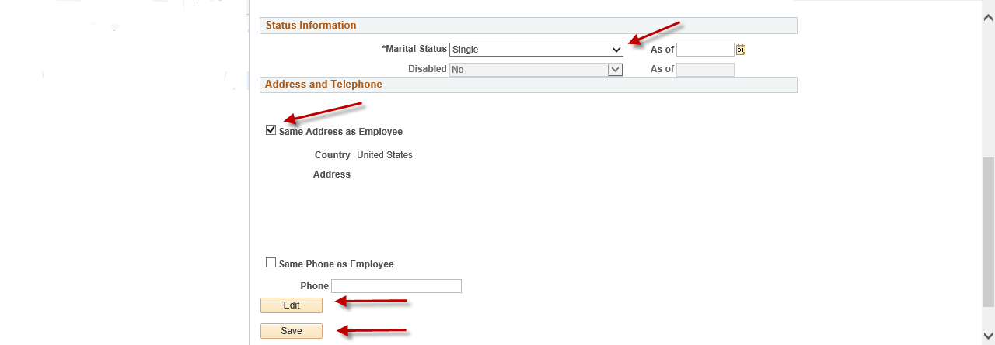

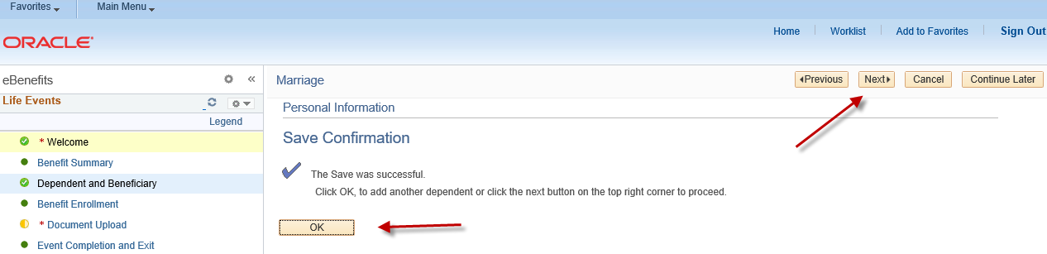

_______________________________________
Step 9: Click on the highlighted Next button to continue.
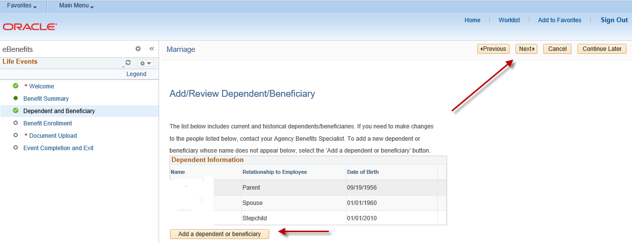

_______________________________________
Step 10: Click on the highlighted Start my Enrollment button to begin your enrollment.
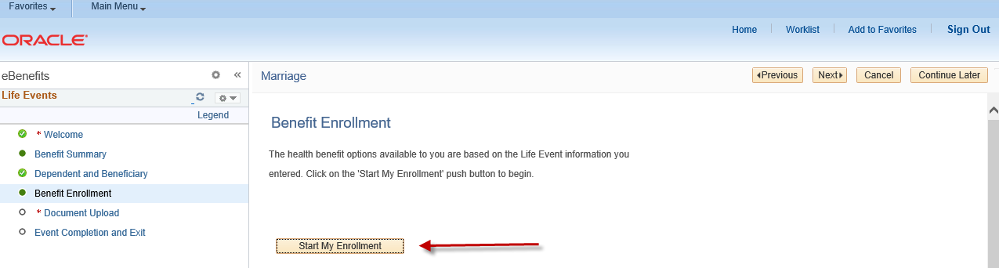
_______________________________________

Step 11: Click on the highlighted Select button next to the Event Description to continue.
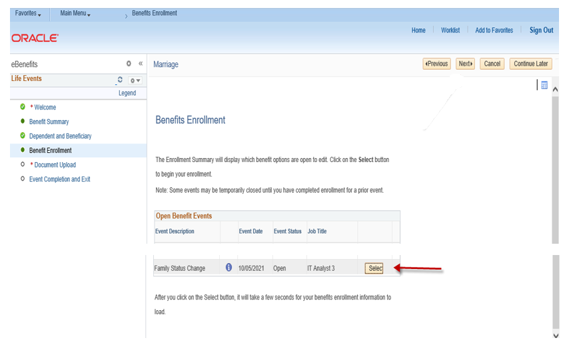

_____________________________________
Step 12: The benefit options available to you will appear. Please read the important information at the top of the page. Click on the highlighted Edit button to add or remove dependents based on your Life Event. If you have a loss of coverage, click on the highlighted Edit button to enroll in coverage and add dependents, if applicable. The Current Costs per Pay Period and Costs Annually are displayed. If any cost changes occur, based on your election chosen, they will be reflected in the ‘New’ line.
Note: The Benefits Summary at the bottom of the page will reflect your ‘Costs Per Pay Check’ and ‘Costs Annually’.

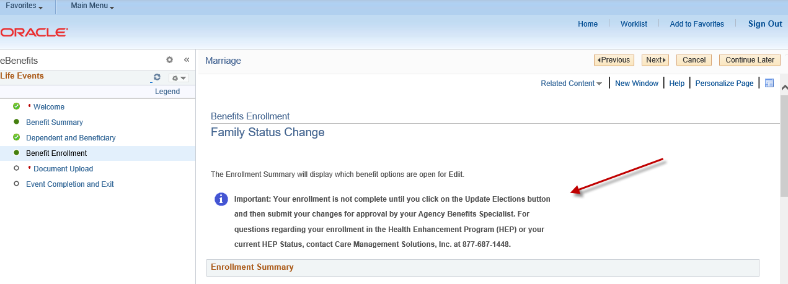
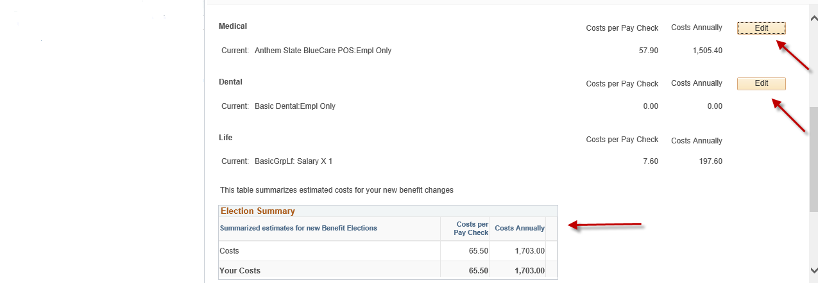
_______________________________________
Step 13: After clicking on the highlighted Edit button, enroll or disenroll any dependents(s) by clicking or unclicking the box next to the dependent’s name. If you have a loss of coverage, click on the Edit button to begin your enrollment. Click on the highlighted Update and Continue button to proceed or click on the highlighted Discard Changes button to restart your enrollment.
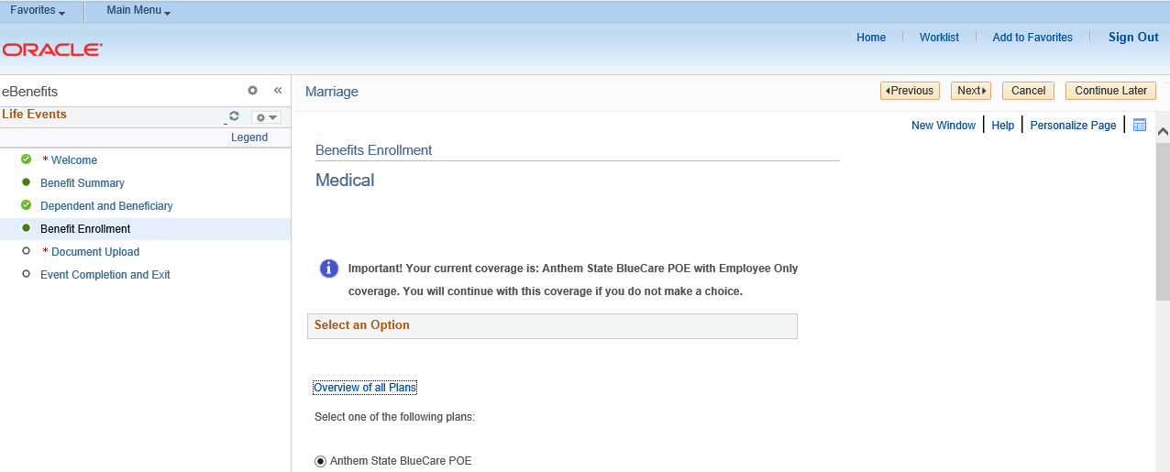
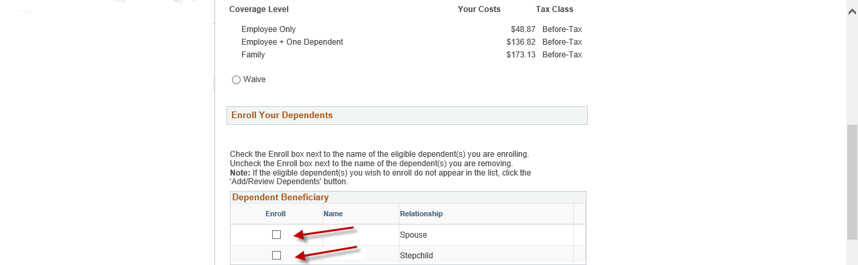

_________________________________________
Step 14: Review your changes or new enrollment based on your Life Event. Click on the highlighted Update Elections button to continue or click on the highlighted Discard Changes button to restart your enrollment.
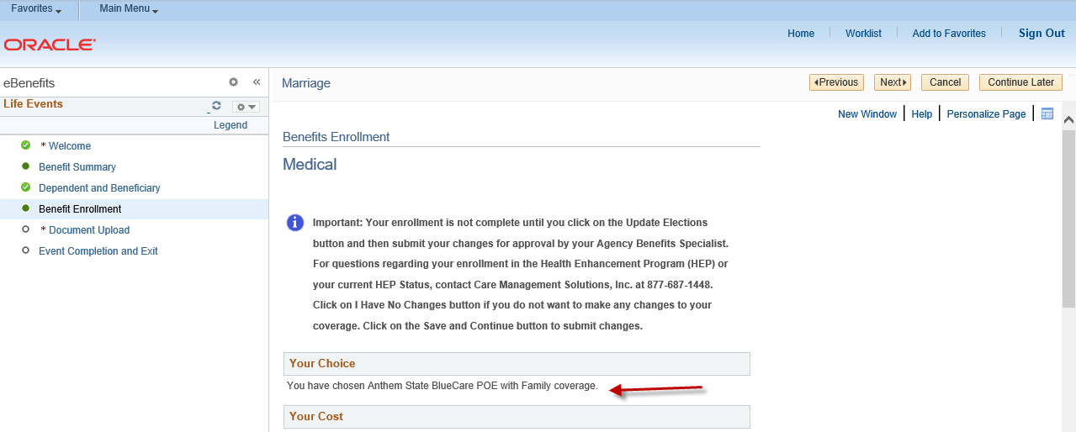

________________________________________
Step 15: To make Dental changes, follow the same Edit process as the Medical example above.
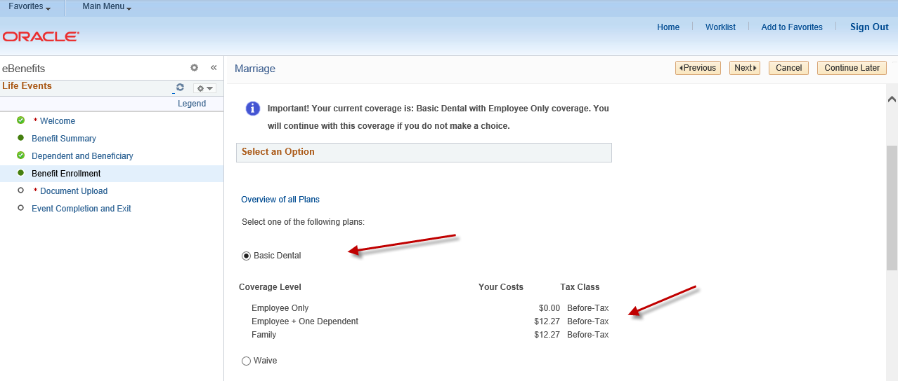

________________________________________
Step 16: Review your changes or new enrollment based on your Life Event. Click on the highlighted Update Elections button to continue or click on the highlighted Discard Changes button to restart your enrollment.
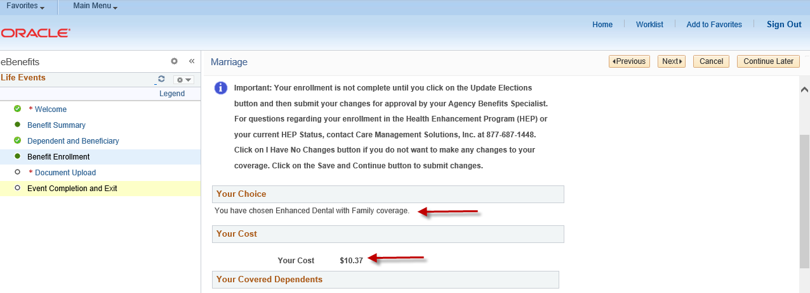
______________________________________

Step 17: Click on the highlighted Save and Continue button to complete your enrollment or discard changes button to cancel your changes. If any cost changes occur, based on your election chosen, they will be reflected in the ‘New’ line. Note: The Benefits Summary at the bottom of the page will reflect your ‘Costs Per Pay Check’ and ‘Costs Annually’.
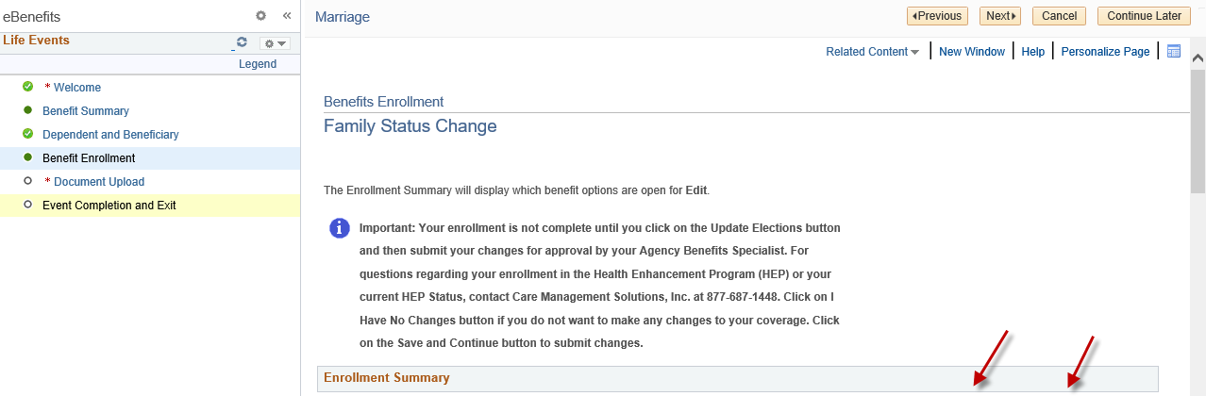
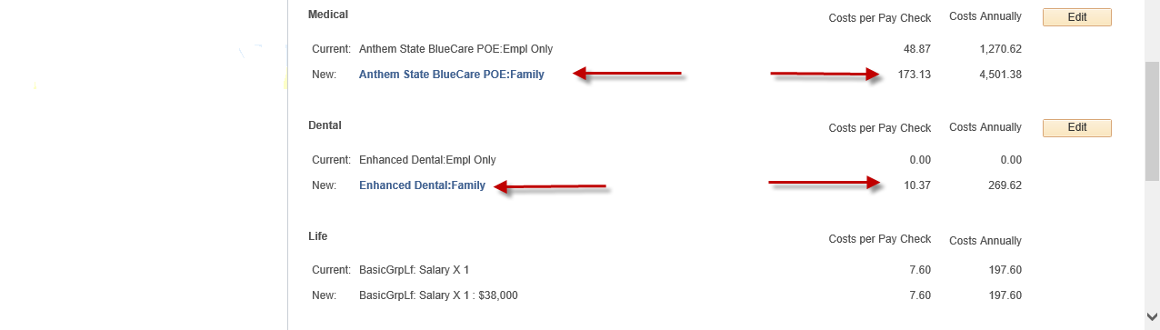
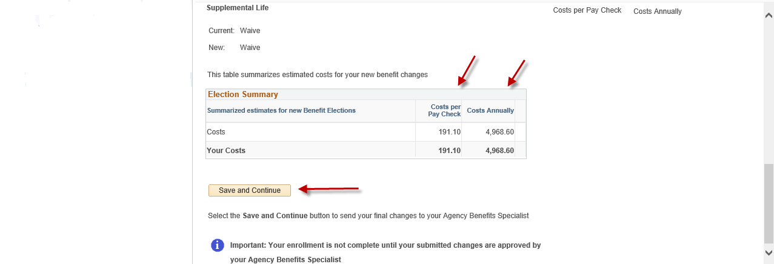

_______________________________________
Step 18: Read the important information on the Authorize Elections page. Click on the highlighted Submit button to authorize and submit your elections.
Click on the highlighted Cancel button to return to the prior Benefits Enrollment page to edit your enrollment.
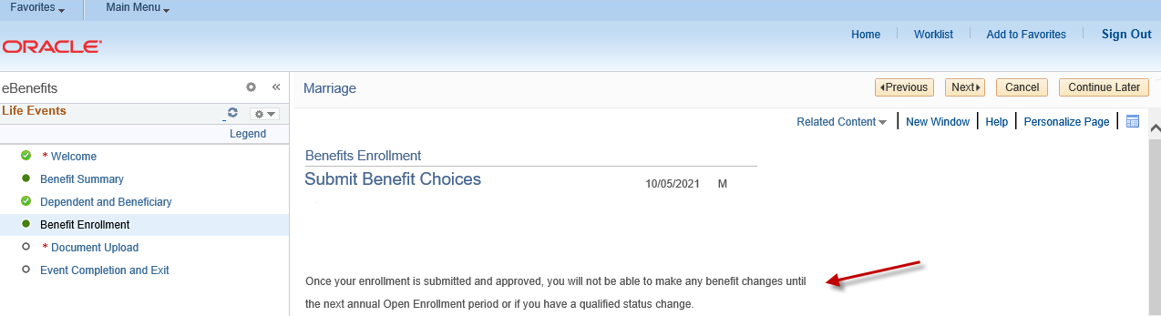
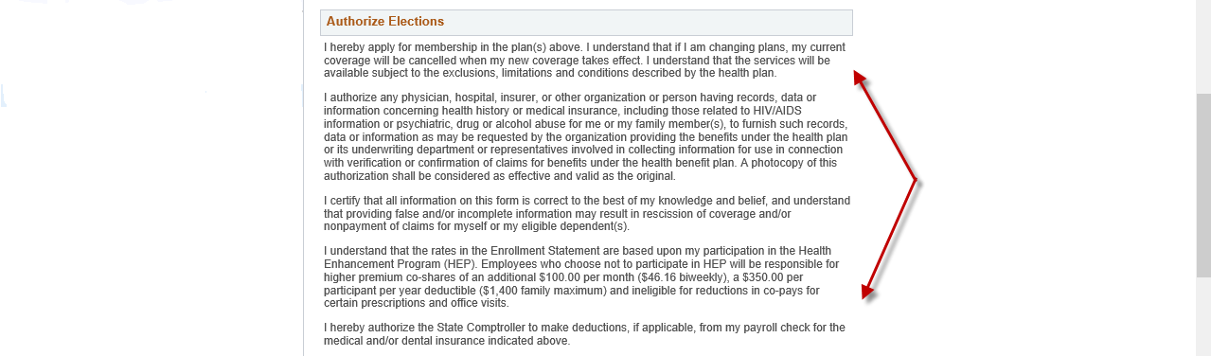
______________________________________
Step 19: The Submit Confirmation page will appear confirming your submission to your Agency Benefits Specialist for approval. Click on the highlighted Next button in the upper right-hand corner to complete your Life Event changes.
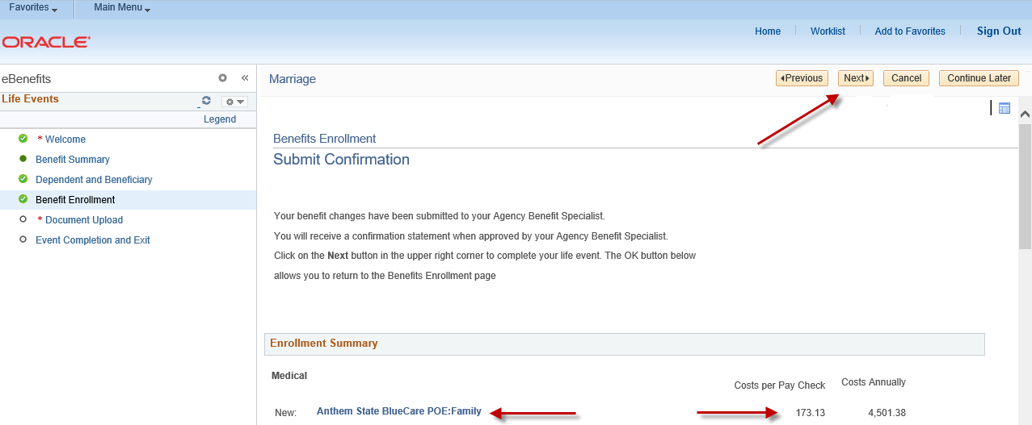
________________________________________
Step 20: Enter required documentation in the highlighted Proof Document Upload page (e.g., long form birth certificate, marriage certificate). Click on the highlighted Add Attachment button. If you will not be uploading required proof documentation, click Add Note.
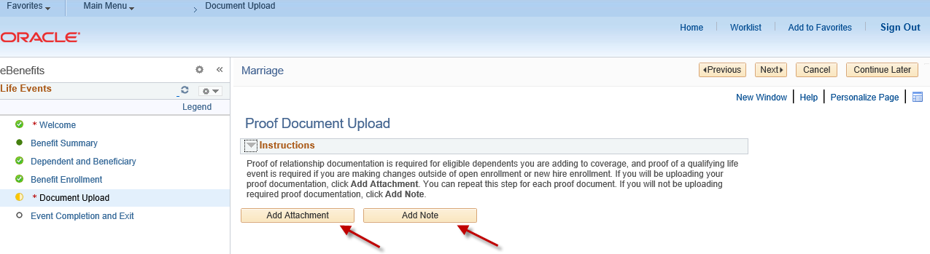

________________________________________
Step 21: Enter a document name on the Subject line and then attach the supporting document (via the Choose File button or Browse button – as either may appear). Click on the highlighted Upload button.
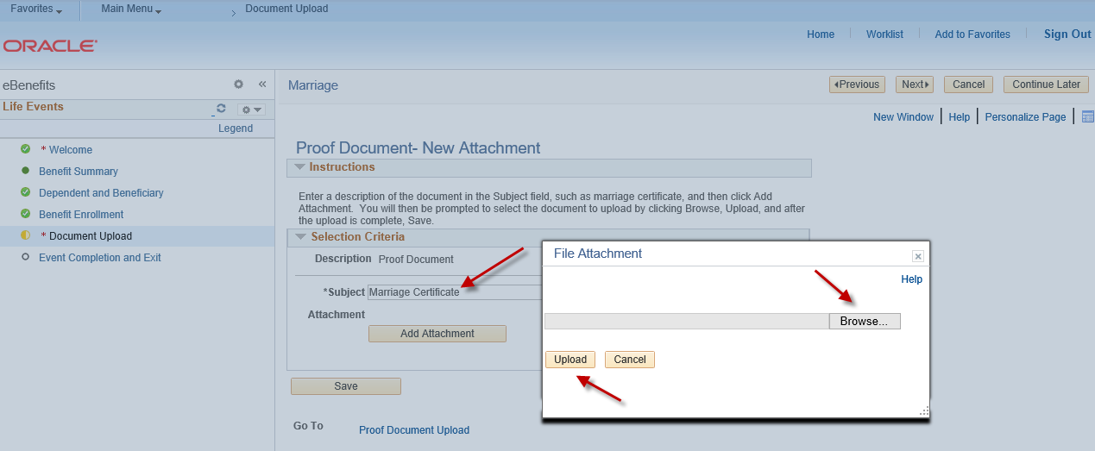
________________________________________
Step 22: Click on the highlighted Save button once your document(s) has been uploaded.
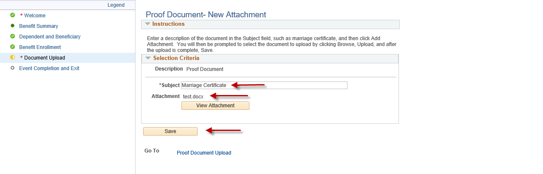
______________________________________
Step 23: Click on the highlighted Next button to complete the document upload process.
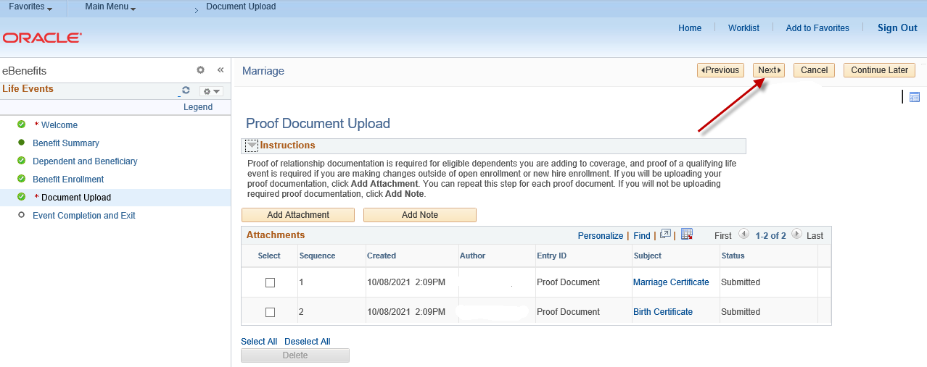
_________________________________________
Step 24: Click on the highlighted Complete button to finalize your Life Event changes. You will be returned to the Life Events page which confirms that your enrollment has been submitted to your Agency Benefits Specialist.

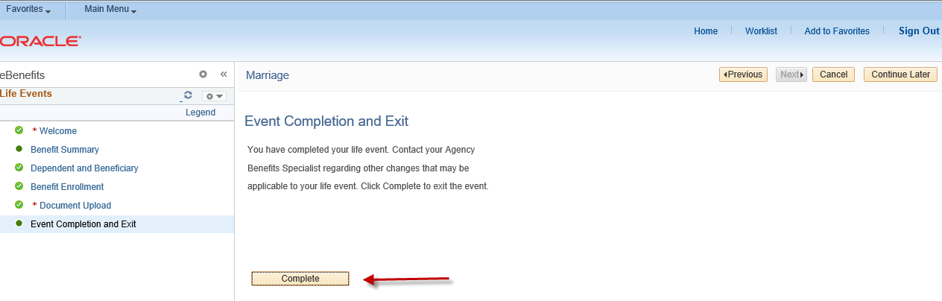

Contact your agency payroll/benefits staff if you have any questions or need assistance with your enrollment.

Revised 1/31/2022

