The following describes how to process employees in Core-CT who are eligible to earn sick time under PA 11-52 Connecticut Paid Sick Leave Law. This document is a summary of the requirements and does not represent all aspects of eligibility or entitlements. Refer to the State Statute for more details.

In general, the law provides the following:

- Sick time is earned on a basis of one hour earned for every 40 hours worked
- Employees cannot use sick time until they have worked a total of 680 hours
- Employees cannot earn more than 40 hours of sick time in a calendar year
- Employees cannot use more than 40 hours in a calendar year
- Employees are allowed to carry over 40 hours from one calendar year to the next but cannot exceed an 80 hour balance.

Employees must be enrolled in the leave plan created specifically for the Law. The plan has a maximum balance of 80 hours and does not award any hours.

S80BPW Leave Plan Setup

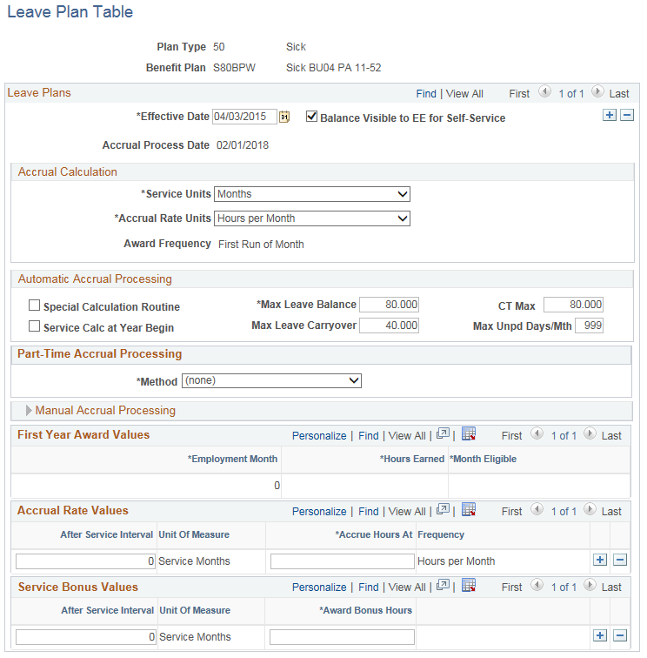

- Enroll Employee in Sick Plan

Enroll the employee in the leave plan S80BPW effective with the first day of a pay period (or the hire/rehire date).

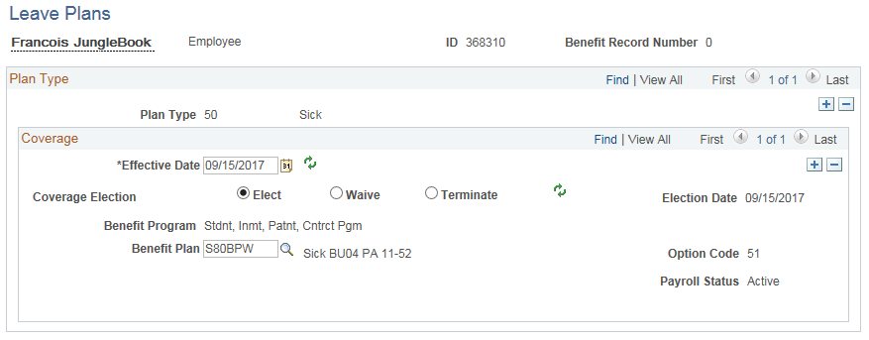

The employee must be in the STU (Stdnt, Inmt, Patnt, Cntrct Pgm), NPS (NB Part-Time w/Sup Min Sal) or the SES (Sessional Employee Program) Benefit Program in order to be enrolled in the S80BPW sick plan.

- Enroll Employee in Workgroup

Enroll employee in one of the Service Worker Workgroups using the same effective date used for the Sick leave plan. These workgroups contain the rule that will create an exception if the employee has used more than 40 hours of sick time in a calendar year.

04PSERVWKA = Needs Approval (Self-Service)
04PSERVWKR = Does not Need Approval

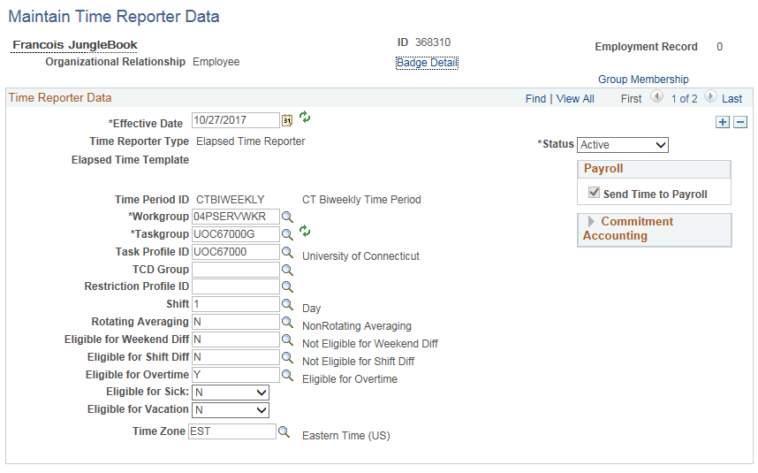

Note: Verify the Sick eligibility flag. The default value is ‘Y’.

Set to ‘N’ if the employee has not met the requirements to use sick time
Set to ‘Y’ if the employee is entitled to use sick time

Set the Vacation eligibility flag to ‘N’

- Update Carryover Table

Update Carryover Table, if needed. The CT_HRS_CTTLB361 table will store any hours in excess of 40 after the calculation of hours earned each pay period. The Carryover Table is available in EPM for reporting purposes.

Sample carryover table:
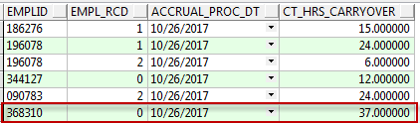

It may be necessary to update this table on occasion. A template has been created that will be uploaded to the table and will replace the carryover that exists for the last accrual process date or will create a new row if one does not exist for the date specified. The template is located on the Core-CT web page under Time and Labor job aids: Main Menu > Core-CT HRMS > Time and Labor > Time & Labor Job Aids > Service Worker Carryover Template. Instructions for completing the Template are contained within the job aid.

Examples of situations when the table may need to be updated:

1. A new hire has hours previously worked for the State of Connecticut that will count towards earning sick time. These hours have never been included in a previous calculation of hours worked for purposes of PA 11-52 Connecticut Paid Sick Leave Law.

2. An employee was paid for working hours that were not processed through Time and Labor. These hours were either paid via Additional Pay or through a Payline Adjustment. In addition, hours entered in Adjust Paid Time will not be picked up in the calculation and may need to be included in the carryover.

3. To correct an error in a manual calculation of hours worked. If an error was discovered in a manual calculation of hours worked that change the number of carryover hours, the hours on the Carryover Table can be adjusted. (Note: If the error only resulted in a change in the number of sick hours earned, make a manual adjustment on the current timesheet using the adjustment codes SKAA or SKAD to add or deduct sick time earned.)

Sample Carryover Template:
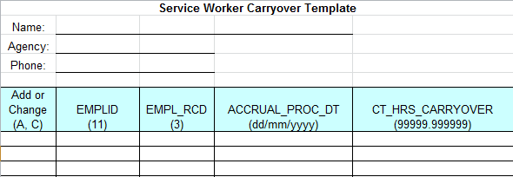

The Template cannot be altered in any way except to insert the information indicated. The format of the columns/cells should be followed when entering employee data. Refer to the format/field size at the top of each column just below the field name. In addition, the column headers (field name) should not be changed. To add a new row to the carryover table, type A (Add) and complete the employee information. To update an existing row, type C (Change) and complete the employee information.

Send the completed Service Worker Carryover Template to the Time and Labor Team via email. You will be notified once it has been loaded.

After the template has been uploaded to Core-CT the Carryover table will be updated.

- How Sick Time is Calculated

Hours worked in the pay period:

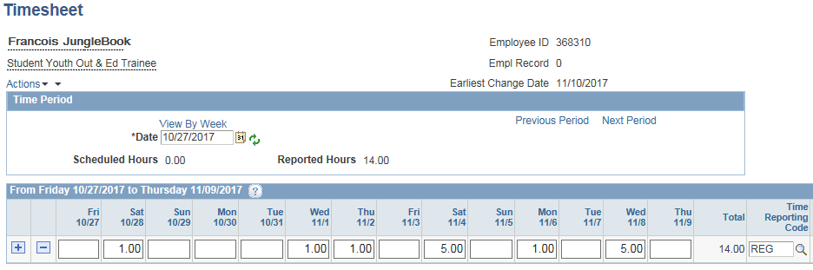

Calculation:
Carryover from previous pay period 37.00
Hours worked current pay period 14.00
Total hours worked 51.00

Hours Earned 51.00 / 40.00 = 1.275 or 1 hour
New Carryover 51.00 – (40 x 1) = 11.00

- System Processing on Pay Confirm Day

After pay confirm, the standard accrual jobs will run and a row will be created with the pay period end date. No hours will be earned. This row will reflect any sick time transactions that had been entered on the Timesheet, Additional Pay or Payline Adjustments for the same pay period end date as the Accrual Date.

Review Accrual Balances page after accrual process creates the pay period end row:

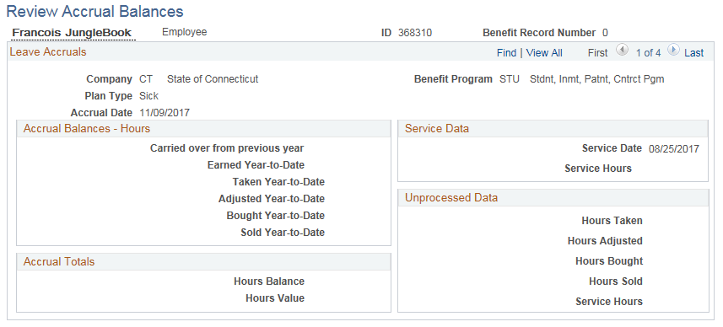

Once all of the accrual jobs have completed, the CTTLB361 will run. This is the program that will calculate hours earned based on the hours worked. The calculation will include the carryover hours from the previous calculation. If this is the very first calculation, the program will include the hours worked from the S80BPW enrollment date to the Accrual Date.

The CTTLB361 program will update the Review Accrual Balances row just created by the standard accrual jobs with the number of earned hours calculated by the program.

Review Accrual Balances after sick time is calculated:

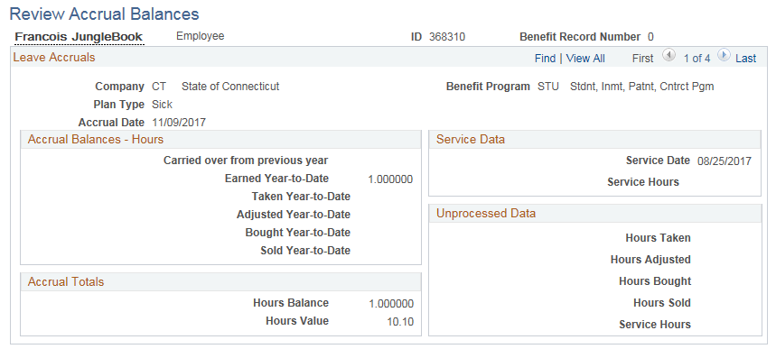

- Review Report

A report will be produced by the CTTLB361 program showing the amount of time accrued for the pay period. It will also display the number of hours earned for the calendar year. Agencies will need to monitor the Earned YTD to ensure that employees do not exceed the 40 hour calendar year maximum. Once an employee reaches 40 hours earned in a calendar year, enroll them in the no accrual plan. At the same time, re-enroll them in S80BPW effective with the following January 1.

Only employees who have earned time in the current pay period will appear on the report.

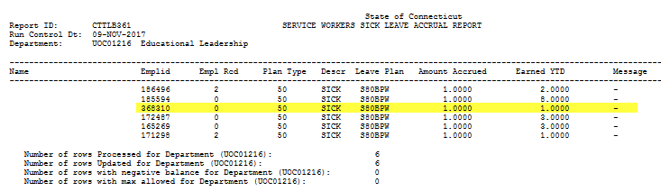
Sample report (Name removed):

- Update Carryover Table

After the hours earned have been calculated for the current pay period, the CTTLB361 program will update the Carryover table with an effective dated row equal to the Accrual date. The new row will reflect any hours in excess of 40-hour increments (or zero if there are none).

Sample employee updated from 37.00 hours to 11.00 hours effective 11/9/17:

- Update Employee Setup

Once an employee has met the requirements for usage of sick time, the Sick Eligibility flag on Maintain Time Reporter must be updated so that sick time can be saved on the Timesheet. The effective date should be the first day of a pay period.

Eligible for Sick flag updated to ‘Y’:

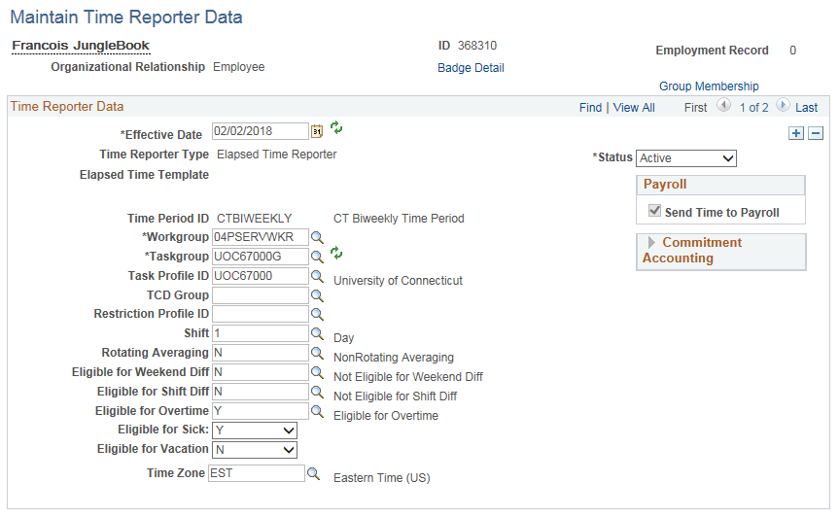

- Timesheet Error Messages

- The employee will be unable to save sick time to the timesheet if the Eligible for Sick flag is set to ‘N’

Timesheet with sick time posted and eligibility flag set to ‘N’:

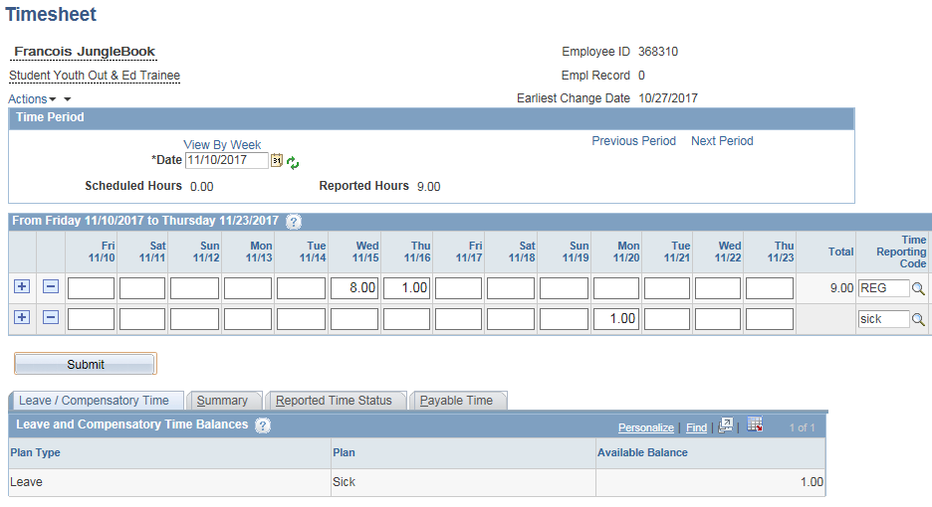

Error Message:

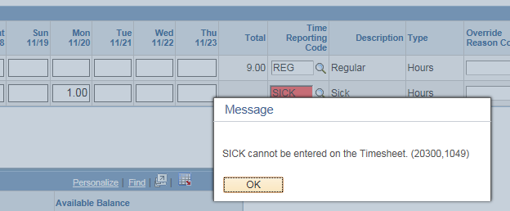

- The employee will be unable to save the Timesheet if the sick time posted exceeds the employee’s balance.

Timesheet with sick time posted, eligibility flag is set to ‘Y’ and sick is posted in excess of balance:

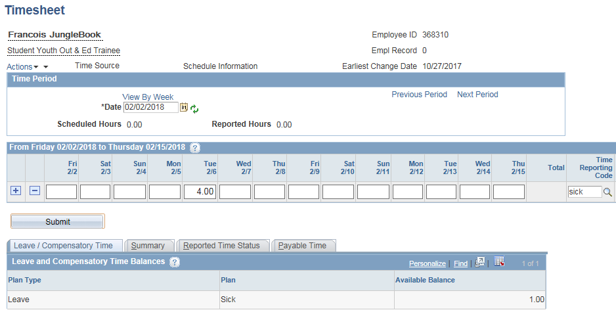

Error Message:

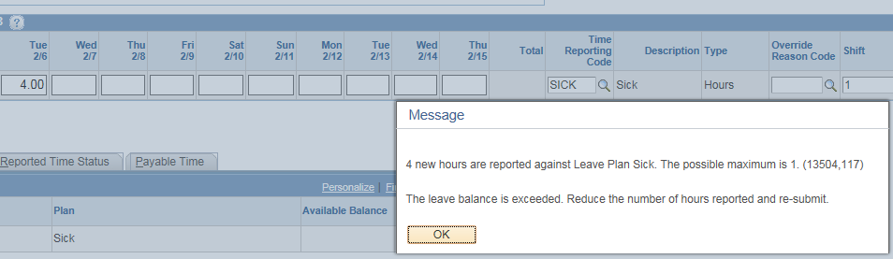

- If the employee has greater than 40 hours in the balance, and the employee uses it, the Timesheet will save even though the maximum is 40 hours used in a calendar year. During the nightly Time Administration process, an exception will be created for the days on which the 40 hour limit was exceeded.

Timesheet with sick posted and employee has already used 40 hours in the calendar year:

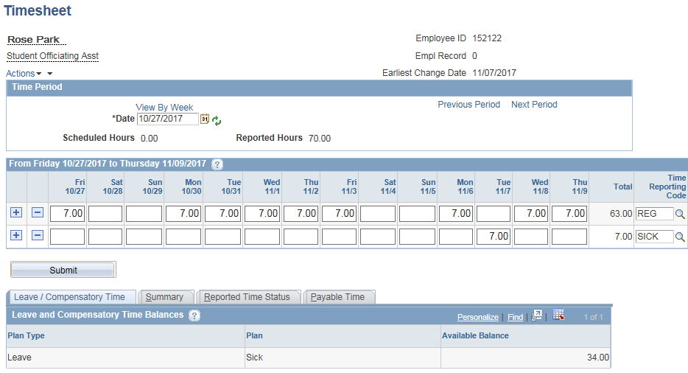

The timesheet will save successfully as the employee has enough sick time to cover what is being posted. Time Administration will run overnight and an exception will be created.

Exception:

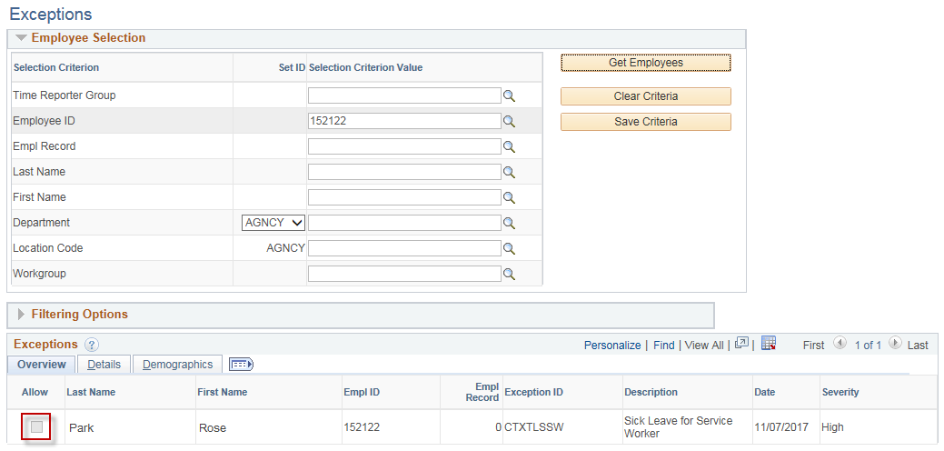

The Allow checkbox is grayed out as the exception is not allowable. To clear the exception the sick time must be changed to another TRC on the Timesheet such as ULSCK or deleted altogether. The only TRCs available to Service Workers and that will count towards the 40 hour maximum are SICK, SFAM and SP. The exception will be cleared with the next run of Time Admin.

Users can check for exceptions on either of two online pages at Core-CT HRMS > Manager Self Service > Time Management > Approve Time and Exceptions > Exceptions or Core-CT HRMS > Time and Labor > View Time > Exceptions.

There is also an Exceptions report that can be found at Core-CT HRMS > Time and Labor > Reports > T&L Exception Rpt – CTTLR365.

Exceptions Report:
