This job aid illustrates how to approve payable time, make changes to employee Timesheets and how to manage prior period adjustments including how to handle erroneous Needs Approval time.

Special Note: This job aid assumes that the employee has entered attendance on the Timesheet and that Time Administration has been run overnight.

Non-Self Service Agencies: If Needs Approval time is created for your employees see Part IV for information.

Table of Contents:
Part I – Approving Payable Time 2
Part II – Managing Prior Period Adjustments 22
Part III – Approving Timesheet Changes 30
Part IV – Managing Unapproved Time 32
(Hover mouse on topic or page number and click Ctrl key to toggle to that topic)

Words to Know

Reported Time | Time that is entered on the Timesheet.
Time Administration | Overnight process to validate attendance entered on the Timesheet. Also referred to as Time Admin.
Payable Time | Time that is created during Time Administration. The time passed validation and is ready to be loaded to the Payroll module for paycheck calculation.
Payable Time Status | Payable Status indicates what processes have been completed. This list only includes those statuses that relate to approving time. For a complete list, refer to the Payable Time Status job aid.  Needs Approval – time entered on Timesheet or from a schedule that has passed validation  Approved – Ready for Payroll – time has been approved and is ready to be loaded to Payroll  Taken by Payroll – Payroll has picked up the time and has calculated a paycheck  Rejected by Payroll – Payroll did not accept the time - see your Time and Labor unit for resolution.  Distributed – paycheck has been confirmed and distributed to the General Ledger
Exception | Time that does not pass validation during Time Administration is flagged with an exception. Refer to the job aid entitled Cleaning up Time and Labor Exceptions for more information. See your Time and Labor unit for resolution.
Prior Period Adjustment | Changes made to payable time having a status of Distributed. There is a limit of four pay periods in which a prior period adjustment can be made. If changes need to be made beyond that, contact your agency’s Time and Labor unit.
Needs Approval Time | Payable Time is assigned a status of ‘Needs Approval’ when one an employee is enrolled in a needs approval workgroup. These workgroups should only be assigned to an employee if your agency uses Self-Service Time Entry.

Part I – Approving Payable Time

Access Approve Payable Time:
Main Menu > Core-CT HRMS > Manager Self Service > Time Management > Approve Time and Exceptions > Payable Time

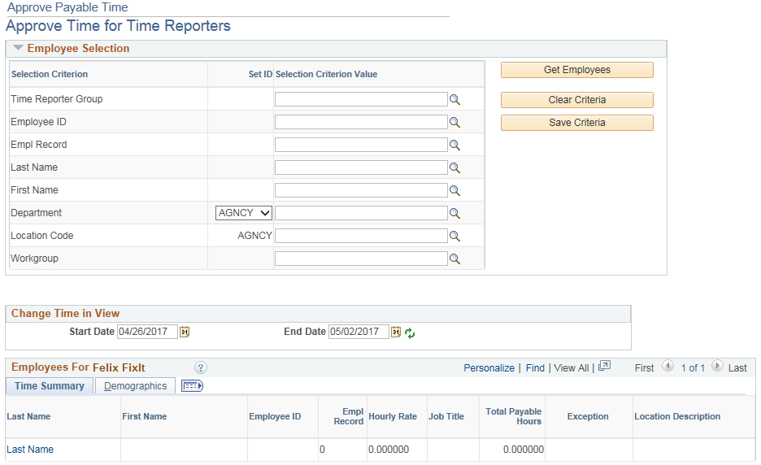

Special Notes:
  - For this section it is assumed that the employee has already posted attendance and the time has been validated by the overnight Time Admin process.
  - Time entered on the Timesheet must be processed by Time Admin before it is ready to be approved.
  - Time Admin runs every night except Sundays and on pay confirm Thursday (non-payday).

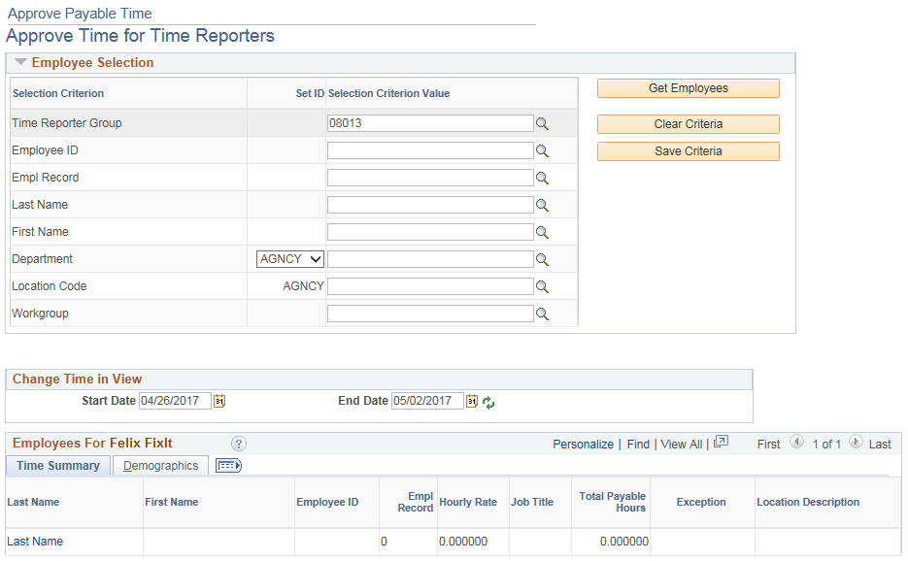

- Enter the Group ID or Empl ID (e.g., Group ID 08013)

- Enter the pay period Start Date and End Date (e.g., 04/28/17 and 05/11/17)

- Click

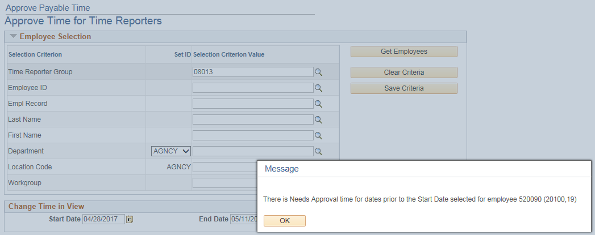

- Click

Special Notes:
  - If there is time that needs approval prior to the Start Date selected a warning message will appear. The affected employee number will be indicated in the warning message. Click OK to bypass the message.
  - Managing prior period adjustments is illustrated in Part II.

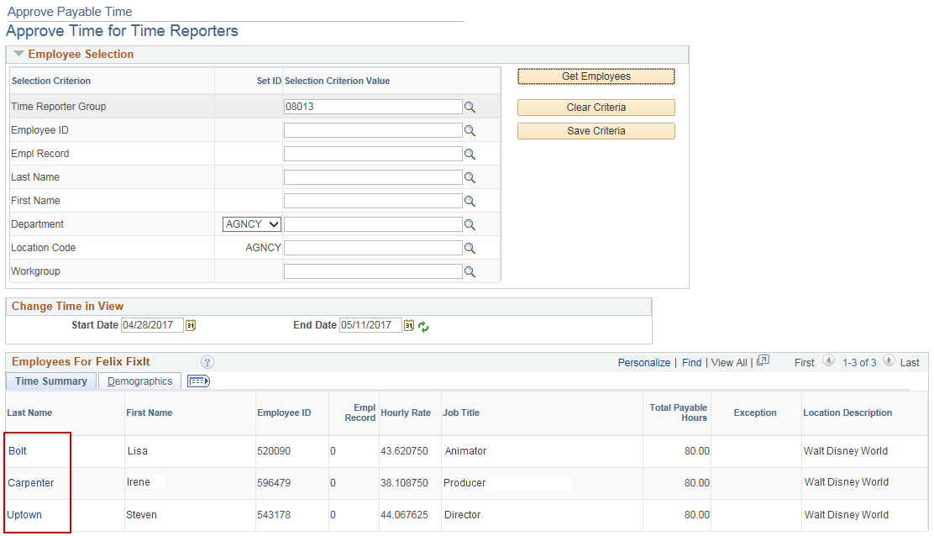

- A list of employees with Needs Approval time is populated.

- Click on a Last Name link to view the attendance details for an employee. (e.g., Bolt)

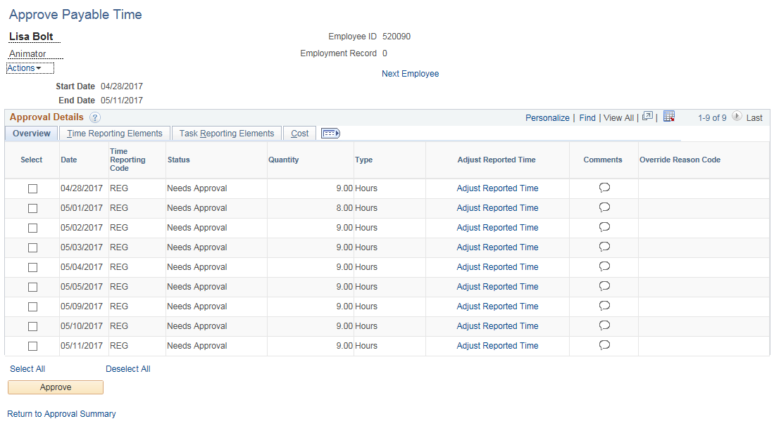

- Verify the attendance details to ensure accuracy.

- Click the Select box on each row to select entries for approval.

Special Note:
  - You may also click the Select All link to select all entries for approval.

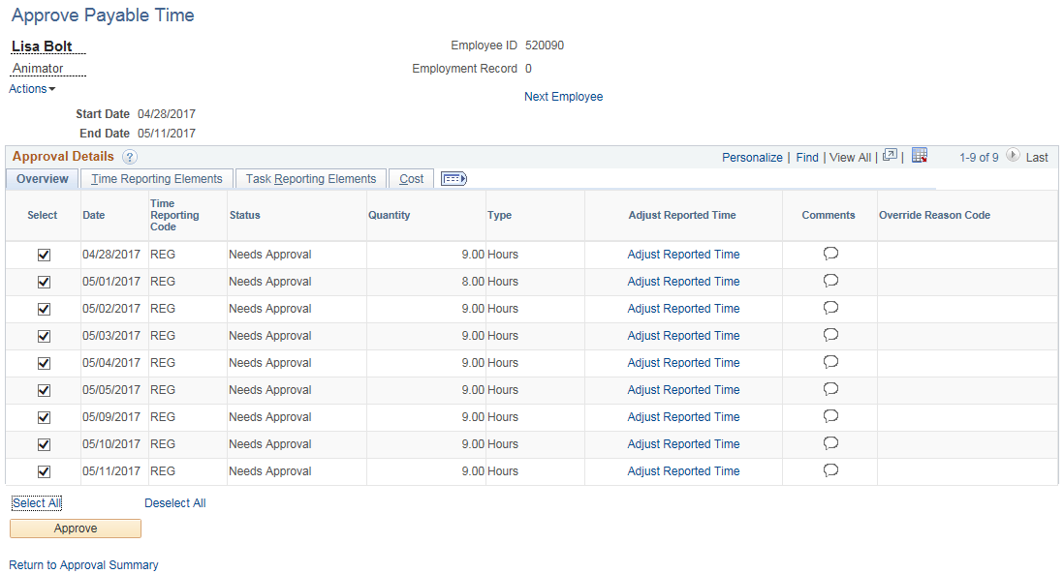

- Click

Special Note:
  - You may deselect individual rows by clicking the Select box on that row

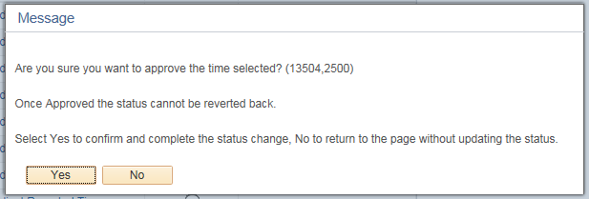

- Click to approve the rows selected

Special Notes:
  - Click the button to return to the details page without approving
  - Once time is approved it cannot be unapproved

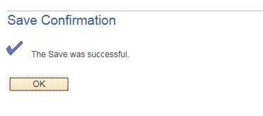

- Click

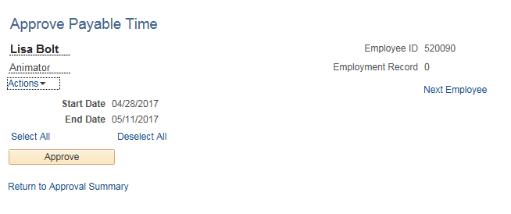

- There is no time left to be approved for this employee for the date range selected.

- Click the Return to Approval Summary link to approve the next employee

Special Note:
  - You may also click on the Next Employee link to access the next employee in the list

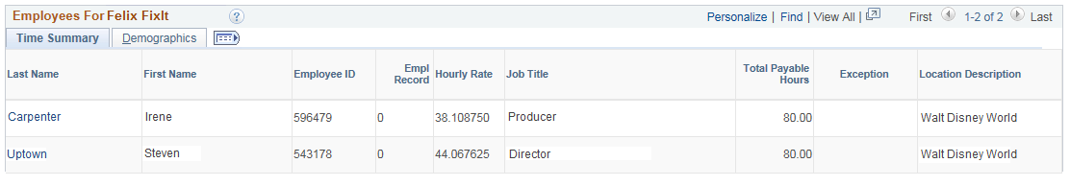

- Click on the link for Carpenter to view the attendance details for Irene Carpenter. Note the Total Payable Hours for this employee (e.g., 80)

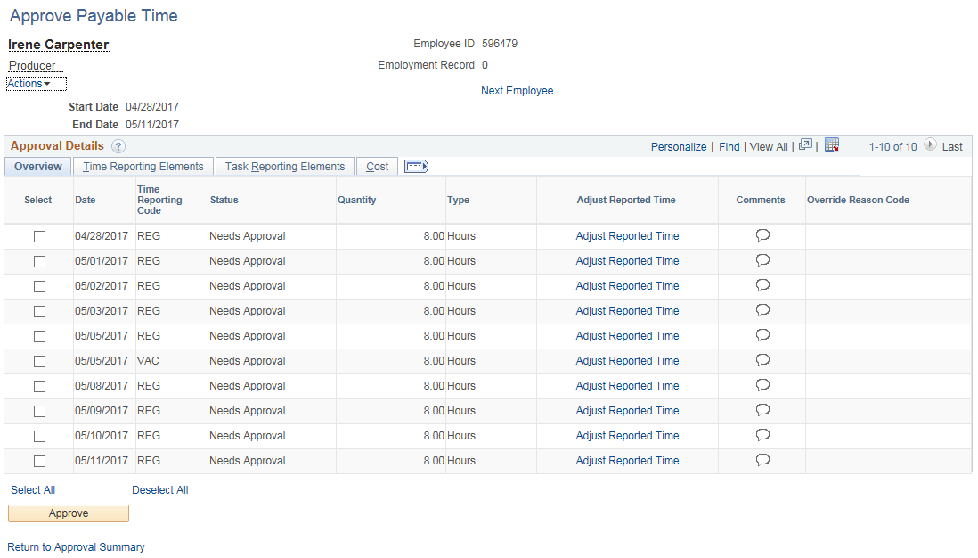

- Verify the attendance details to ensure accuracy. Notice the employee has double entries for 5/5/17 and has no entry for 5/4/17.

- Click the Adjust Reported Time link on any row to make corrections to this employee’s Timesheet

Special Notes:
- You may also directly access employee timesheets by navigating to Main Menu > Core-CT HRMS > Manager Self Service > Time Management > Report Time > Timesheet
- Approvers at agencies where employees are set up as an Exception Time Reporter (schedules default to REG on the timesheet) need to click on the Adjust Reported Time link to verify that the timesheet has been submitted BEFORE approving.

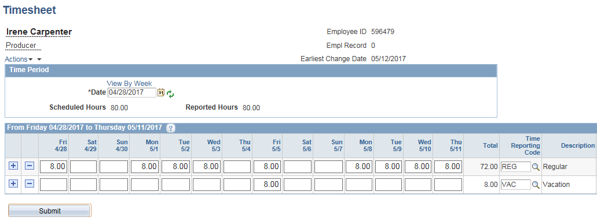

- Make any necessary changes

Special Notes:
- Follow your agency’s business process for notifying the employee of the Timesheet change
- Notice that the Reported Hours field indicates 80.00 hours. This indicates that the employee has submitted (signed) the timesheet. Do not approve if the Reported Hours is 0.00. Have the employee submit the timesheet and approve after the next Time Admin process runs.

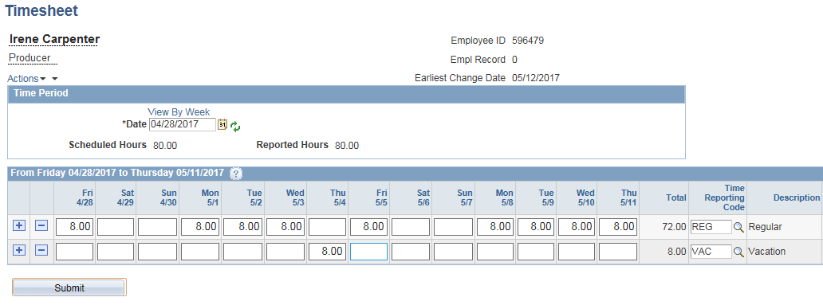

- Click to save your changes

Special Note:
- Any changes made to employee Timesheets must be approved after the next Time Admin process runs. Supervisors can approve changes they themselves made to their employee’s Timesheet.

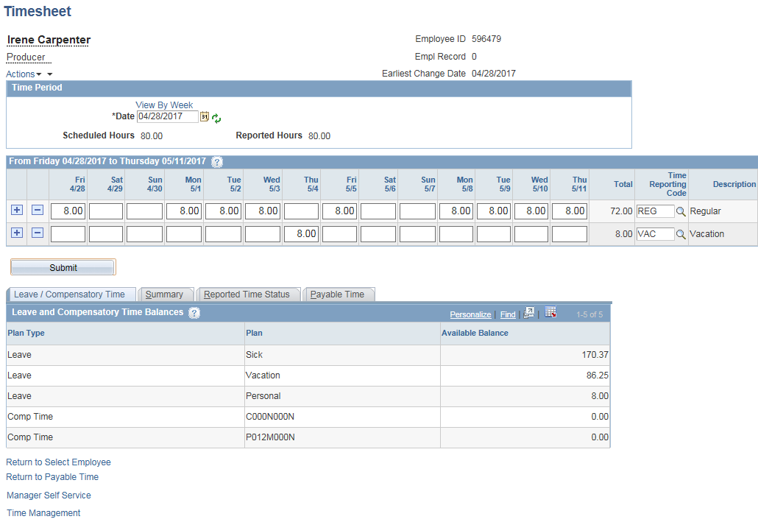

- The page is saved

- Click the Return to Payable Time link

Special Note:
- Approving changes is illustrated in Part III.

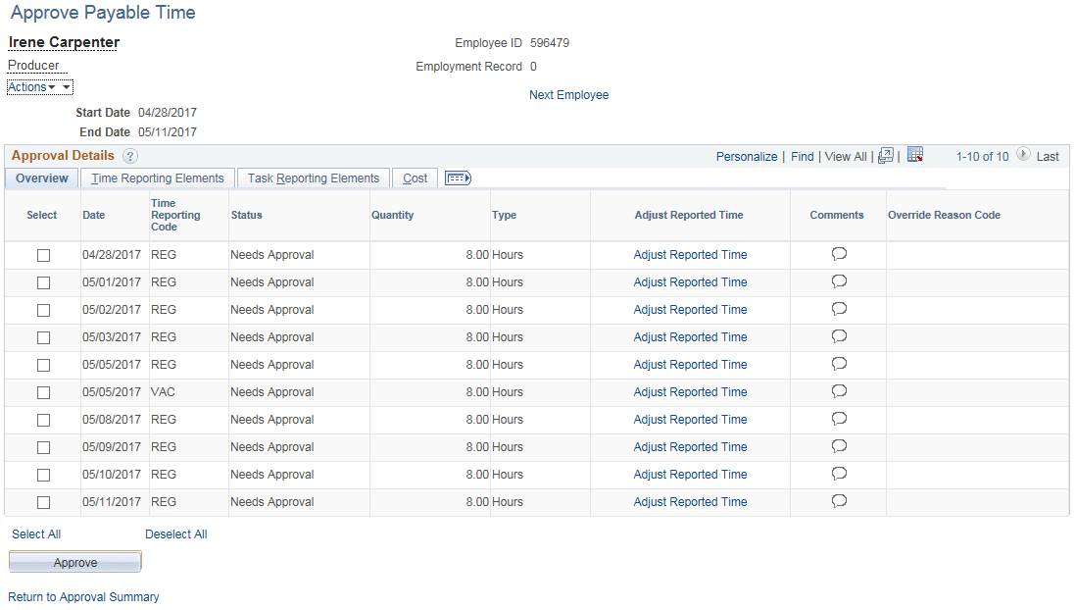

- Click the Select All link

Special Notes:
- A comment can be entered by clicking the Comment icon on the desired row. Comments are associated with the TRC. The comment field can be used as an audit record of any changes made to the Timesheet. Comments can be entered on the Timesheet or on the Approval Details page. If you need to enter a Comment to record why attendance was deleted you will need to choose another TRC in the pay period to associate the Comment with.
- Adding a comment is illustrated in Part II

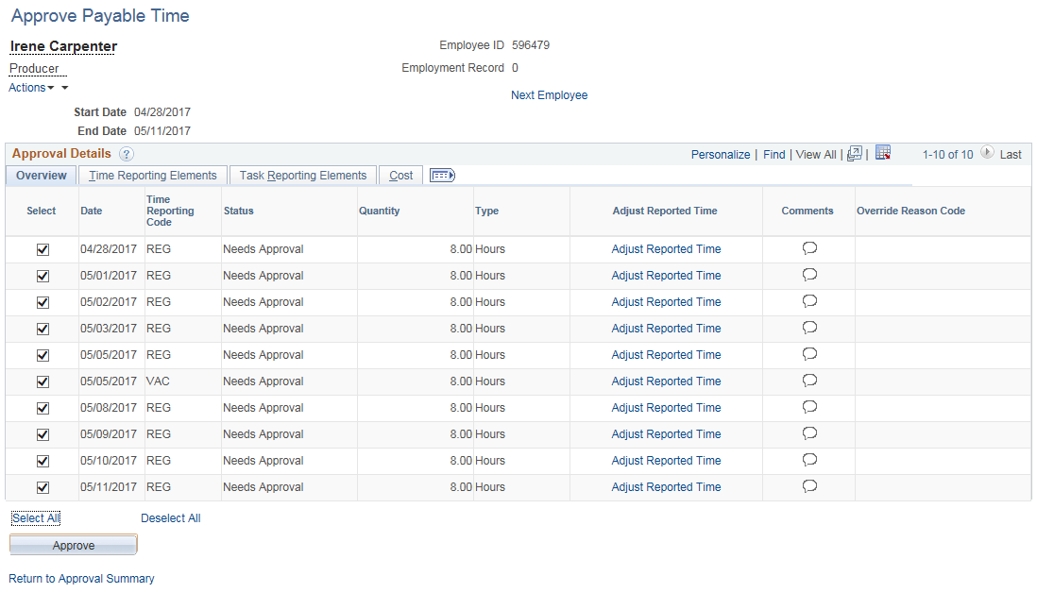

- Click the Select checkbox on each of the two 5/5/17 rows to deselect them

Special Notes:
- If the Payable Time you are deleting has a status of Needs Approval it will not be necessary to approve the deletion later. This is because Time Admin recognizes that the original Needs Approval time has not yet been loaded to Payroll and offsetting entries do not need to be created. Deleting or changing time that has already been approved and passed to Payroll (status of Taken by Payroll) requires approval of the changes.
- Please note that deleting time with a status of Taken by Payroll or Distributed will create a negative entry for the deleted time and a positive entry for any new time added. Both the negative and positive payable time has to be approved. Approving Timesheet changes are discussed further in Part III.

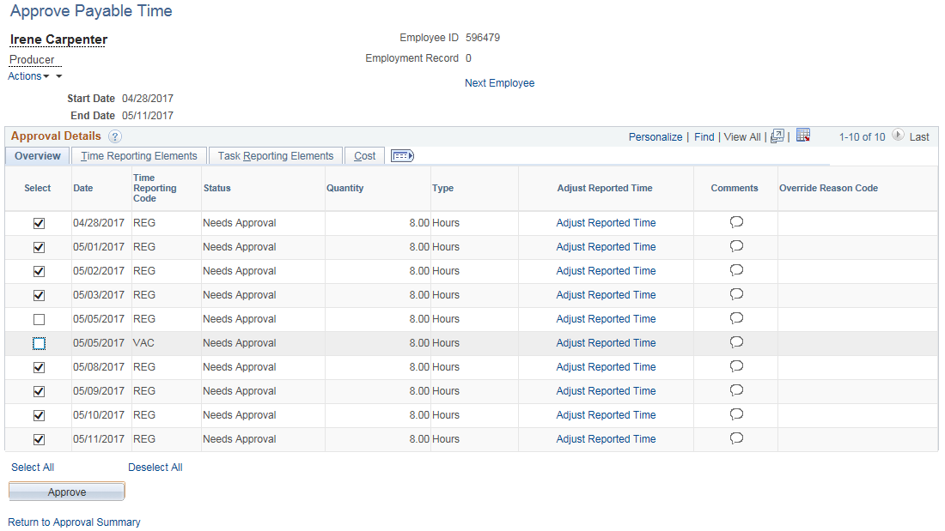

- Click

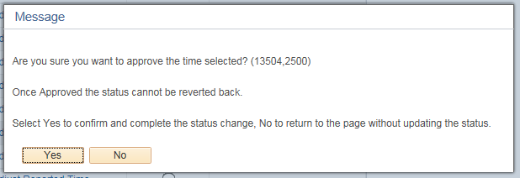

- Click to approve the rows selected

Special Note:
  - Click to return to the details page without approving

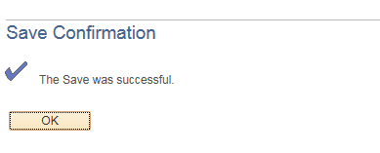

- Click to confirm the approval

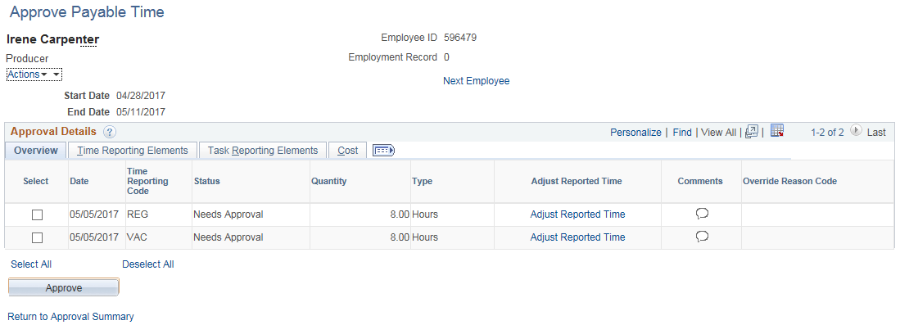

- Click the Return to Approval Summary link

Special Notes:
  - The deselected rows remain as needing approval
  - Time that is not approved will NOT be paid
  - The Next Employee link can also be used to approve the next employee in the list
  - Approving changes will be discussed in Part II

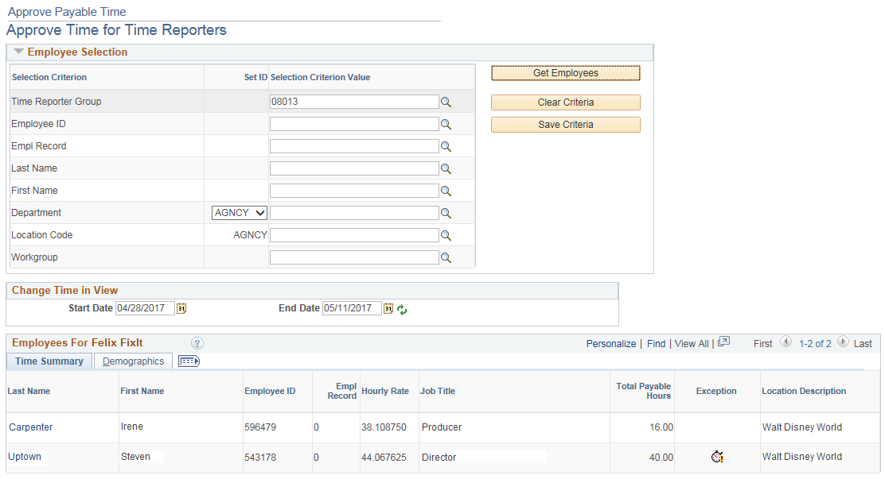

- Click on Uptown link. Note the Total Payable Hours for this employee.

Special Note:
  - The Alarm Clock icon indicates that an Exception exists for attendance within the date range selected.

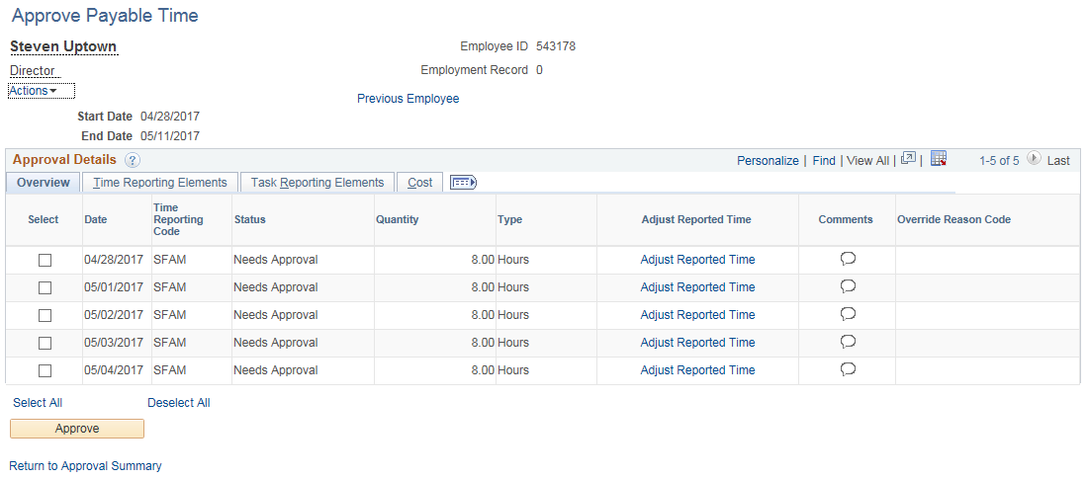

- Verify the attendance details to ensure accuracy. Note that the employee is short 40 hours.

- Click the Adjust Reported Time link to verify the Timesheet entries.

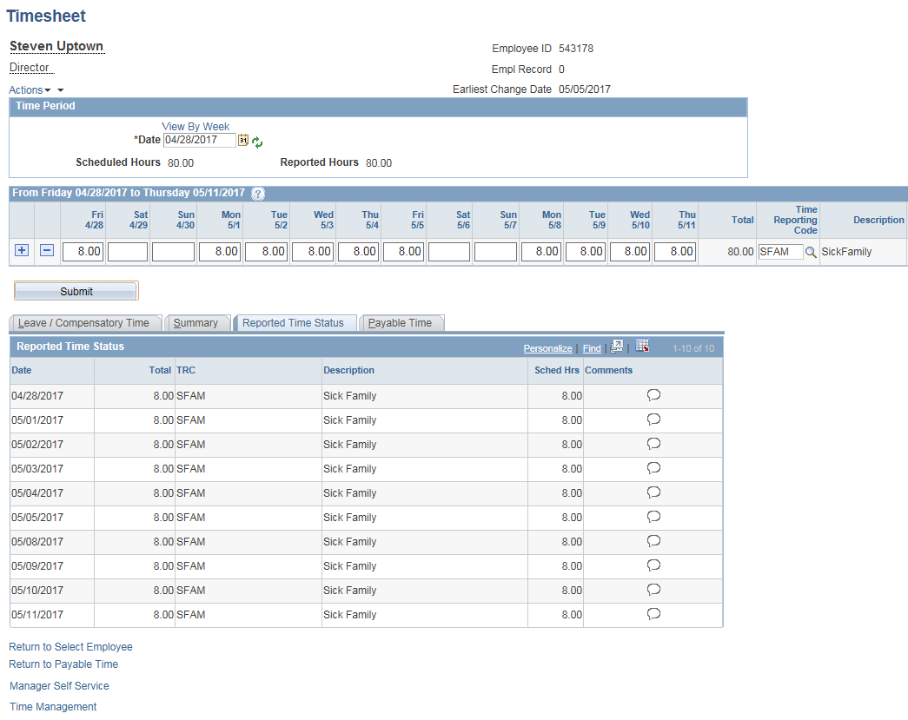

- Note that time has been entered for each day of the pay period. The Exception is due to the employee exceeding the allowed Sick Family limit for his bargaining unit. You can see Exception descriptions by navigating to Core-CT HRMS > Time and Labor > View Time > Exceptions.

- Click Return to Payable Time link

Special Notes:
  - During Time Admin all time entered on the Timesheet is validated for accuracy. Time that does not pass validation is flagged with an Exception.
  - Time flagged with an Exception will NOT be paid. The Exception will prevent any time posted on that day from being paid.
  - Follow your agency’s business process for clearing exceptions.

- Click Select All link

- Click

- Click to approve the time selected

- Click to confirm the approval

Special Note:
- Depending on your agency’s business process for clearing Exceptions, you may need to approve additional time once the Exceptions have been cleared.

Part II – Managing Prior Period Adjustments

Approvers can be made aware of prior period adjustments in the following ways.
- Employee communicates Timesheet change directly to the supervisor.
- Approver receives warning message on Approve Payable Time page.
- The supervisor uses the Approval page to search for prior period adjustments.
- Approver runs Payable Status Report CTTLR252.*
- Notification by your Agency’s Time and Labor unit.

* Refer to the job aid How to Run an HRMS Report for instructions on running this report. Access the job aid on the Core-CT web page by navigating to HRMS > Cross Module > Cross Module Job Aids > How to Run an HRMS Report. Refer to the job aid Time and Labor Reports for more information about the CTTLR252 report. The job aid is available on the Core-CT web page by navigating to HRMS > Time and Labor > Time & Labor Job Aids > Time and Labor Reports.

Access Approve Payable Time:
Main Menu > Core-CT HRMS > Manager Self Service > Time Management > Approve Time and Exceptions > Payable Time

Special Note:
  - This section illustrates how a supervisor can use the Approval page to find prior period adjustments.

- Enter the Group ID or Employee ID

- Enter the Start Date of the current pay period

- Click

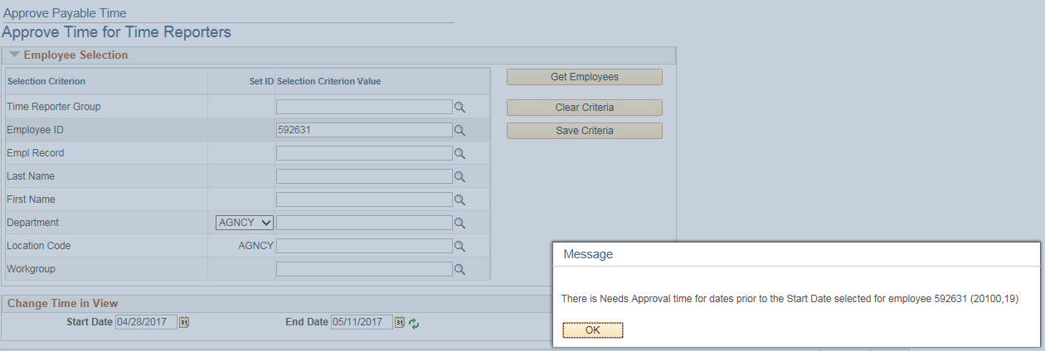

- A warning message appears stating that there is time that needs approval prior to the Start Date selected.
- Click
- Delete the Start Date
- Click
- Click on the employee’s last name link

Special Note:
- Deleting the Start Date will display any time that needs approval prior to the End Date. To automatically check for prior period adjustments, a supervisor could delete the Start Date as the first step, avoiding the warning message.

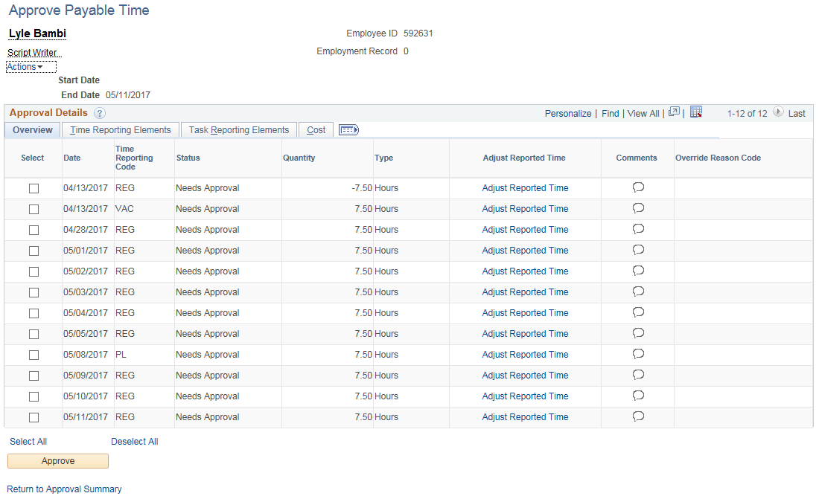

- Verify all attendance details to ensure accuracy. If the prior period attendance change is appropriate, approve the time following the steps illustrated in Part I. For this example, it assumed that the prior period adjustment is not appropriate and the supervisor will change it back to what it was prior to the change.

- Note the two rows of attendance for 4/13/17. The negative hours represent what the attendance was before the change. The positive hours represent what the attendance was changed to.

- Click on the Adjust Reported Time link on the prior period adjustment row

Special Notes:
- Needs Approval time for erroneous or inaccurate Timesheet changes must be cleaned up. Needs Approval time cannot be left as unapproved.
- If erroneous or inaccurate Timesheet changes are made do not approve them. Instead, make the necessary corrections on the employee’s Timesheet then approve those changes. The employee will need to be notified of the change according to your agency’s business process.
- Consult your agency’s Time and Labor unit for any questions regarding Timesheet changes and/or approving prior period adjustments.

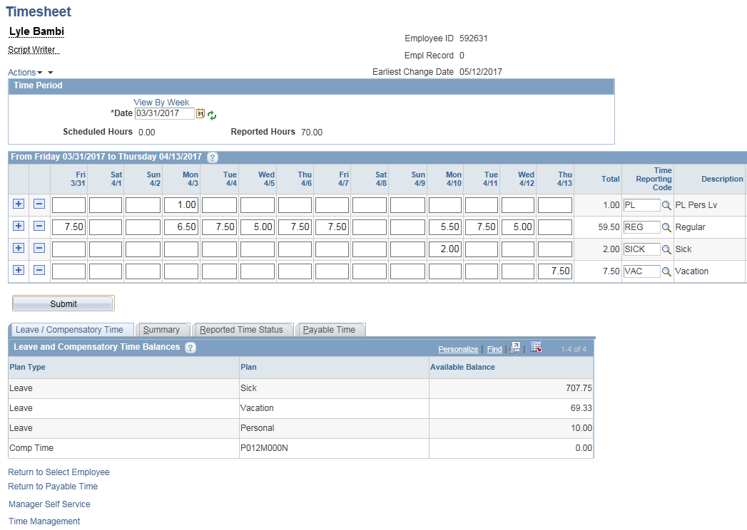

- Change the 7.5 VAC on 4/13 back to REG

- Click

- Timesheet is saved

- Click Reported Time Status tab

Special Notes:
- You can also navigate directly to the Timesheet to make changes at Main Menu > Core-CT HRMS > Manager Self Service > Time Management > Report Time > Timesheet.
- The change must run overnight through Time Admin before it is ready to be approved.
- Attendance older than four pay periods in the past cannot be changed. Notify your agency’s Payroll/HR unit for assistance.
- Some agencies do not allow prior period adjustments by employees or approvers. Approvers in these agencies should notify their Payroll/HR units for assistance.

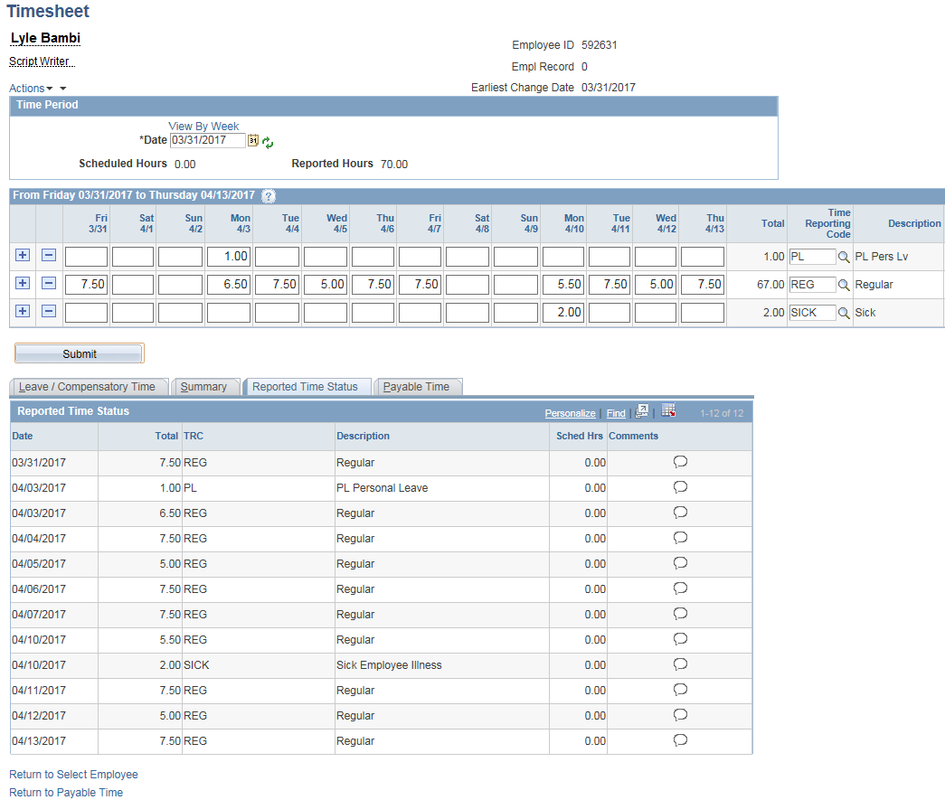

- Click on the Reported Time Status tab
- Click on the 4/13/17 REG row to add a comment

Special Note:
- The Reported Time Status link will not update until the Timesheet is submitted. If the correct attendance is not displayed click Submit then return to the Reported Time Status tab.

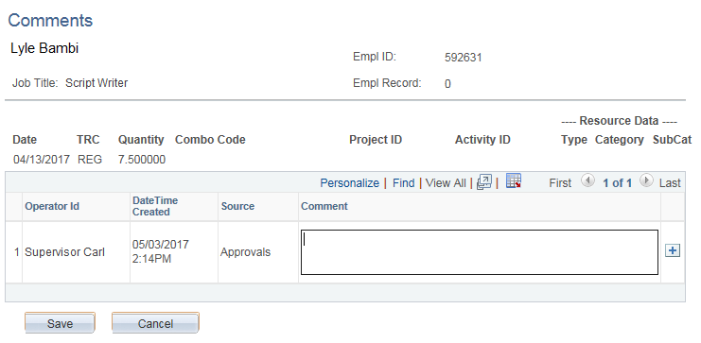

- Enter the desired Comment into the Comment field.

- Click

Special Notes:
- Click to save the comment
- Click to return to the Timesheet page without saving the comment

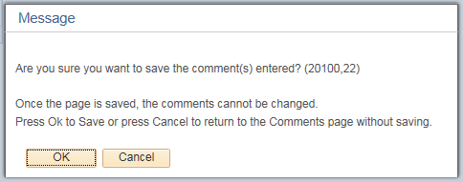

- Confirmation: Click

Special Notes:
- Click to save the comment.
- Click to return to the Comments page without saving

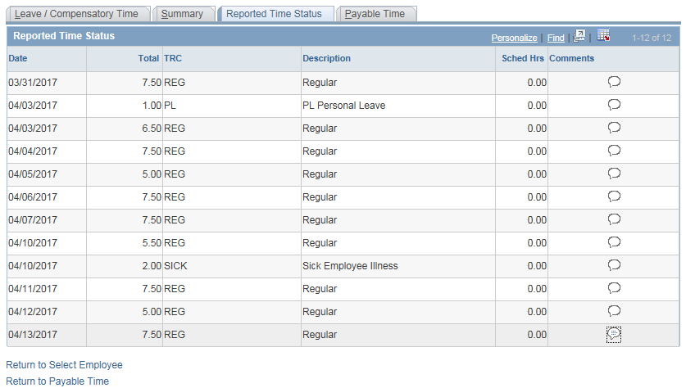

- The Comment has been saved. Note that the icon is now shaded.

- Click on the Return to Payable Time link

Special Notes:
- It is not necessary to submit the Timesheet after entering a Comment.
- Comments are associated with a TRC.
- A comment cannot be deleted once it’s saved. Additional comments can be entered at any time.

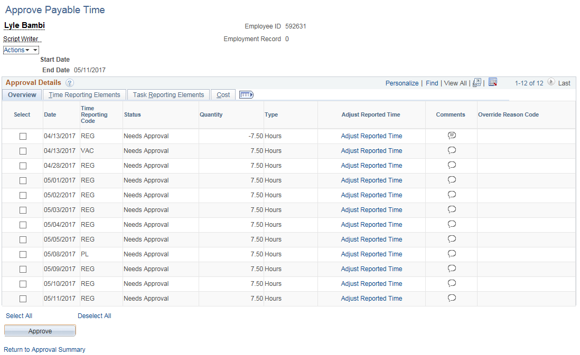

- Note that the Comments icon is now shaded.

- Do not approve the 4/13/17 row at this time.

Special Notes:
- After Time Admin runs, navigate to the Approve Payable Time page (Main Menu > Core-CT HRMS > Manager Self Service > Time Management > Approve Time and Exceptions > Payable Time) and approve the changes that were made.
- In this illustration, there is only one row needing approval. In some cases, there could be two rows for a single attendance change. One negates the original attendance and the other reflects the new entry. Both rows would need to be approved in order to correctly process the adjustment.
- Approving changes is illustrated in Part III.

Part III – Approving Timesheet Changes

Approvers can approve changes they made to their employees’ Timesheets. Time Admin must run overnight. The changes will be ready for approval the next day.

Access Approve Payable Time:
Main Menu > Core-CT HRMS > Manager Self Service > Time Management > Approve Time and Exceptions > Payable Time

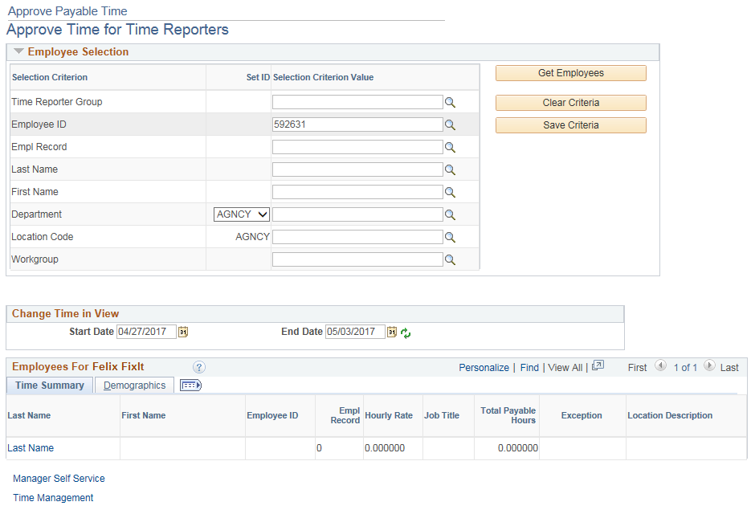

- Enter the Group ID or Employee ID

- Delete the Start Date or leave it blank

- Enter the End Date of the current pay period (e.g., 05/11/17)

- Click

Special Note:
- Deleting the Start Date will display any time that needs approval prior to the End Date.

- Click the employee’s Last Name link

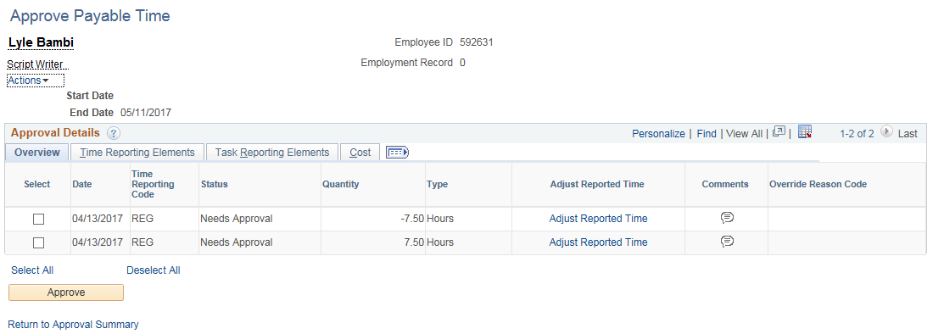

- Click the Select All link (You may also click the individual Select checkboxes)

- Click

- Click to approve the time selected

- Click to confirm the approval

Special Notes:
  - Note that the icon is shaded indicating the Comment entered in Part II.
  - The prior period adjustment will be processed with the current pay period and will be reflected in that pay period’s paycheck.
  - Deleting or changing time that has previously been approved and has been sent to Payroll (status of Distributed) will need to be approved. Please note that both the negative and positive payable time has to be approved. The negative time takes away what was already processed by Payroll and the positive time adds the new attendance.

Part IV – Managing Unapproved Time

This section explains the actions needed for time that will not be approved.

Special Note:
- There are various scenarios in which you would have unapproved time that cannot be approved. These scenarios are listed below with the recommended course of action.

Scenario 1 - There is old Needs Approval time for a date that cannot be accessed on the Timesheet.

Solution: Do not approve it. Log a Help Desk ticket with the Time and Labor team to have it deleted.

Scenario 2 – An employee makes an erroneous or inadvertent attendance change that should not be approved.

Solution: Do not approve it. Change the attendance back to the original values. To find those values, review the Payable Time Detail page. After Time Admin runs overnight approve any offsets that were created. Both the positive and negative offsets must be approved. Please note that the attendance MUST be put back exactly as it appeared originally. This includes any Shift, Override Reason Code, Combo Code, etc. that was entered. All of the original entry’s values can be found on the Payable Time Detail page. Click on the various tabs to view all values.

Scenario 3 – Time was not approved before the pay period was closed and the employee will be paid in a subsequent pay period.

Solution: Approve the time as soon as possible. The time will be reflected in the next confirmed paycheck.

Scenario 4 – Time was not approved before the pay period was closed and the payment will be made through Central Payroll.

Solution: Delete the unapproved time from the Timesheet. The time will be deleted during the next Time Admin. No further approvals should be necessary; however, it is recommended that you review the Payable Time Detail page to ensure the needs approval time has been removed. Once the appropriate pay period has been confirmed and has a status of Distributed, the time paid through Central Payroll must be entered in Adjust Paid Time by the agency’s Time and Labor unit.

Scenario 5 – You are not a self service agency and do not have access to the Needs Approval page.

Solution: Log a Help Desk ticket for Core-CT assistance.

