06/15/2018 update: Since the lump sum payments are being paid using earnings code MPS, the below method will only work on state withholding taxes. Federal taxes will be taken on the current supplemental rate as described on pages 19 + 20 of Publication 15.

The 2017 SEBAC agreementauthorizes a $2,000 lump sum payment to all bargaining unit employees, or a top step lump sum plus $1,000 if greater, pro-rated for part-time.

Agencies can designate the number of tax periods for those employees who want to distribute their taxes over multiple weeks. Agency HR/payroll staff are responsible for informing/coordinating this option with employees. Employees may choose up to 12 Tax Periods depending on how often they are paid. For Bi-weekly and Special Bi-weekly employees, up to 12 tax periods may be used; for Semi-monthly, up to 11 tax periods may be used; and for Monthly, up to 6 tax periods are available. For reference, 10 days equals 1 Tax Period.

IMPORTANT
Employees that have additional amounts withheld for taxes will affect the Tax Periods. For example, if an employee has $100 additional withholding and sets their Tax Periods to 10, they will have an additional $1,000 withheld.

To change the number of Tax Periods, Navigate to the Create Additional Pay page for the employee, Payroll for North America/Employee Pay Data USA/ Create Additional Pay.

Under the MPS Earnings code, which is being used for the Lump Sum Payment, add a row, use the effective date of 6/23/18.

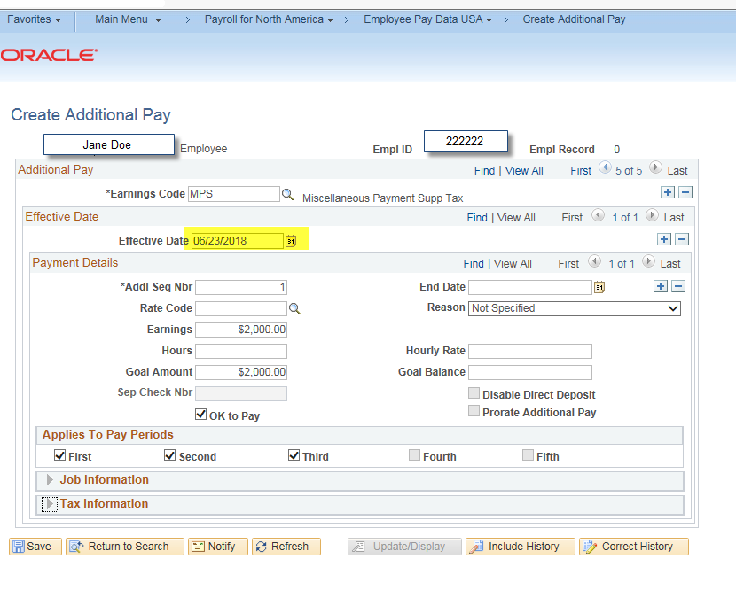

Click on the Tax Information arrow. Before the change.
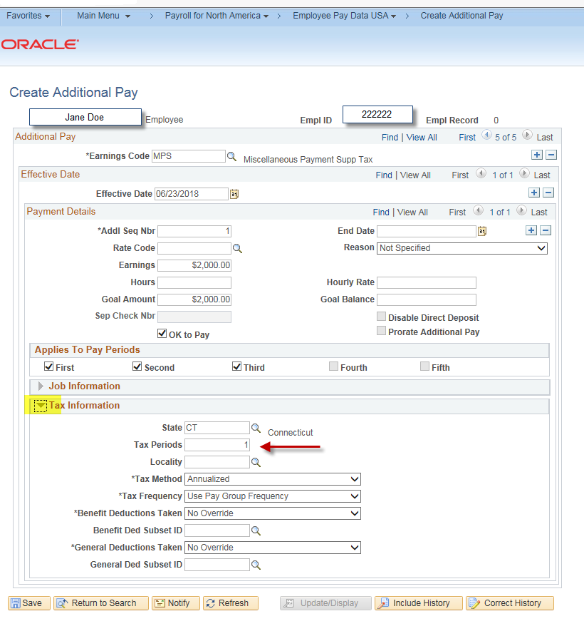

Change the tax period per the employee’s request. Save the page.

