The Furlough Processing page was developed to assist Time and Labor agencies with multiple entries of additional pay transactions for Furlough Days where the effective and end dates are the same. This process cannot be used by Limited Scope agencies. The new process and resulting report is available to users with the Agency Payroll Specialists role.

NOTE: This process cannot be used for employees who will have Combo Code overrides on the Timesheet. The Additional Pay record for those employees will automatically be charged to the override Combo Codes entered on the Timesheet unless the default or another funding source is entered on the Additional Pay record. In order to enter a funding source you must manually enter the Furlough Additional Pay transaction.

- Access the process through the following path:

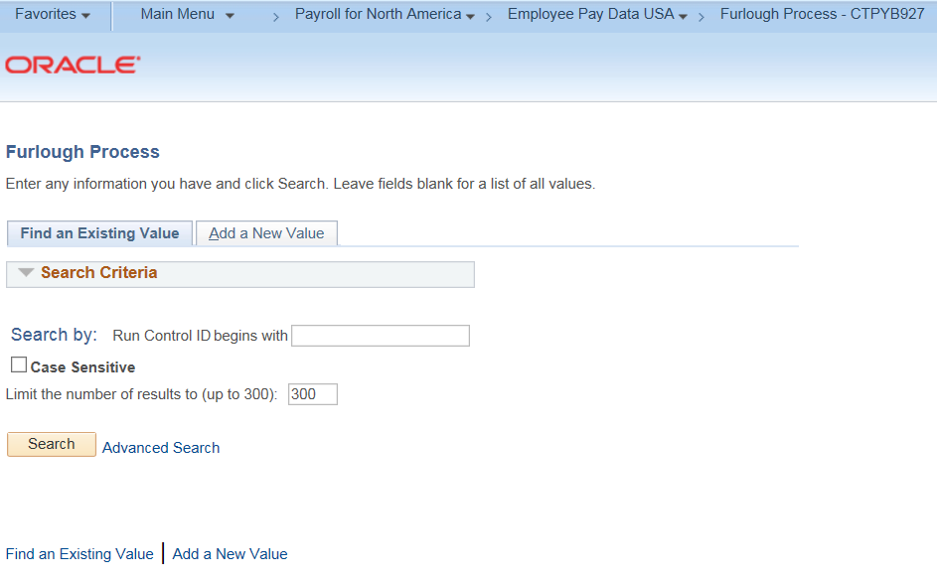

- Click on Add a New Value tab.

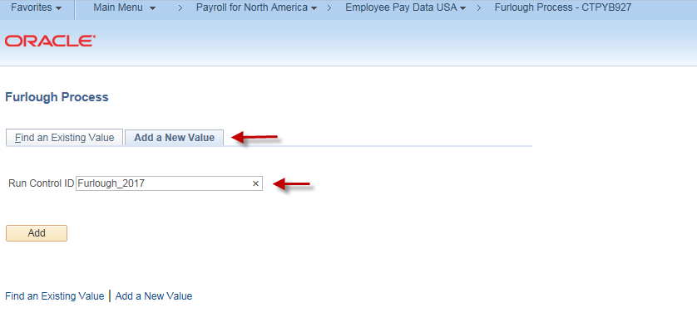

- Name your report (i.e Furlough_2017)
Special Notes:
Run Control ID is the name of your process (i.e.,Furlough_2017)

Users should name the run control in such a way that they can identify or reuse it later (i.e., business unit, facility, location code, etc.). Run Control IDs cannot contain spaces; an underline
( _ ) can be used to separate characters, if needed

- Click ADD to access the Furlough Process.

- The Effective and End Dates MUST be the first and last day of a pay period, respectively. For reductions that will be taken across a fiscal year enter the start date of the pay period in which the reduction will first be taken as the Effective Date. The End Date is the last day of the pay period in which the final reduction will be taken (i.e., Effective Date 08/18/2017, End Date 06/07/2018).

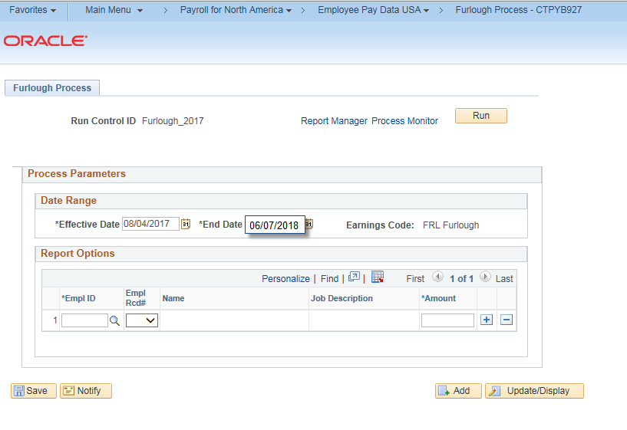

NOTE: The employees processed on this page MUST be only those employees whose Furlough pay reduction will occur for the dates entered. A separate Run Control page must be created for employees having reductions with other dates.

7. EmplID: Enter the employee’s ID (i.e., 123456).

8. Tab out of the field and the Employee’s name and job description will display.

9. Empl Rcd#: Verify the defaulted value. Use the drop down box to select another record number, if the default value is incorrect (i.e., choose 1 instead of 0).

10. Amount: Enter the amount of the Furlough pay reduction as a negative (-) amount (i.e., -50.00).

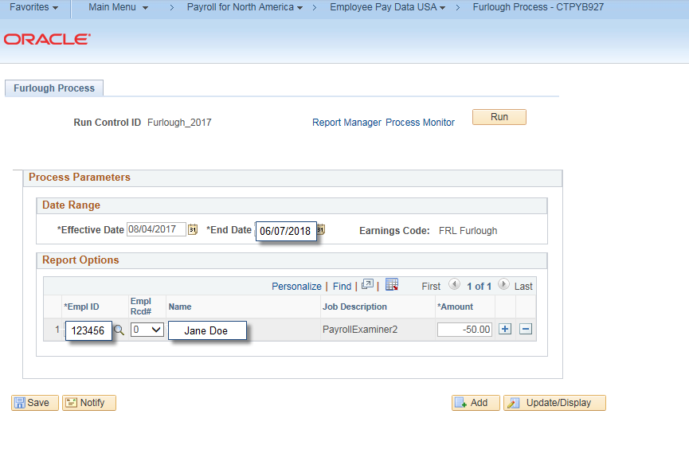

Special Notes:
- Refer to Office of Labor Relations on how to calculate the reduction in pay amount.
- The page will not accept positive entries or negative ones in excess of -$999.99.
- Employees who use an override Combo Code on the Timesheet must NOT be selected for this process. The Furlough Additional Pay transaction must be manually entered with either the default funding source or another funding source. Failure to do so will result in the Furlough transaction being charged to the Timesheet’s override Combo Code.

11. Click to add a new row.

12. Complete steps 7-10 to process additional employees.

Special Note:
- No more than 200 employees should be processed on a single Run Control ID to avoid performance issues.

13. Click SAVE to save the Run Control ID and the criteria indicated.

14. Click RUN to run the process.
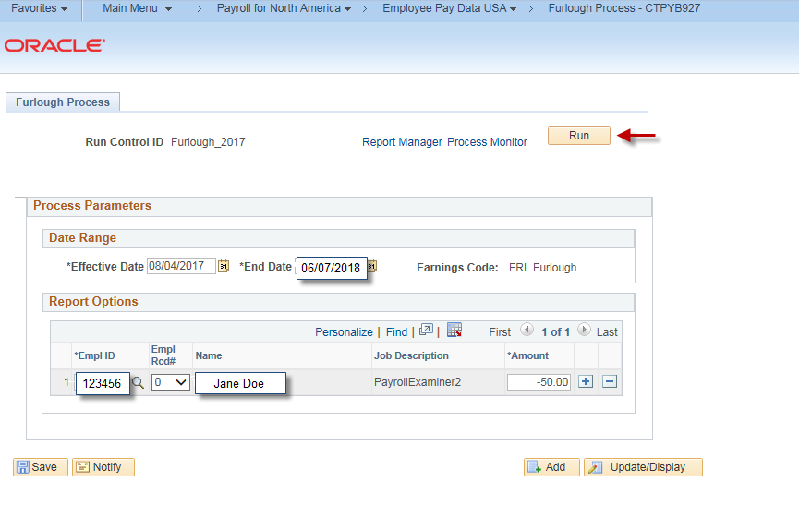

Special Note:
- This process will create an Additional Pay record using the employee’s default funding source. If a different funding source is required, a manual entry must be made in Additional Pay.
- Employees who are terminated, on a leave of absence or on a paid leave as of the 1st day of the pay period will not be processed. Employees having a Termination, LOA or Paid Leave status processed on a day during the pay period will have an additional pay record created.

15. Click OK.
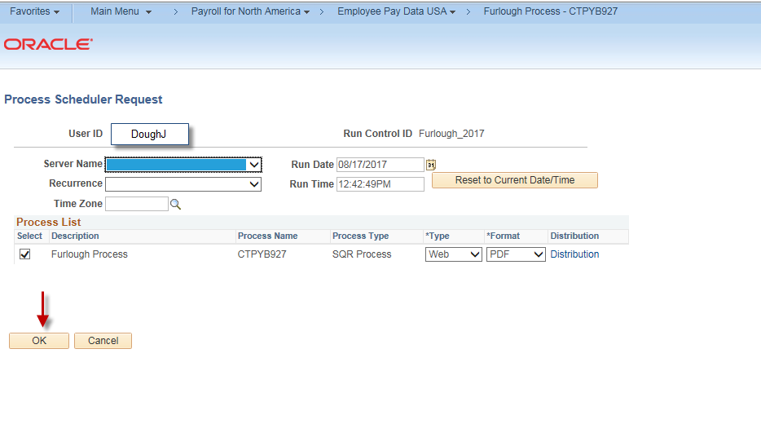

Special Note:
- The necessary fields auto-populate the information you need to run the process and view your report.
- Clicking will insert a row in Additional Pay for the dates, employee (s) and amount indicated on the Run Control page.

16. Click Report Manager.
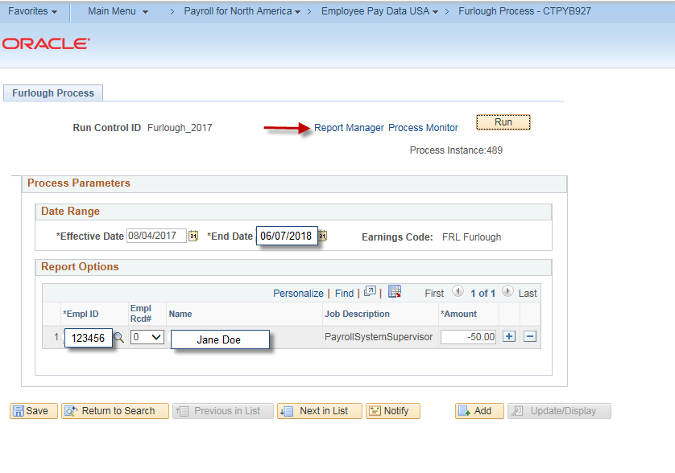

Special Notes:
- The Report Manager link takes you to the Reports page, from which you can click the Report link to view your report.
- The Process Monitor link takes you to the Process List page, from which you can view your report's Run Status: Queued, Processing, Success, Error or No Success.
- Note the Process Instance number as this may help you search for your report on the Report Manager or Process Monitor pages later.

17. Click the Report link (i.e.CTPYB927).
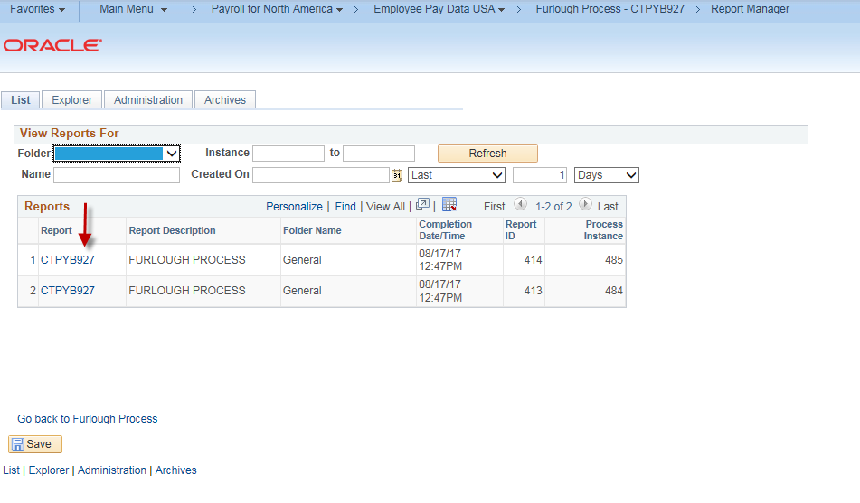

Special Notes:
- When your report has successfully run, its link will populate in the Report column.
You can click until your report link populates.

18. Click the link under the Name column to view your report (i.e., CTPYB927_27.PDF).
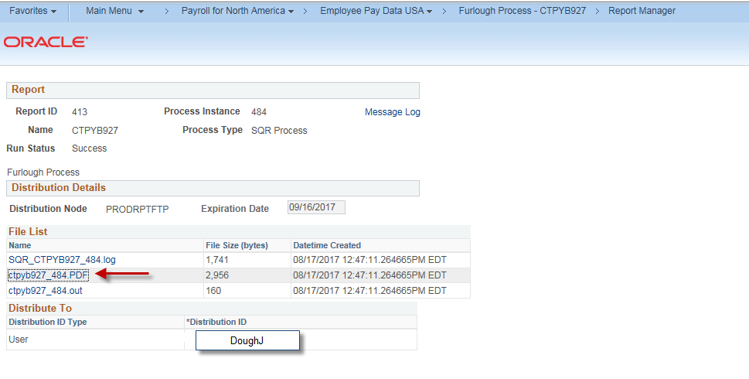

Special Notes:
- File List: Your report will be listed here.
- Your report will be saved in Core-CT for 30 days. You should print the report or save it to a local or agency network drive to retain a copy for auditing purposes.

Print the report or save it on a local or network drive.

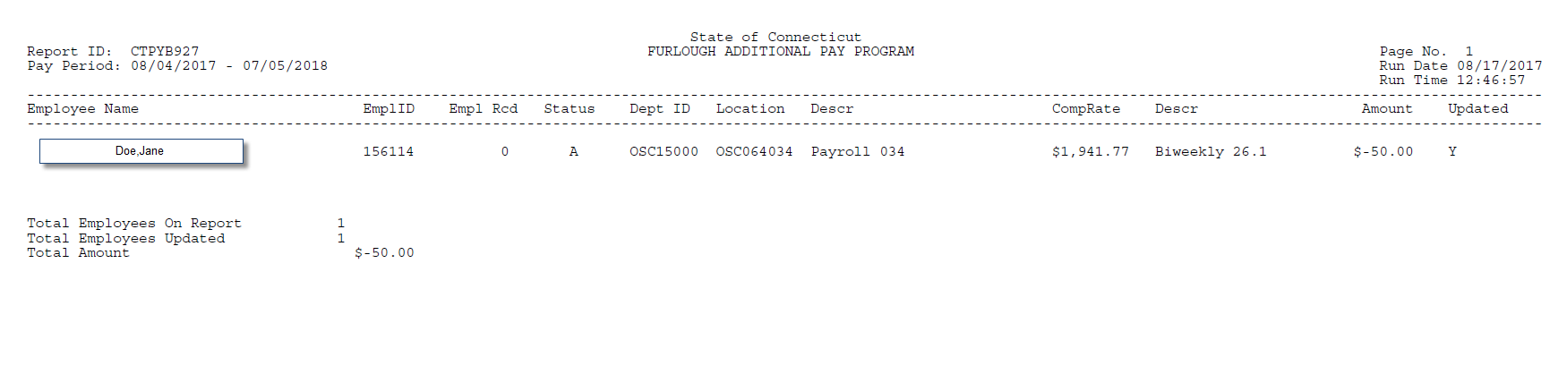
19.

Special Notes:
- The employee’s CompRate from Job Data is printed on the report to assist in auditing the reduction amount.
- Agencies need to verify that all employees were updated by first comparing the Total Employees on Report to the Total Employees Updated. If these numbers are not equal check the Updated column for each employee to determine the employee (s) who was not updated as indicated by ‘N’.
- Incorrect amounts need to be shut off in Additional Pay by entering a new row for the FRL earnings code. Enter the SAME date for the Effective Date and End Date. Use a date that is one day later than the original entry’s Effective Date (for example, 8/18/17 original entry – new row 8/19/17).
- Employees not updated by this process who need to have a Furlough reduction processed will need to be manually entered.

