**PFMLA Implementation**

**State of CT Non-Union Employees**

**PFMLA Go-Live Date**

* Check Date 4/23/2021

**PFMLA Eligibility will be administered by Core-CT**

* Agencies are not required to enroll employees in the PFMLA Tax. Core-CT will administer the PFMLA tax enrollment and collection based on the below Definition of a Non-Union Employee.

**Definition of a Non-Union Employee**

* All employees who are NOT in the following Bargaining Unit/Union Codes:



**The PFMLA Eligibility Flag: State Tax Data Page in Core-CT**

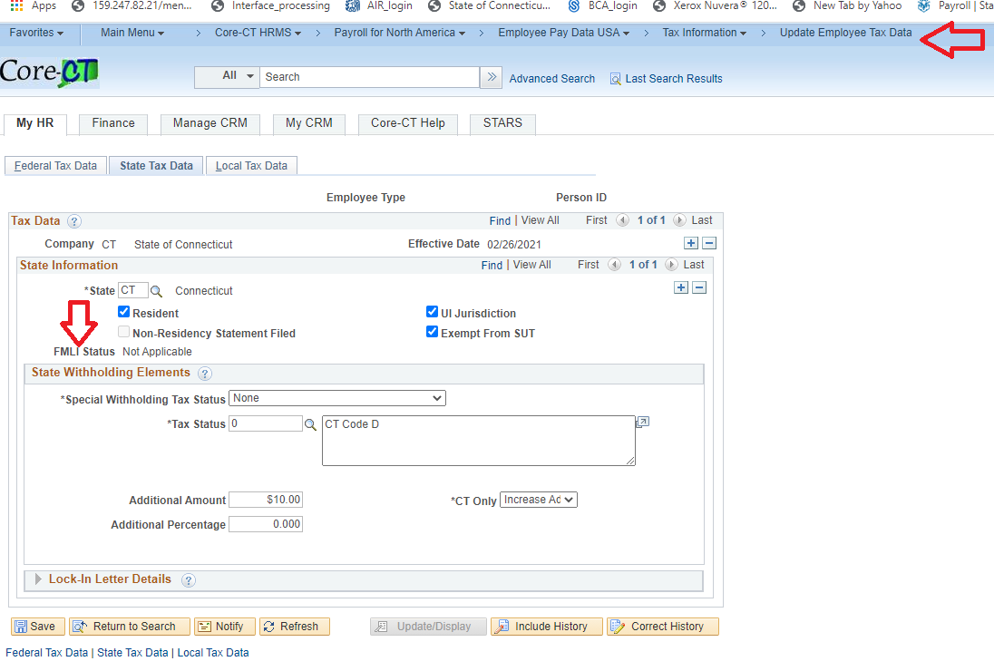

*The FMLI Status Flag will be greyed out for Agency Users (Administered by Core-CT). It will read as ‘Subject’ for PFMLA Tax eligible employees.

**Current Year Standard PFMLA Tax Amount**

* **The standard PFMLA Tax Amount will be ½ of 1 %.**

**There will be a Retroactive PFMLA Tax Amount dating back to January 1st, 2021**

* The retroactive PFMLA Tax payback amount will be capped at 1% per paycheck.

|  |  |
| --- | --- |
| Sample: Non-Union Employee PMFLA Tax deduction with Retroactivity | |
| **Payroll Periods**  **1, 2, 3 & 4:** | **Employee earned $1,000 in eligible wages, missed $5.00 each pay period in PFMLA tax. (at 1/2 of 1 %)** |
| **Payroll Periods**  **5 & 6:** | **Employee earns $1,000 in eligible wages, a total of $15.00 is deducted each pay period. Breakdown: $5.00 (standard ½ of 1% rate) + $10.00 (retroactive 1% max rate) = $15.00 (1.5% in total)** |
| **Payroll Period 7:** | **Retroactivity payments are complete. Employee earns $1,000 in eligible wages, a total of $5.00 is deducted.** |

**Earnings Base for PFMLA**

* PFMLA tax will be based on all Social Security Eligible earnings. If an employee reaches the current social security maximum (2021 = 142,800), the PFMLA will discontinue for the remainder of the calendar year.

**Multi-Job Employees who are both Non-Union and Union, where Non-Union job is PRIMARY**

Employees who are designated as non-union on their primary job will be subject to the PFMLA tax on the non-union job only (the secondary, union designated job is not subject to PFMLA). Reminder: PFMLA eligibility is administered by Core-CT. Agencies **will not** have to designate PFMLA eligibility for single or multi job employees.

**Multi-Job Employees who are both Non-Union and Union, where Non-Union job is SECONDARY**

For the remainder of calendar year 2021, multi-job employees who are designated as union on their primary job and non-union as their secondary job (or jobs), will NOT be subject to PFMLA. This group of employees will be subject to PFMLA beginning in calendar year 2022 (prospectively). Reminder: PFMLA eligibility is administered by Core-CT. Agencies **will not** have to designate PFMLA eligibility for single or multi job employees.

**PFMLA on Check Stub**

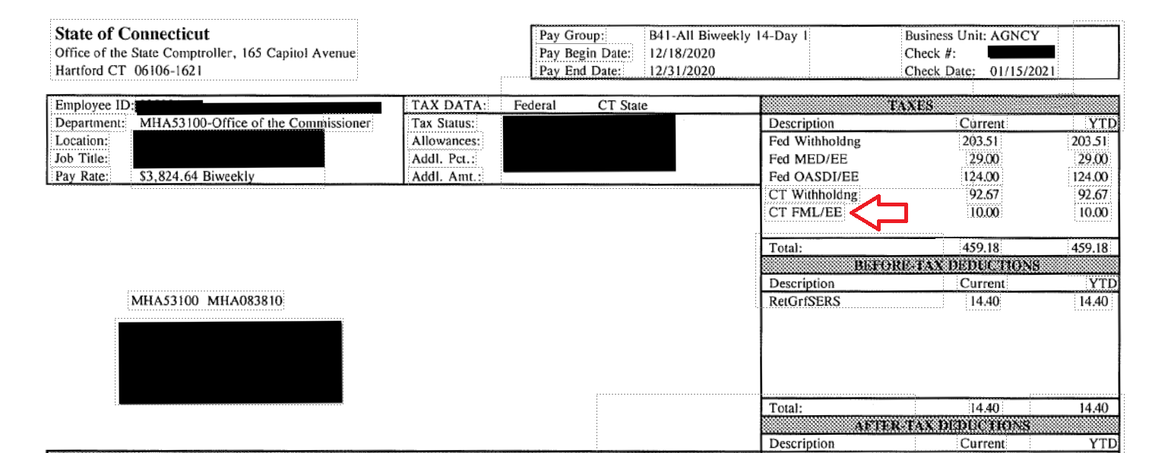

**PFMLA on Direct Deposit Stub**

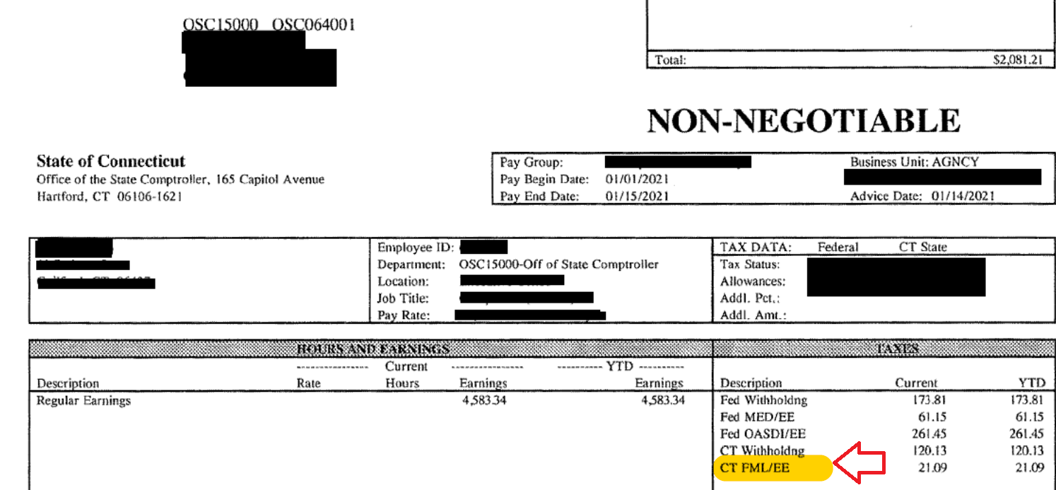

**Queries for fall out of PFMLA Assignment Programs**

All employees will be assigned a PFMLA status based on primary job criteria. Employees that have only one job and are union will default to “Not Applicable”. For those that have non-union jobs or are multi employed, Core-CT has created a process, job CTPYFML2, to assign the status. Based on this process, Active and Pension Payroll Services will be running queries to provide to the agencies. These queries will show employees that need a further look and possible manual intervention.

The two queries are “No Primary Job” and “Multi Employee Transfers”. These queries will be run every day except confirm day.

For those employees that have no Primary Job assigned, agencies will need to review the results. If the primary job can be changed, agencies will be responsible for that change. Once the change is made, the Program, CTPYFML2, which runs every night except confirm day, will then assign that employee the correct PFMLA status. Below is an example of the query results for “No Primary Job”.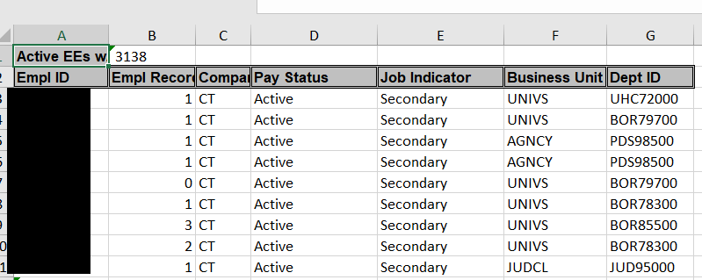

If the primary job cannot be changed, as is the case when an employee is a retiree as well as a rehired employee, the PFMLA status on Update Employee Tax Data, State Tax Data tab will need to be manual set by Active and Pension Payroll Services. Another example is when an employee works for multiple agencies and has no primary job. Agencies will follow the set guidelines for these cases and then contact Active and Pension Payroll Services for correction if need be.

Regarding the Multi Employee Transfers query, this is for agency review as well. This query will show all multi transfers by the employee and the PFMLA status. The results of this query are not necessarily an indication of incorrect PFMLA status but should be review by the agency. In some cases, as in retro transfers, the PFMLA status is incorrectly set. In these cases, a manual fix will be needed, and agencies should send in the request. An example of the results from this query are below.

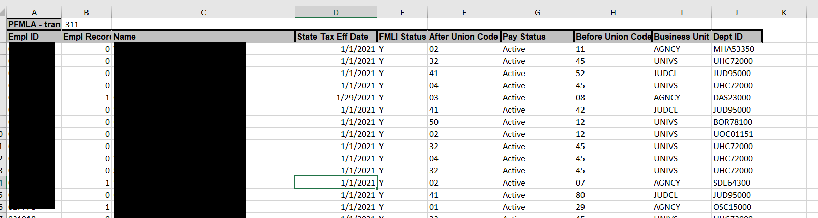

**PFMLA Core-CT Processes**

There are some special processes that Core-CT payroll will run for certain circumstances regarding PFMLA in order to calculate the employees check(s).

For those employees that owe PFMLA and to catch up those employees, Jobs CTPYB944 - PFMLA Tax Balance Calculation and CTPYB943 - PFMLA Tax Balance Adjustment will run. Both of these jobs will run only once. For the Tax Calculation Job, this program calculates the initial tax balance for employees who have not been paying PFMLA based on the employees taxable gross. This program loads the amounts to a staging table and produces a report, it doesn’t directly update the Tax Balances.

Once that is done, the Tax Balance Adjustment program will run. This program updates employees tax balances. You will see the entry here in Balance Reviews, Taxes, under the Tax Balance Adjustments

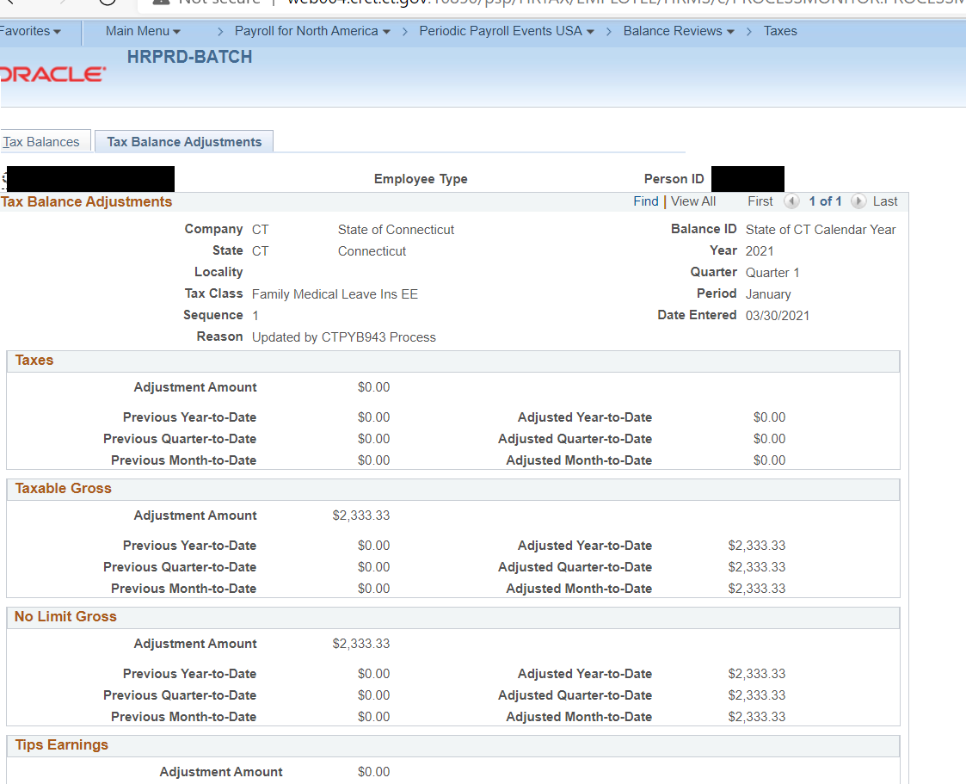

Related to the above processes, the job named PFMLA Auto Payline Tax Limit CTPYB945 will reduce the PFMLA tax to the 1.5 limit. This is needed for those that owe prior tax, but a limit is set so that the PFMLA Tax is not greater than 1.5% of their current earnings. This job will run during Core-CT Payrolls confirm day process.

The report is for example purposes only, agencies will not receive this. But agencies and employees will see the results on the employees checks.

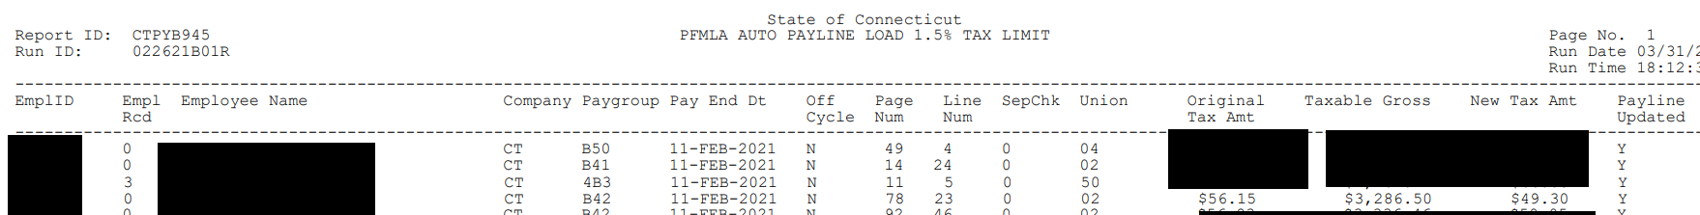

The employee’s check based on the CTYPB945 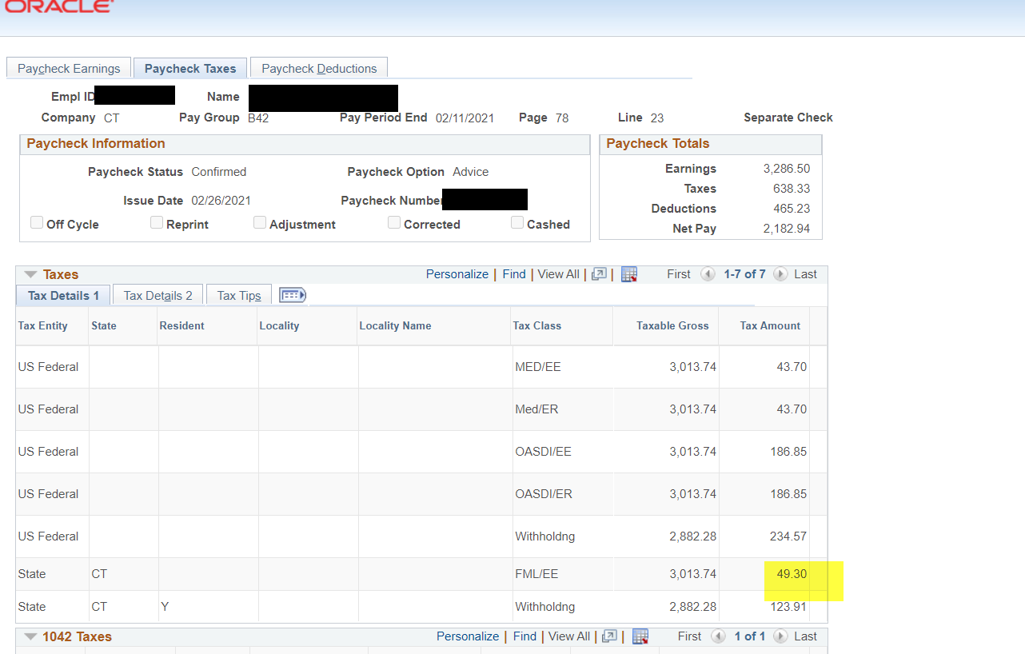

For multi employed that have Primary Non-Union and Secondary Union jobs: These are employees that pay PFMLA tax on their primary Non-union job, but do not pay the PMFLA tax on their secondary union job.

** Please make note that employees who have a Union job that is primary and a Non-union job that is Secondary will not pay PFMLA taxes on their non-union job this year. The roll out for this is slated for January 2022.

The new program, **PFMLA Auto Payline Multi Job CTPYB942,** will create Payline adjustments that zero out the union job record for PFMLA taxes. This job will run during Core-CT confirm day process.

Below is an example of the report for CTPYB942 and what it will look like on the employee’s check. Again, agencies will not be receiving this report, as this is for explanation use only. Agencies and employees will see the results on the employees checks.

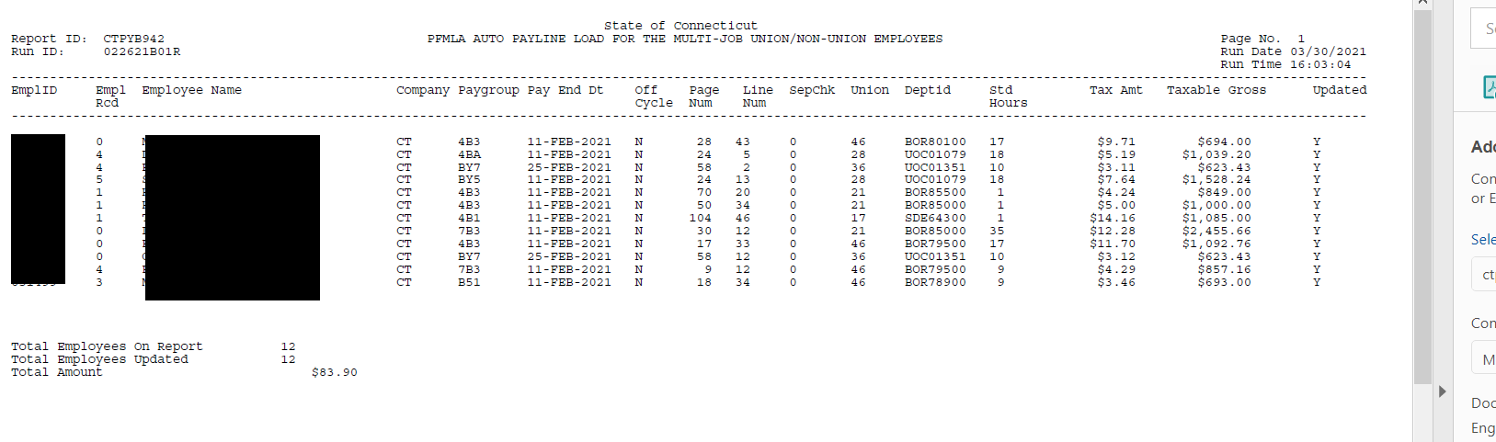

The employee’s union paycheck will have the tax removed. The taxable gross shown for FML/EE will be removed via a separate process, CTPYB943.

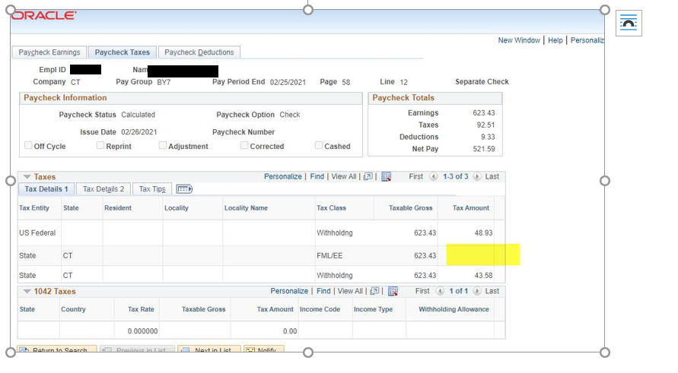

The employees non-union check will remain untouched and will have the PFMLA tax withheld.

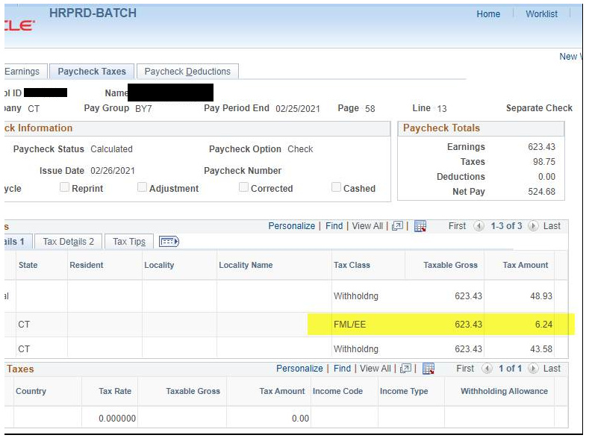

**PFMLA Q&A:**

|  |
| --- |
| **1. Is each State Agency required to register as an employer with PFMLA?**  **Answer:** No, the Comptroller’s Office has registered as employer for all State of CT employees/agencies. |
| **2. Should PFMLA tax continue against the wages of non-union employees who are on workers comp?**  **Answer:** The 0.5% is taken from the employee’s wages. If the non-union employee is supplementing its WC benefits, then the 0.5% should be taken from that payment. Not the WC benefit itself, but the supplemental earnings are subject to the 0.5% tax. |
| **3. Are non-union employees who are not subject to Social Security tax, subject to PFMLA?**  **Answer:** Yes, the non-union employees are subject to PFMLA tax regardless of what their Social Security flag is set to in Core-CT (including Medicare Only and Exempt). |
| **4. A non-union employee transfers to a union job effective with the check date of April 23rd, 2021. The employee owes PFMLA tax for the 7 missed pay cycles from January through the check date of April 9th. Will the retroactive PFMLA tax be included in the union job payment when the PFMLA tax process starts on check date April 23, 2021?**  **Answer:** Yes, the retroactive process will deduct the PFMLA tax that is owed for the 7 previous payroll cycles and will be capped at 1% per paycheck. No current PFMLA tax will come out of the employee’s union (job) payment, but the check will include a 1% capped retroactive PFMLA tax. The retroactive tax will continue to be deducted until the union employee pays the total amount owed for the 7 missed cycles while he/she was a non-union employee. |
| **5. Are Quasi/Non-Union employees subject to PFMLA tax?**  **Answer:** Yes, The CT Paid Leave Act was deliberately very expansive and applies to all employers who have one or more employees. Not currently covered under the Paid Family and Medical Leave program are unionized employees of the State of Connecticut and employees of the federal government, a municipality, a local or regional board of education, or a non-public elementary or secondary school. |
| **6. Should PFMLA tax apply to employees who are non-dues paying bargaining unit members?**  **Answer:** No, not currently |
| **7. If a non-union employee lives outside of CT, should the employee be subject to PFMLA tax?**  **Answer:** Yes |
| **8. Can an Agency change an employee’s PFMLA eligibility in Core-CT?**  **Answer:** No, the eligibility is based on the employee’s bargaining unit/union code. If a non-union employee transfers to a bargaining/union code job and is now a bargaining unit employee, the PFMLA indicator will be automatically changed by Core-CT and the PFMLA tax will discontinue. |
| **9. Will rehired retirees be subject to PFMLA tax as they would fall into the non-union category?**  **Answer:** Yes, because they are state employees receiving wages who are not in a union (rehired retiree records are typically set up with union code 04). OSC/APPSD will be manually changing the PFMLA eligibility flag to subject for these employees until the program can be modified to accommodate this scenario. |
| **10. Are Non-Union employees who are Students and Non-Resident Aliens subject to PFMLA?**  **Answer:** Yes. |
| **11. Student Employees cannot have sick time (Public Act 11-52) charged to work study positions. Would a PFMLA tax also be allowable under the Federal Work Study regulations?**  **Answer:** Yes, Per CT DOL: Although federal work-study programs are technically a type of financial aid, they allow you to earn money to pay for expenses instead of taking out a loan. Therefore, the IRS looks at these earnings as taxable income. This is because the earnings aren’t directly applied to tuition or other qualified education expenses. Instead, the student receives the money as a paycheck, just like any other job. Students can use this money for whatever they see fit, such as offsetting cost-of-living expenses. |
| **12. Do employees who retired on January 1st, 2021 owe for the missed payroll cycle of PFMLA tax?**  **Answer:** No, the contribution obligation applies only to individuals working on or after 1/1/2021. PFMLA has determined that we are not authorized to take the taxes from individuals who did not work after 12/31/2020, even if their final paycheck was issued after 1/1/2021. |
| **13: If a union employee is transferring to a non-union job title/bargaining unit code, will there be a PFMLA retroactive tax for this employee that dates back to 1/1/2021?**  **Answer:** No, the PFMLA tax will only be taken from the date of the transfer into the non-union job title/bargaining unit code forward (prospective only). |
| **14. Is the PFMLA standard tax and retroactive maximum calculated on every payment that a non-union employee receives?**  **Answer:** Yes, the PFMLA standard tax and retroactive maximum will be applied to all of the payments (against social security eligible earnings) a non-union employee will be receiving. See question #4 regarding if there is a transfer into a union job related to this scenario. This excludes Non-Reportable payments, as Non-Reportable payments are not subject to social security. |
| **15. What if a non-union employee transfers to a union position in the middle of a pay period?**  **Answer:** No PFMLA tax will be taken since the employee is in a union bargaining unit code prior to the end of the pay period. If the opposite was true and the employee transferred from a union position to a non-union position, the PFMLA tax would be taken. |
| **16. Are external wages (external to Core-CT wages) factored into the FICA/social security max?**  **Answer:** No, external wages are not factored into the FICA/Social security max. A non-union employee will only stop contributing towards social security and PFMLA when they reach their social security maximum based on Core-CT FICA/social security wages. *More information will be available on how PFMLA refunds will be processed soon.* |
| **17. How will employees who left state service (e.g. terminated, retired after January 1st, 2021, etc.) and have a PFMLA tax balance pay back the PFMLA retroactivity since they are no longer receiving pay in Core-CT HRMS?**  **Answer:** OSC APPSD will be running queries on a bi-weekly basis to determine this population of individuals who owe PFMLA tax. *More information will be sent to the agencies regarding this process as soon as possible (which will include who the checks should be made out to, where the checks should be sent, etc.)* |
| **More information will be available on this topic as soon as possible.**  **You may also refer to the CT Paid Leave Authority Q&A which answers many common questions.  The document can be found here:**  <https://ctpaidleave.org/s/frequently-asked-questions?language=en_US>  Additional questions may be sent to OSC.Payroll-Auditors@ct.gov |