Reset a Forgotten Password Job Aid

Navigate to the eSupplier portal using the link on the Comptroller’s website in Vendor Resources. http://www.osc.ct.gov/vendor/index.html

Click on the Forgot Password? link.
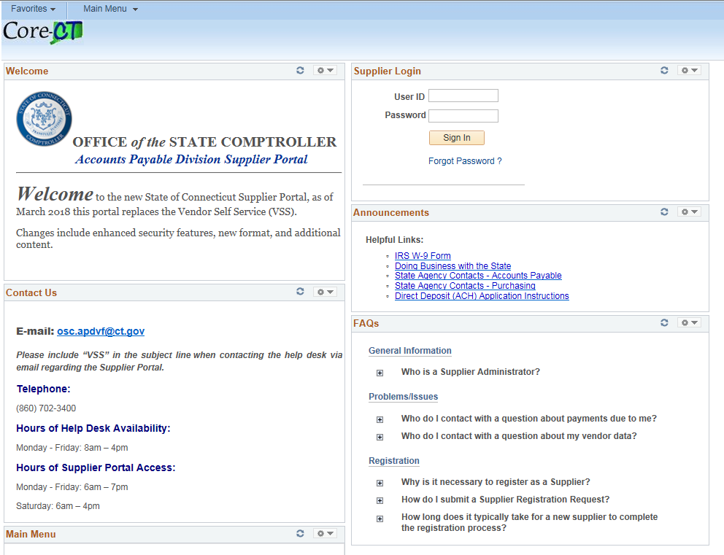
Enter your User ID and click Send.
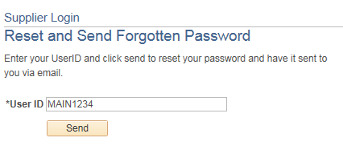

Click the OK button to return to homepage.
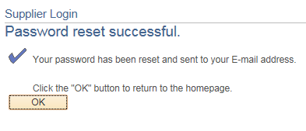
You will receive an email with a temporary password.

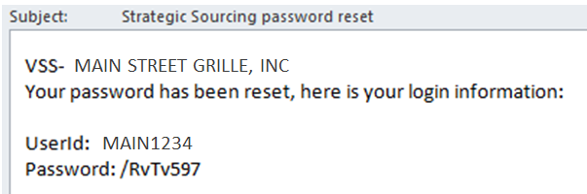

Return to the log in screen and enter your User ID and the temporary Password.
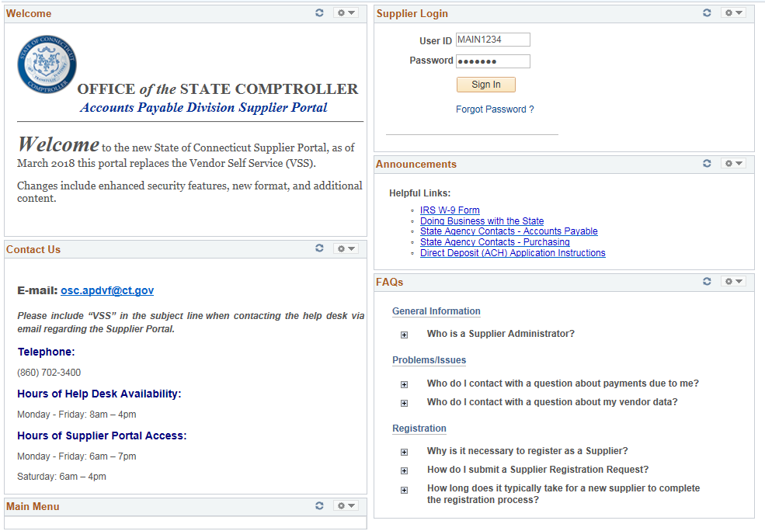

You will be logged in to the Supplier Homepage.
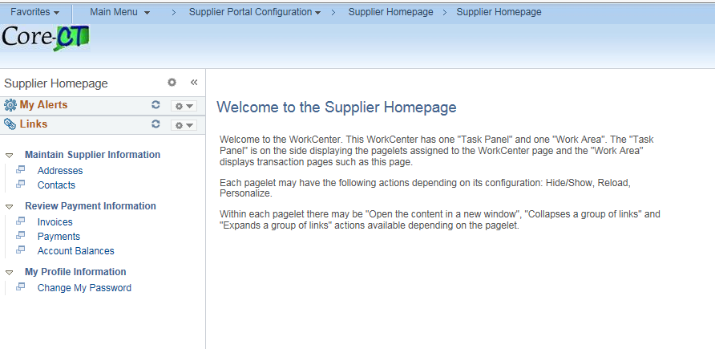
You may continue to use this password, or reset it to one of your choosing.

