Administrator Job Aid

From the Supplier Homepage page, click on the User Profiles link.
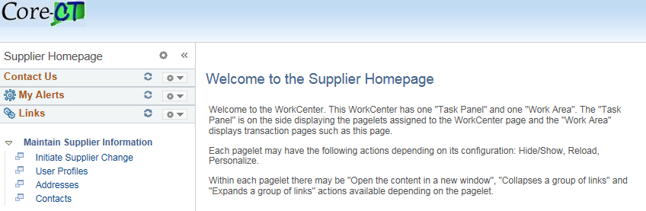

Click on the Add a New Value tab.
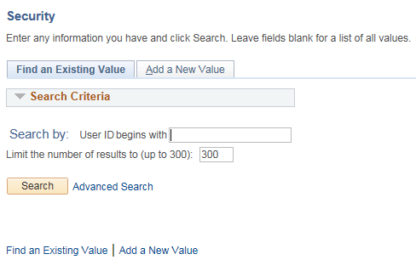

Enter the User ID for the New User Profile and then click Add.

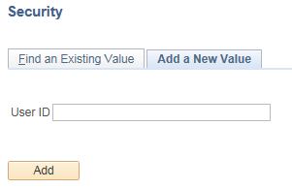

Enter the User Profiles Description.
Enter the Operator Password and repeat for Confirm Password.
Enter the User’s E-mail Address.
Set the Currency Code to USD.
Set the Rate Type to Current.
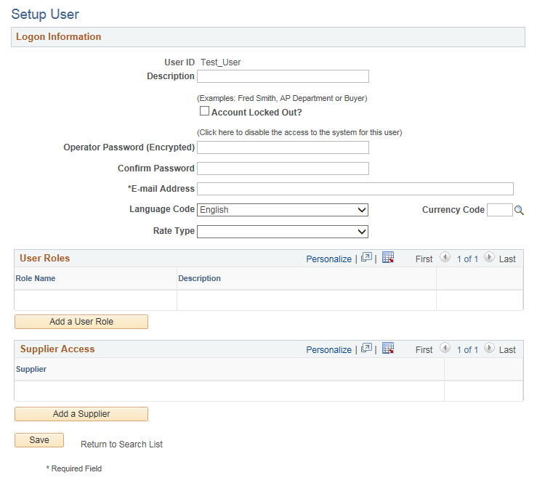

Click on the Add a User Role button.
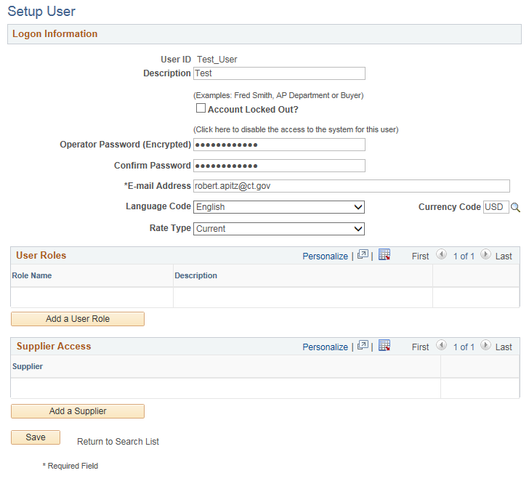

Select both of the User Roles and then click OK. If the User requires Supplier Contract Management or Budget Workbook roles, contact the State Agency to fill out the appropriate security forms. Those additional security roles will be added by the state agency.
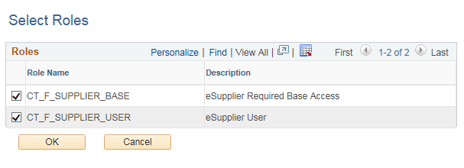

Click on the Add a Supplier button.
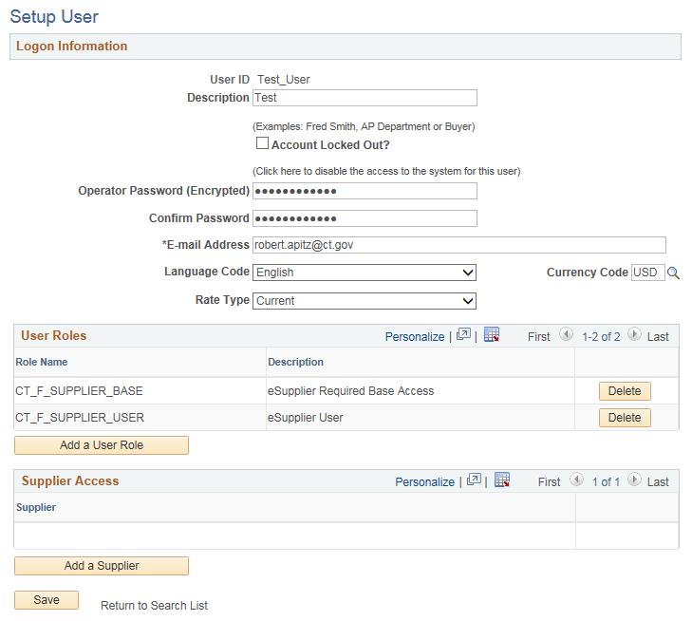

Select the Supplier checkbox and then click OK.
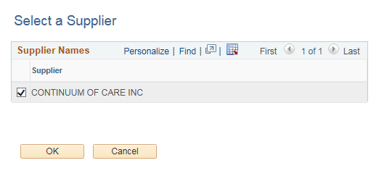

Review all entered data and click Save.
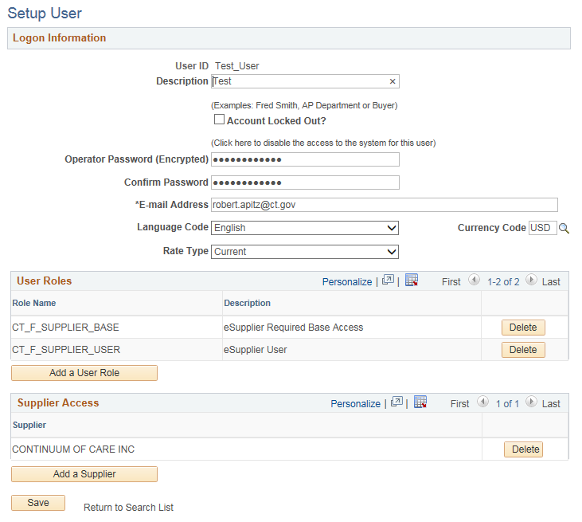

To submit an update request for an address or contact, navigate to Initiate Supplier Change using either the navigation bar or left hand link.
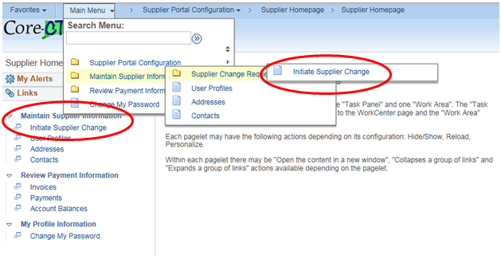

On the company profile train stop you may update the Payee Name, Profile Questions, and Add an Attachment. Only enter information for those fields that are changing, any field that is not updated will remain the same in your eSupplier profile.
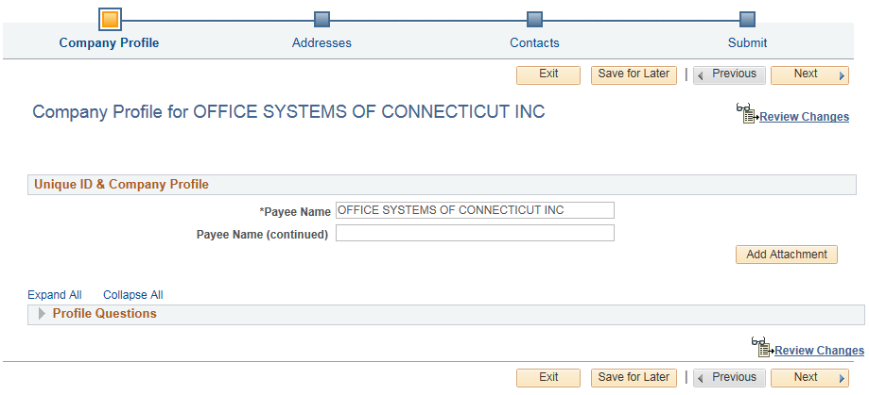

Use the Add Attachment link to provide any documentation that supports the change request.

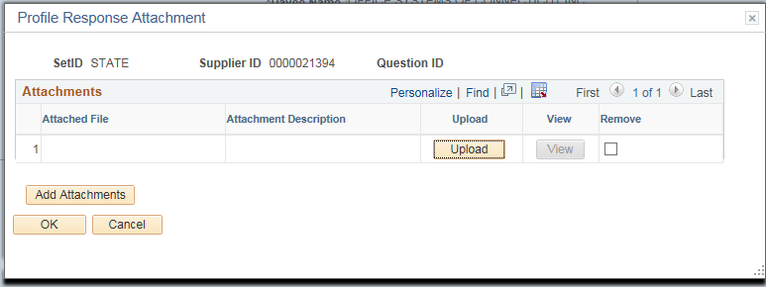

To view all of the profile questions click on Expand All or use the arrow to expand the section.
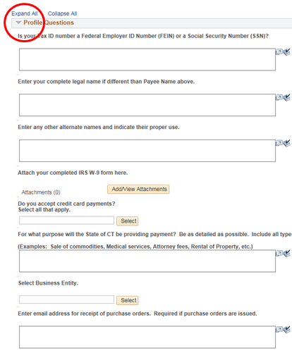

The next stop is the address page. Your eSupplier profile may contain several addresses. Some addresses will also contain alternate supplier names. The description field will display the delivery line of the address or the alternate supplier name. A description of 1099 Address indicates that is the address which contains the legal business name if different from the payee name in the company profile.
To add a new address, click on the Add New Address button. The Address Information window does not permit the entry of alternate names. If an alternate name is required, you may enter that information in the profile question designated for alternate names or in the comments section of the update request.
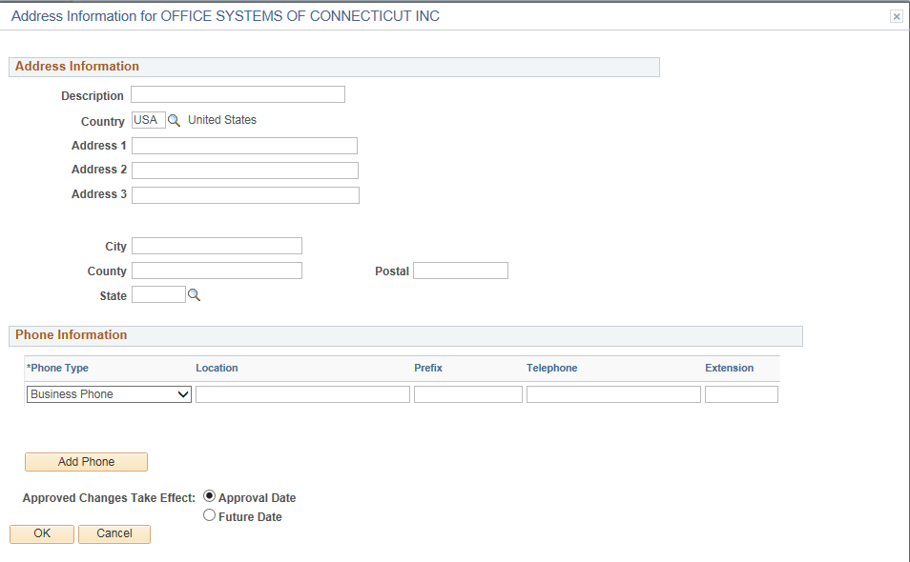
To request a change to an existing address, click on the edit icon.
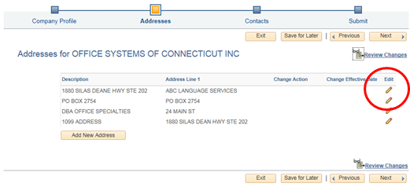

With the Address information box open you may change the address information, change or add phone numbers associated with this address, or add additional phone numbers. It is not necessary to update the description; this will be formatted by the Office of the State Comptroller during the approval of your request.
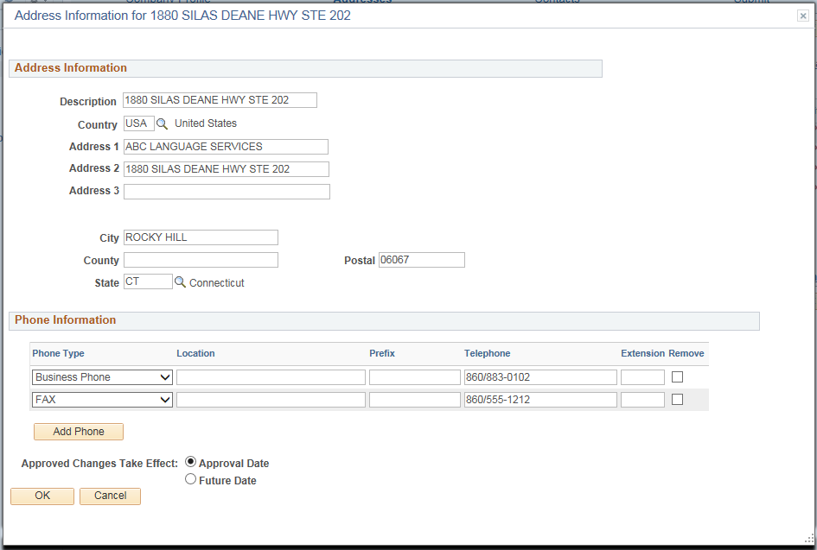

The address information box does not display the alternate names. These names may be viewed in the address inquiry section of eSupplier.
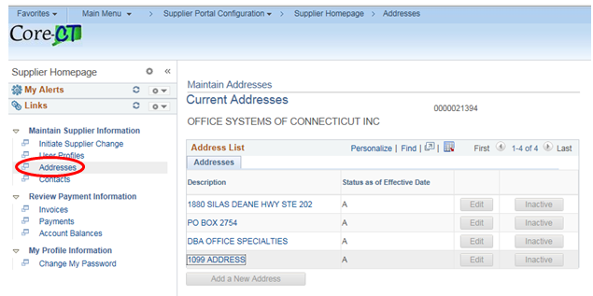
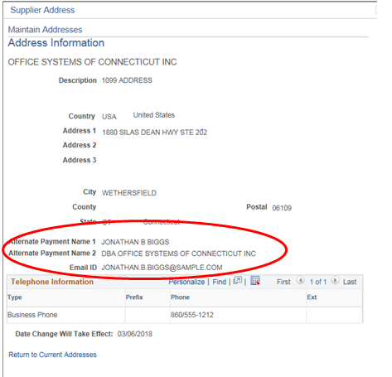

The next stop is for contact information. In this area you may update existing contacts or add a new contact.

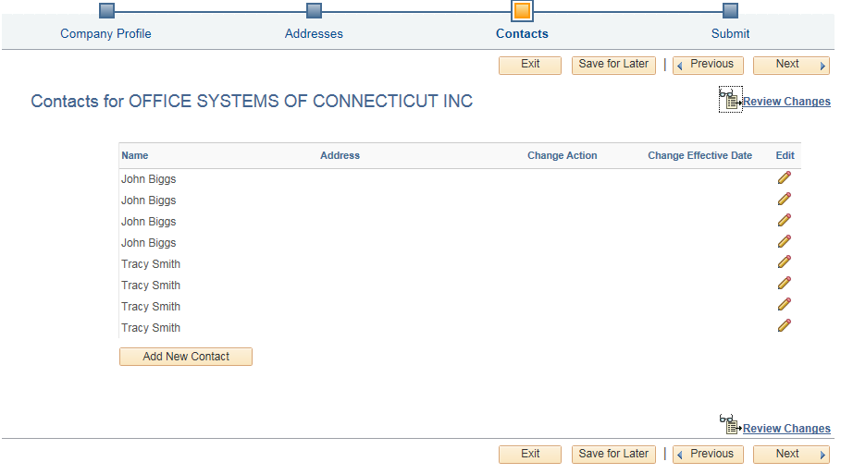
To add a new contact, click on the Add New Contact button. Always include the First Name, Last Name, Email Address, and Contact Type. You may add additional phone numbers to the contact by selecting the Add Phone button.
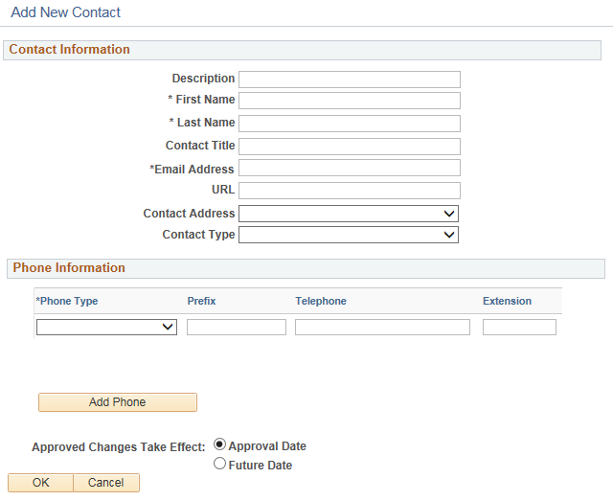

To update an existing contact, select the contact using the edit icon. Only enter information for those fields that are changing, any field that is not updated will remain the same in your eSupplier profile.
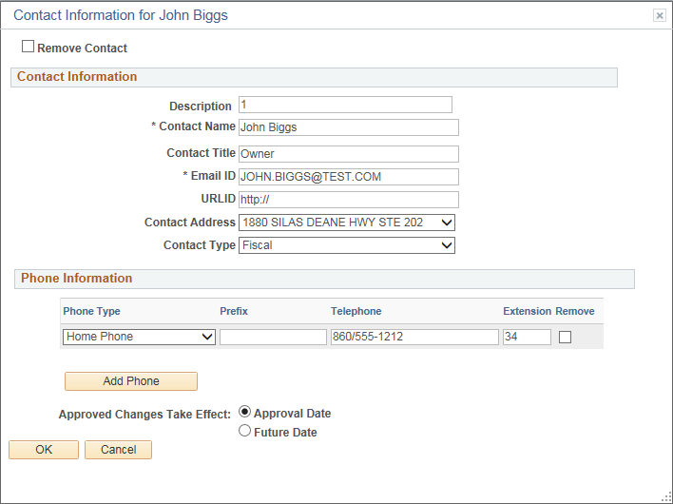
To remove a contact, select the contact using the edit icon, select the Remove Contact checkbox, and then click OK.

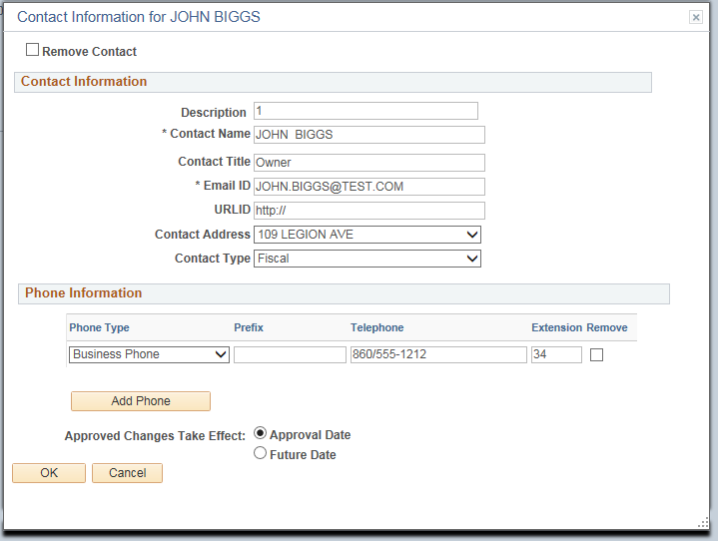
Changes to addresses and contacts may be future dated by selecting Future Date and entering a date when the changes will be effective.
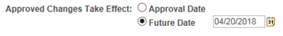

The final stop is the Submit page. Use the review button to verify the requested changes to be made. If a change is needed, return to the appropriate trainstop and make any necessary changes. Once the review is complete, enter the Audit Reason Code of Supplier Approval, enter any additional comments in the Comments field, select Confirm Changes, and then click Submit. Your request will be submitted to the Office of the State Comptroller for review and approval.
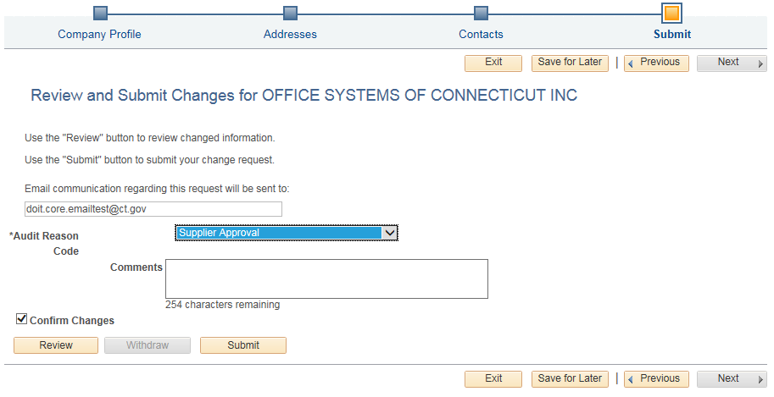

Your request will be displayed in eSupplier as Pending Approval. If you have any questions about the status of your request, contact osc.apdvf@ct.gov and include the request ID in your email.
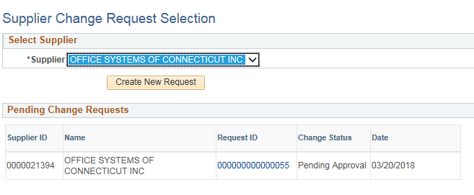
You will be notified by Email when your request has been approved.

