Frequently Asked Questions – Supplier Communications and Roles
(Note: Supplier and Provider are one in the same)
- What has the Supplier received from OSC-APD, Core-CT, etc.?
ANSWER: There were three different communications that were sent to Suppliers, dependent upon the Supplier within a week of implementation (3/26/2018).
Existing Suppliers (current Vendor Self-Serve Suppliers, not just Providers), to announce the new look for the eSupplier Portal. They were sent the following communication:
The State of Connecticut Core-CT eSupplier portal is now live. VSS/eSupplier has a new format and also provides increased security. You will still be able to view your invoice and payment information as before.
Please log in to eSupplier https://corevss.ct.gov/ using your existing VSS User Id [Insert userid here] and password. All users will be prompted to reset their password on this first log in. If you have forgotten your password, you may use the “Forgot My Password” feature to receive a temporary password via email.
http://www.core-ct.state.ct.us/financials/vendor/doc/Reset_A_Forgotten_Password_Job_Aid.docx
http://www.core-ct.state.ct.us/financials/vendor/doc/Non_HHS_Vendor_Self_Service_Overview.docx
For additional assistance, please reply to this email or call the VSS/eSupplier help desk at (860)702-3400.
Existing HHS Providers (current Vendor Self-Serve Providers)
they were sent the following communication:
The State of Connecticut Core-CT eSupplier portal is now live. VSS/eSupplier has a new format and also provides increased security. You will still be able to view your invoice and payment information as before. Additional functions will be available for those with designated roles in Supplier Contract Management. You have been identified as the Supplier Administrator for your profile in our system. Please notify us if this is not the correct contact for this purpose.
Please log in to eSupplier https://corevss.ct.gov/ using your existing VSS User Id [Insert userid here] and password. All users will be prompted to reset their password on this first log in. If you have forgotten your password, you may use the “Forgot My Password” feature to receive a temporary password via email.
http://www.core-ct.state.ct.us/financials/vendor/doc/Reset_A_Forgotten_Password_Job_Aid.docx
http://www.core-ct.state.ct.us/financials/vendor/doc/Non_HHS_Vendor_Self_Service_Overview.docx
A Supplier administrator is the supplier’s designated liaison between the supplier and the Core-CT accounting system. Only one administrator is permitted per supplier and this individual will be responsible for granting access to additional users within their organization. Work with your state agency to set up security for you and other staff in your organization who interact with the state on contracts and the Budget Workbook (UCOA).
Once you have logged into VSS, the following functionality will be available to you, based on your work with your state agency/agencies:
- Update your organization’s address and contact information
- Add new users within your organization to VSS
- Collaborate on contracts (if allowed by your state agency/agencies)
- Sign contracts using DocuSign
- Manage the Budget Workbook and Reporting (if required by your state agency/agencies)
To learn more about this functionality, visit the e-learnings available on the VSS landing page under FAQs. Reach out to your state agency if you have additional questions concerning these roles.
For additional assistance, please reply to this email or call the VSS/eSupplier help desk at (860)702-3400.
New HHS Suppliers (Suppliers that were currently not on VSS/eSupplier), were sent the following communication:
The State of Connecticut Core-CT eSupplier portal is now live. You have been identified as the Supplier Administrator for your profile in our system. Please notify us if this is not the correct contact for this purpose.
Please log in to eSupplier https://corevss.ct.gov/ using your assigned VSS User Id [Insert userid here] and temporary password (password). All users will be prompted to reset their password on this first log in.
http://www.core-ct.state.ct.us/financials/vendor/doc/Reset_A_Forgotten_Password_Job_Aid.docx
http://www.core-ct.state.ct.us/financials/vendor/doc/Non_HHS_Vendor_Self_Service_Overview.docx
A Supplier administrator is the supplier’s designated liaison between the supplier and the Core-CT accounting system. Only one administrator is permitted per supplier and this individual will be responsible for granting access to additional users within their organization. Work with your state agency to set up security for you and other staff in your organization who interact with the state on contracts and the Budget Workbook (UCOA).
Once you have logged into VSS, the following functionality will be available to you, based on your work with your state agency/agencies:
- Update your organization’s address and contact information
- Add new users within your organization to VSS
- Collaborate on contracts (if allowed by your state agency/agencies)
- Sign contracts using DocuSign
- Manage the Budget Workbook and Reporting (if required by your state agency/agencies)
To learn more about this functionality, visit the e-learnings available on the VSS landing page under FAQs. Reach out to your state agency if you have additional questions concerning these roles.
For additional assistance, please reply to this email or call the VSS/eSupplier help desk at (860)702-3400.

- What does the Supplier see on the Portal?
ANSWER: The Supplier has a different login screen than State Employees, see below.
Login screen for Supplier -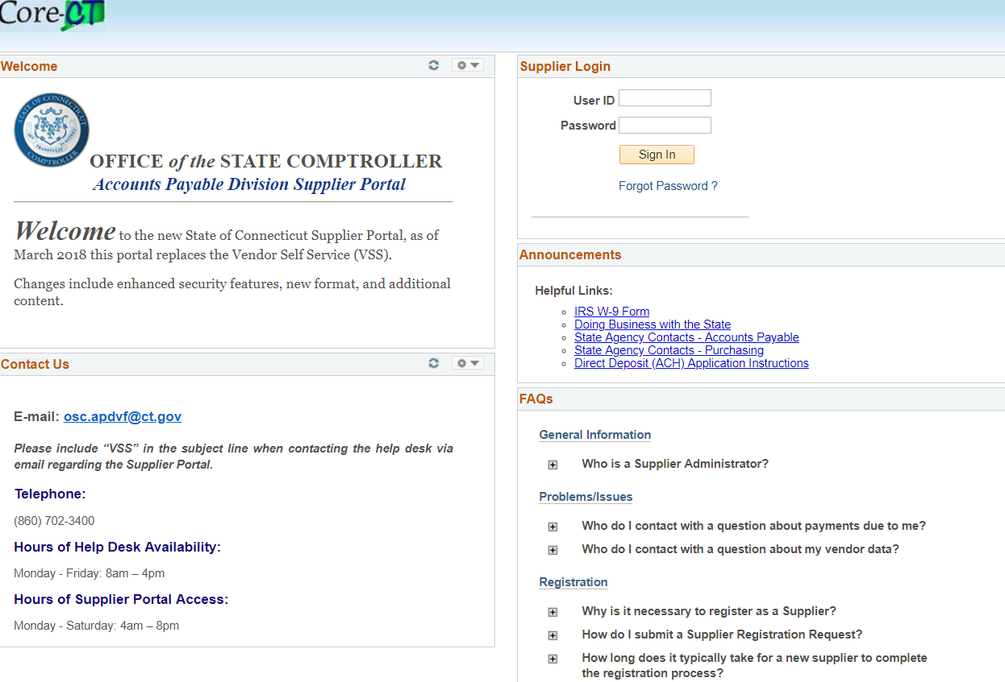
Once logged in, the Supplier is directed to the landing page where access to the UPKs is located under FAQs, highlighted in yellow below.
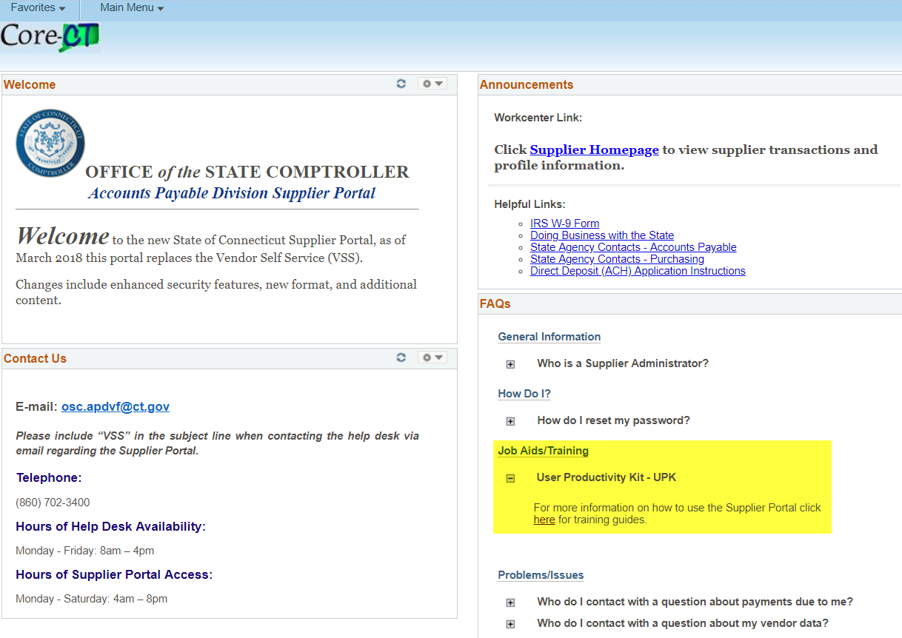
- How do I get the Supplier the correct roles for Core-CT? Who is responsible for establishing roles for Suppliers?
ANSWER: On the Core-CT website there is a How to Guide: Requesting Supplier Financial roles. This job aid has all the steps necessary to setting up a Provider with the correct access.
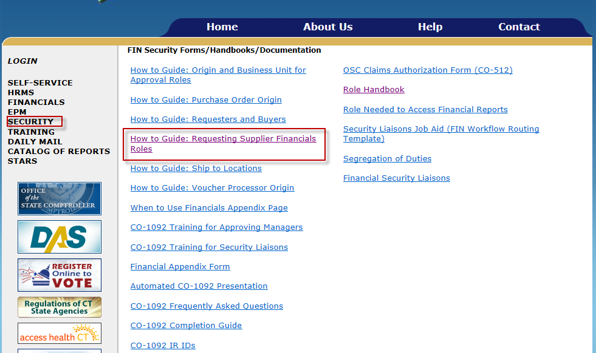
Navigation: Core-CT website > Financials>Security>How to Guide…
Cliff Note version:
- Supplier (with Administrator role) adds individual User IDs, which are established with view only role access.
- The State Agency talks to Supplier and determines what access is required for which User IDs. The request is then prepared by the State Agency.
- The State Agency’s Security Liaison will create the CO-1092 for the given roles and User IDs.
- The job aid contains screenshots of what is necessary with further details.
- Requesting Administrator access HHS Suppliers?
ANSWER: All existing (as of 3/26/2018) HHS Suppliers were set up with the eSupplier Administrator role and sent an email with instructions to log in to the new system.
A web form is now available to request a new HHS Supplier, add an administrator user for an existing HHS Supplier, or change the administrator user for an existing HHS Supplier.
Requests should only be made by a State Agency. To request administrator access for HHS suppliers please complete the following form: https://oscweb.ct.gov/vendor/VssRequest.aspx .
Please be sure to provide the supplier contact name of the individual who will be their designated administrator. If the vendor already exists in Core-CT, we will set up eSupplier access and send an email to them with instructions. If the vendor does not exist in Core-CT, we will send an invitation with a link to register as a new supplier.
- What roles can an Administrator have? Can there be more than one Administrator per Supplier?
ANSWER: Administrators can have all the roles, or only the Administrator role. The only restriction is that per Supplier there can only be one person with the Administrator role.
- Is there other information available for Suppliers or Agencies?
ANSWER: Yes. On the Core-CT website there are job aids and presentations available for Suppliers and State Agencies.
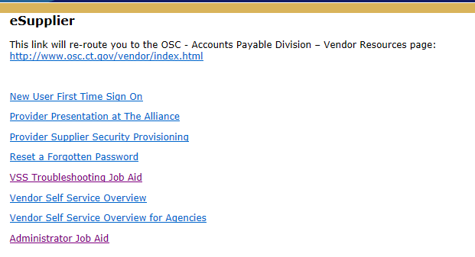
There is also information available to all Suppliers on the Comptroller’s Website under Vendor Resources.
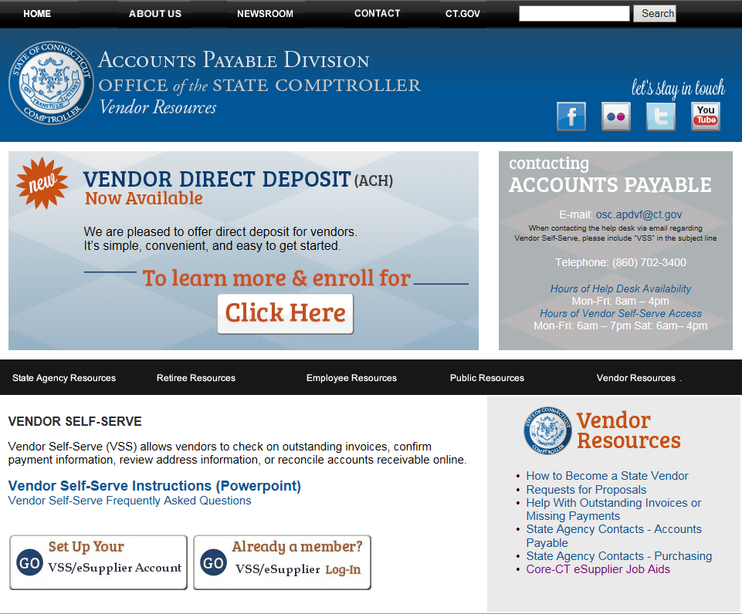

- What roles does a Provider have or don’t have?
ANSWER: On the AP and/or PO Workcenter under the Queries header there is an eSupplier User Information link. The Supplier ID will be needed to enter into the field and click on View Results. This will show the Provider users IDs, their roles and email. If you cannot see the AP and/or PO Workcenter, then you need to add the Purchasing Module Viewer (CT PURCHASING REVIEWER) role or Voucher Viewer (CT VOUCHER VIEWER) role at a minimum.


