PAYMENT CANCELLATIONS

- Payment Review
- Request for Payment Information (Form CO-860)
- Payment Cancellation CO-790 Request
- Analysis of Improper Payment/Internal Control Statement (Form CO-790S)
- Reversal Vouchers

When a voucher is created in error, there are three possible actions that can be taken to correct the error. The action that is taken is dependent on how far along the voucher is in the payment process:

- If the voucher has not been posted yet, delete it. The Core-CT navigation to do this is Accounts Payable > Vouchers > Add/Update > Delete Voucher. If the voucher is successfully deleted, there is no need to contact the Comptroller’s Office.

- If the error is discovered after the voucher has been posted, but before it has been paid, put the voucher on hold immediately. The hold reason should be Voucher Close. In the Payment Comments section on the Payments tab on the voucher, enter “To Be Closed by OSC” with the details for the closure; for example, To Be Closed by OSC. This would be a duplicate payment. Save the voucher. The voucher closure will be processed by the Comptroller’s Office at month end.

- For an erroneous voucher that is not identified until after a payment has been generated, or for payments identified as needing to be canceled for other reasons, proceed to the Payment Review section of this job aid.

Payment Review

When an agency becomes aware that a payment was made in error or is missing, stale, or damaged, the following steps should be taken.
- Verify the Reconciliation Status in Core-CT
- The reconciliation status indicates the status of vendor checks at the bank, and this status is updated daily.
- A status of ‘Reconciled’ generally means that the check was cashed; the reconcile date is the date that the check cleared the State’s bank account.
- A reconciliation status of ‘Unreconciled’ generally means that the check has not been cashed and is still outstanding.

- Navigate to Core-CT Financials > Accounts Payable > Review Accounts Payable Info > Payments > Payment.

- Enter the payment reference ID in the ‘From Ref ID’ box, then click ‘Search’ on the Payment Inquiry screen.

- Reconciliation Status is Reconciled:
- If a check has a reconciliation status of ‘Reconciled’ and payment status of ‘Paid’, it generally means that the check was cashed.
Note: If the payment status is ‘Stopped’ or ‘Void’ that means the payment has had some action taken on it and is no longer a valid payment; more than likely the payment was previously canceled. Clicking on the Payment Reference ID will provide further details.
- Based off the ‘Reconciled’ status, a Payment Cancellation CO-790 request is not applicable and should not be submitted.
  - A ‘Request for Payment Information (Form CO-860)’ may be completed and submitted to the Office of the State Treasurer to request a copy of the cashed check. See the ‘Request for Payment Information (CO-860 Form)’ section of this job aid for additional detail.

- If the payment is an ACH and notice of a returned ACH payment is received, or if the ACH payment is in error and needs to be retracted, or if the payment is a Wire, disregard the reconciliation status in Core-CT and proceed with the Payment Cancellation CO-790 request.

- Reconciliation Status is Unreconciled:
- A reconciliation status of ‘Unreconciled’ and a payment status of ‘Paid’ generally means that the check has not been cashed (i.e., is still outstanding), and that the check can be canceled.
- Based off the ‘Unreconciled’ status, proceed with the Payment Cancellation CO-790 request.

Request for Payment Information (Form CO-860)

If a check has a reconciliation status of ‘Recon’ and payment status of ‘Paid’, a ‘Request for Payment Information (CO-860 Form)’ (https://www.osc.ct.gov/agencies/forms/index.html) may be completed and submitted to the Office of the State Treasurer (ott.cashvendor@ct.gov) to request a copy of the cashed check. A CO-860 cannot be used to reissue a check.

- Navigate to Core-CT Financials > Accounts Payable > Review Accounts Payable Info > Payments > Payment.

- Enter the payment reference ID in the ‘From Ref ID’ box, then click ‘Search’ on the Payment Inquiry screen. See below for a screenshot of the Payment Inquiry results and chart to identify where the payment information can be found using the Payment Inquiry results.

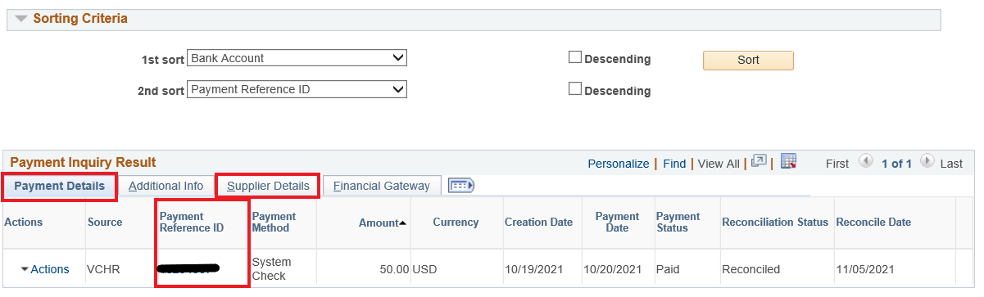

Form Field | Payment Inquiry Screen Tab
Business Unit | Payment Details > Click on the Pmt. Ref. ID
Agency Name, Address | N/A – List Agency Name and Address
Supplier ID | Supplier Details
FEIN/SSN | N/A
Supplier Name | Supplier Details
Payment Reference ID | Payment Details
Payment Method | Payment Details
Payment Handling Code | N/A – Review the voucher for this information
Payment Amount | Payment Details
Payment Date | Payment Details
Voucher ID | Payment Details > Click on the Pmt. Ref. ID
Voucher Accounting Date | Payment Details > Click on the Pmt. Ref. ID
Voucher Amount | Payment Details > Click on the Pmt. Ref. ID
Additional Vchrs | Payment Details > Click on the Pmt. Ref. ID
Control Group | N/A

Fill out the remaining boxes of the CO-860 as follows:
Box 17 – If check is missing, mark this box.
Box 18 – Mark this box to receive a copy of the check.
Box 19 – Complete this section if additional information justifying the request is needed.
Boxes 20 thru 23 – Complete the contact information of the requesting individual.
Boxes 24 thru 28 – The form must be signed and dated for OTT to process.

Payment Cancellation CO-790 Request

- Complete the Payment Cancellation CO-790 Request

Navigate to Core-CT Financials > Accounts Payable > Review Accounts Payable Info > Payments > Payment Cancellation CO-790 and select “Add a New Value”. The Payment Cancellation CO-790 will appear, defaulted on the ‘Form’ tab.

Note: If the navigation for the Payment Cancellation CO-790 request is saved to ‘Favorites’ or ‘My Links’ in Core-CT, select the ‘Add a New Value’ tab. The user will then have to either enter ‘CO790’ in the ‘Form’ field or select ‘CO790’ from the lookup search results, then click ‘Add’.

Note: The Payment Cancellation CO-790 request has three tabs. The ‘Form’ tab is where the Payment Cancellation CO-790 request is entered. The ‘Instructions’ tab provides the steps required to complete the Payment Cancellation CO-790 request. The ‘Attachments’ tab is where any supporting information relating to the Payment Cancellation CO-790 request is uploaded (defaced checks, pertinent email correspondence, CO-790S form for pre-approval, etc.)

On the Form tab:

- Enter header information:
- Enter a brief description of the request in the ‘Subject’ field, for example: ‘OSCM1 – Missing Check’.
- Select the ‘Priority’ – the selected status will be reviewed and further assessed by OSC.
- Disregard the ‘Due Date’.

- Enter the historic payment details (i.e., Agency Information, Payment Details, Voucher Information, Supplier Details).

Note: Using the ‘Click here For Payment Info. and To Verify Reconciliation Status’ link on the form is recommended to pull up the Payment Inquiry screen and obtain the historic payment information to be entered on the form. It also can be used to verify the reconciliation status if not previously reviewed (see Payment Review section.)

- Enter the payment reference ID in the ‘From Ref ID’ box, then click ‘Search’.
- See below for a screenshot of the Payment Inquiry results and chart to identify where the payment information can be found using the Payment Inquiry results.
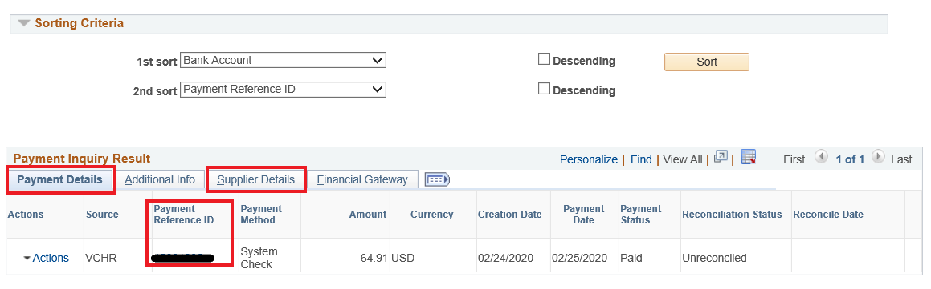
Form Field | Payment Inquiry Screen Tab
Business Unit | Payment Details > Click on the Pmt. Ref. ID
Agency Name | N/A – List Agency Name
Payment Reference ID | Payment Details
Payment Method | Payment Details
Payment Amount | Payment Details
Payment Date | Payment Details
Voucher ID | Payment Details > Click on the Pmt. Ref. ID
Amount | Payment Details > Click on the Pmt. Ref. ID
Additional Vchrs | Payment Details > Click on the Pmt. Ref. ID
Supplier ID | Supplier Details
Supplier Name | Supplier Details

- If the check is within your possession, click the ‘Check Attached’ check box and attach the defaced check image via the ‘Attachments’ tab (see Section II. for additional details). The physical check must also be forwarded to Central Accounts Payable.

- Select the Reason for the cancellation from the dropdown.
  - If ‘Other’ is selected as the reason for the cancellation, enter an explanation in the dialog box.

- Select the Action from the dropdown.
  - If the action selected is ‘Reissue With Changes’, specify the changes required, for instance: Changes in Payee Name/Address #, Payment Location, Payment Method, Payment Handling, Separate Payment, etc. in the ‘Specify Changes’ dialog box.
  - If the action selected is ‘Do Not Reissue’, enter the reason why the payment is not to be reissued in the ‘Specify Changes’ dialog box. A CO-790S may be required if the payment is not being reissued due to the wrong supplier being paid, wrong payment amount, duplicate payment, etc. See the ‘Analysis of Improper Payment/Internal Control Statement (CO-790S Form)’ section of this job aid for addition details.

- Click ‘Save’ at bottom of form
  - When the form is saved, a ‘Seq. #’ appears in the top left of form, and the ‘Preview Approval’ and ‘Submit’ buttons also appear at the top of form.

- Use the ‘Attachments’ tab to Attach Defaced Check Images, CO-790S (if applicable), and other Documents Deemed Pertinent
- Note; it is imperative that defaced check images are provided, if within the Agency’s possession, in order to expedite the processing of the Payment Cancellation CO-790 request. The physical check must also be forwarded to Central Accounts Payable.
- The request must be saved (i.e. hitting ‘Save’ on the Form tab) after attaching the file for the attachment to be retained.

- Review for Accuracy and click Submit
- The Payment Cancellation CO-790 request is not complete until the ‘Submit’ button is clicked. The “Submit’ button will appear at the top of the form once the form is saved.
- To see the status of a submitted request, navigate to the Accounts Payable WorkCenter > Report/Queries tab > AP CO-790 Payment Cancellation > enter the business unit.
- If a Payment Cancellation CO-790 request needs to be rescinded, please send an email request as soon as possible to osc.apd@ct.gov listing either the Sequence # or Payment Reference ID and a brief explanation as to why the request needs to be rescinded.

- CO-790 Forms Requiring Clarification or Correction
- At times, a Payment Cancellation CO-790 request may be returned to the agency with a note that more information is required.
  - The user who created the Payment Cancellation CO-790 request will receive an email with the following subject line: [Form Approval] Information has been requested for the Form XXXX (CO790). This email will contain a link to the Payment Cancellation CO-790 form. Alternatively, the user can navigate to the Payment Cancellation CO-790 request via Core-CT Financials > Accounts Payable > Review Accounts Payable Info > Payments > Payment Cancellation CO-790, select the ‘Find an Existing Value’ tab and enter the request sequence number.
  - On the form, click the ‘Approval Status’ button.
  - Click on ‘Comments’ under the CAP Initial Approval section to see what information is needed to complete the Payment Cancellation CO-790 request.
  - Once the Payment Cancellation CO-790 request has been updated, provide notice by replying to the email notification received.
- In order to ensure that staff who use the Payment Cancellation CO-790 request receive notification emails, navigate to Main Menu > My System Profile in Core-CT and check the ‘Primary Email Account’ checkbox next to the employee’s work email address.

Analysis of Improper Payment/Internal Control Statement (Form CO-790S)

The purpose of the CO-790S is to evaluate how an erroneous payment was made and identify improvements that can be implemented to prevent a recurrence.

- Section A must describe the situation in detail. If the payment was to the wrong vendor or for the wrong amount, indicate who the correct vendor is or what the amount should have been. Also include how the incorrect information was selected and why it was not caught at the approver level.

- Section B must describe the internal controls that were in place at the time of the error. Even if the controls may not have been a factor, this section still needs to be filled out.

- Section C should describe changes that are going to be made to internal controls that will prevent a similar error from happening again. If a refund or credit are required from the vendor, the statement “Copy of the refund check/credit will be submitted to OSC CAP when received” must be included in this section.

OSC CAP will pre-approve the CO-790S forms to eliminate the need for multiple signatures. For pre-approval email the unsigned CO-790S form to osc.apdsp@ct.gov. After OSC CAP pre-approves the CO-790S form, it can be sent to the agency head to be signed. The CO-790S must be signed by the agency head or deputy.

Reversal Vouchers

When prior fiscal year payments are canceled and not being reissued, a reversing voucher is required to reverse the accounting entries. If a reversal voucher is required, your agency will be notified via email with instructions on how to create the reversal voucher. Reversal vouchers should not be created unless the agency is instructed to do so.

